

Azure SQL Database

Hands-On Lab

Manual

Version 2.4

1/20/2016

Prepared for: Guy Haycock

Azure SQL Database

Prepared by: Prowess Consulting

Table of Contents

Overview 3

Task 0: Lab Setup 4

Task 1: Purchasing a Ticket 10

Task 2: Creating a Database 13

Task 3: Vertical Scaling 16

Task 4: Azure SQL Database Elastic Database Pools 23

Task 5: Auditing (Optional) 28

Task 6: Point-in-Time Restore 35

Task 7: Geographic Disaster Recovery 46

Task 8: Transparent Data Encryption with Azure SQL Database 60

Task 9: Azure Search 64

Task 10: Azure Search Code Review (Optional) 66

Task 11: Azure DocumentDB 71

Task 12: Azure Data Factory 76

Task 13: Azure Data Warehouse 81

Task 14: Power BI 83

Conclusion 83

# Overview

In this lab, you will explore features of Microsoft Azure SQL Database in the context of a software-as-a-service (SaaS) provider, WingTipTickets, who provides ticketing software for artists. The tenant you will encounter in this lab is the following artist:

* Julie and the Plantes (a fictitious pop-music tenant)

Other tenants that will be discussed in future labs will include the following:

* The Archie Boyle Band (a fictitious rock-music tenant)
* Walla Walla Symphony (a fictitious classical-music tenant)

## What You’ll Learn

In the course of this lab, you will gain greater familiarity with Azure SQL Database through performing the following tasks:

* Familiarize yourself with one of the tenant-company’s websites and its Azure SQL Database backend by purchasing a ticket.
* Create a new database using the Azure portal.
* Configure and implement vertical scaling by increasing the capacity of a database.
* Configure and implement elastic database pools to dynamically manage the capacity of a pool of databases.
* Use Azure SQL Database auditing features to track down an erroneous deletion from a database.
* Use Azure SQL Database point-in-time restore to correct the deletion.
* Configure and implement Azure SQL Database geographic disaster recovery to prevent large-scale data loss.
* Implement transparent encryption on an Azure SQL Database.
* Locate events using Azure Search.

## Estimated Time to Complete

You should budget four hours to complete all the tasks in this lab.

## Architecture

**Figure 1** Overall architecture of the various lab components

# Task 0: Lab Setup

Because this lab uses the Azure public cloud, all server names must be unique. To help ensure this, the New-WTTEnvironment Azure PowerShell script that you used to configure this lab automatically generated unique server names based on the environment name that you supplied during configuration. This hands-on lab (HOL) manual uses the following server names to illustrate an example of where the environment was set up:

This line represents an example of the PowerShell command that will be used to setup the WingTipTickets Azure demo environment.

New-WTTEnvironment -WTTEnvironmentApplicationName XX00julieXX00julieandtheplantes

* XX00julieandtheplantesprimary.database.windows.net (primary database server)
* XX00julieandtheplantessecondary.database.windows.net (secondary database server)
* XX00julieandtheplantesprimary.azurewebsites.net (primary Azure Web App)
* XX00julieandtheplantessecondary.azurewebsites.net (secondary Azure Web App)
* [XX00julieandtheplantes.trafficmanager.net](http://mbchristophanhalt.trafficmanager.net/) (Azure Traffic Manager profile)
* XX00julieandtheplantes (Azure Storage account that contains the audit-events table)
* XX00julieandtheplantes (resource group)

Your particular server names will have your initials prepended to them. For example, the primary Azure Web App might be ghjulieandtheplantesprimary.azurewebsites.net.

## Task 0 Steps

1. (Optional) Connect Microsoft SQL Server Management Studio (SSMS) to:

* Primary database server(in this example, XX00julieandtheplantesprimary.database.windows.net)
* Secondary database server(in this example, XX00julieandtheplantessecondary.database.windows.net)

Use the following credentials to connect:

* User name: **developer**
* Password: **P@ssword1**

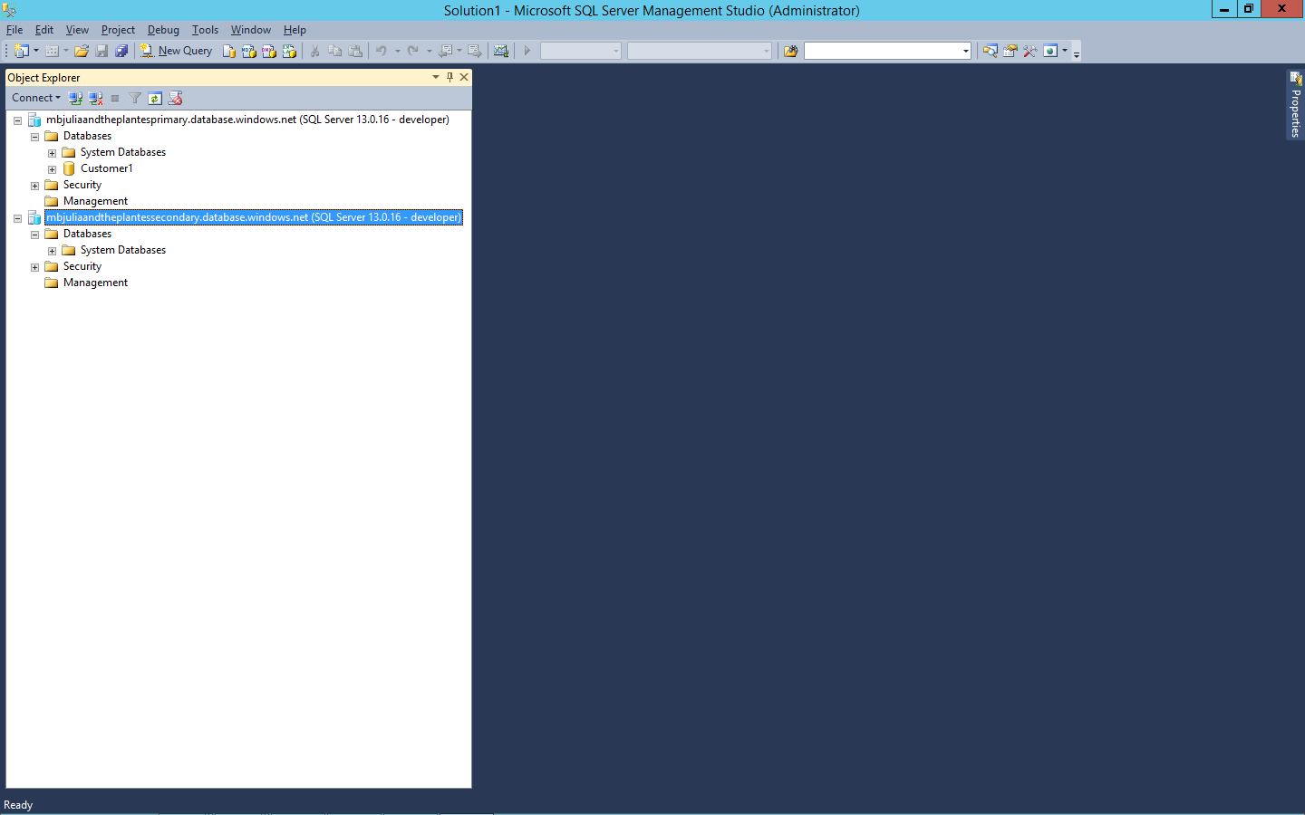

**Figure 2** Connect to the primary and secondary database servers with Microsoft SQL Server Management Studio

If this is your first time setting up the environment, skip steps 2 and 3.

1. From **portal.azure.com**, make sure the **Primary Database Server/Customer1** database is set to **Basic SKU** and **Geo Replication** is disabled. (In this example, the primary database server is *XX00julieandtheplantesprimary.database.windows.net/customer1*.)
2. Makes sure **Customer1 DB** doesn’t exist on the secondary database server.

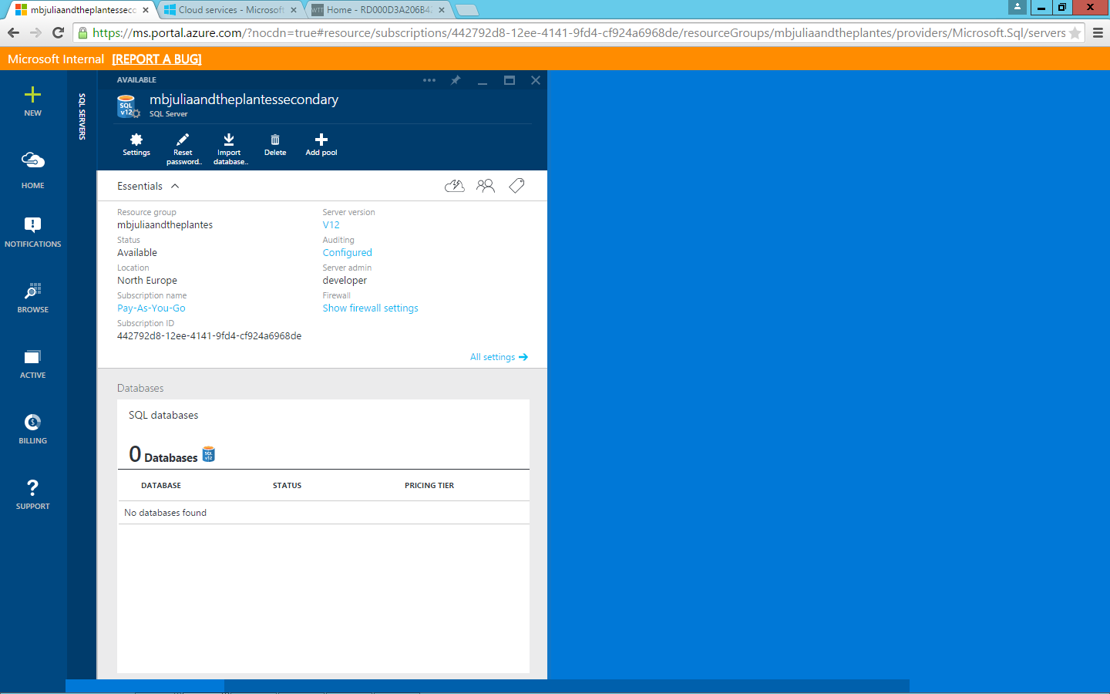

**Figure 3** Ensure that Customer1 DB does not already exist on the secondary database server

1. (Optional) If you’d like to explore the auditing scenario, please complete steps 5–14.

Make sure your Microsoft Excel template **01-Azure SQL DB Audit Logs Report Template** is connected to your storage account.

1. Open **01-Azure SQL DB Audit Logs Report Template**.
2. Click the **PowerQuery** tab if using **Excel 2013**, or click the **Data** tab if using **Excel 2016**.
3. Make sure **Show Pane** is enabled if using **Excel 2013**, or click **Show Queries** if using **Excel 2016**.
4. On the right, under **Workbook Queries**, right-click **AuditLogs**.
5. Click **Edit**.
6. Click the gear next to **Source**.
7. Insert your Azure Storage account that was created during setup (in this example, *XX00julieandtheplantestorage*).

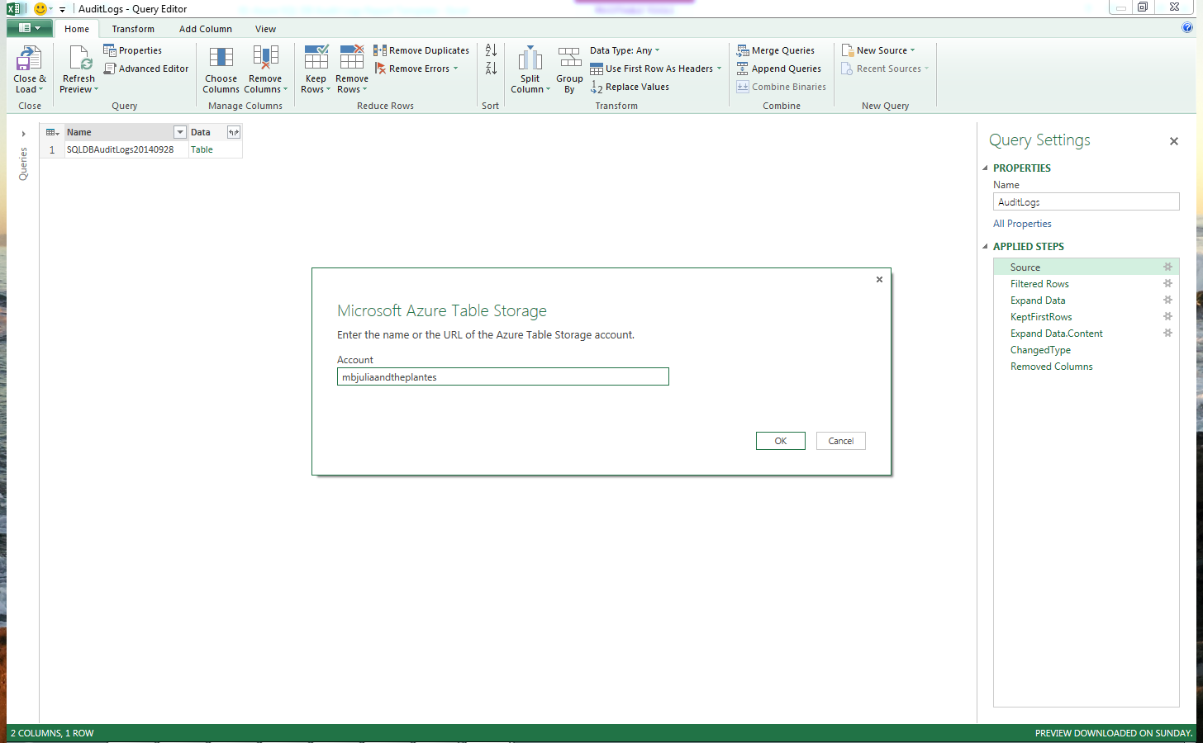

**Figure 4** Ensure that the correct Microsoft Azure Storage account is set up in the AuditLog Report Template

1. In case you are prompted to provide the Azure Storage key, browse to **portal.azure.com**, click **Browse** > **Storage Account**, and then select the storage account that was previously created. Click the key and then copy the **Primary Access Key**.

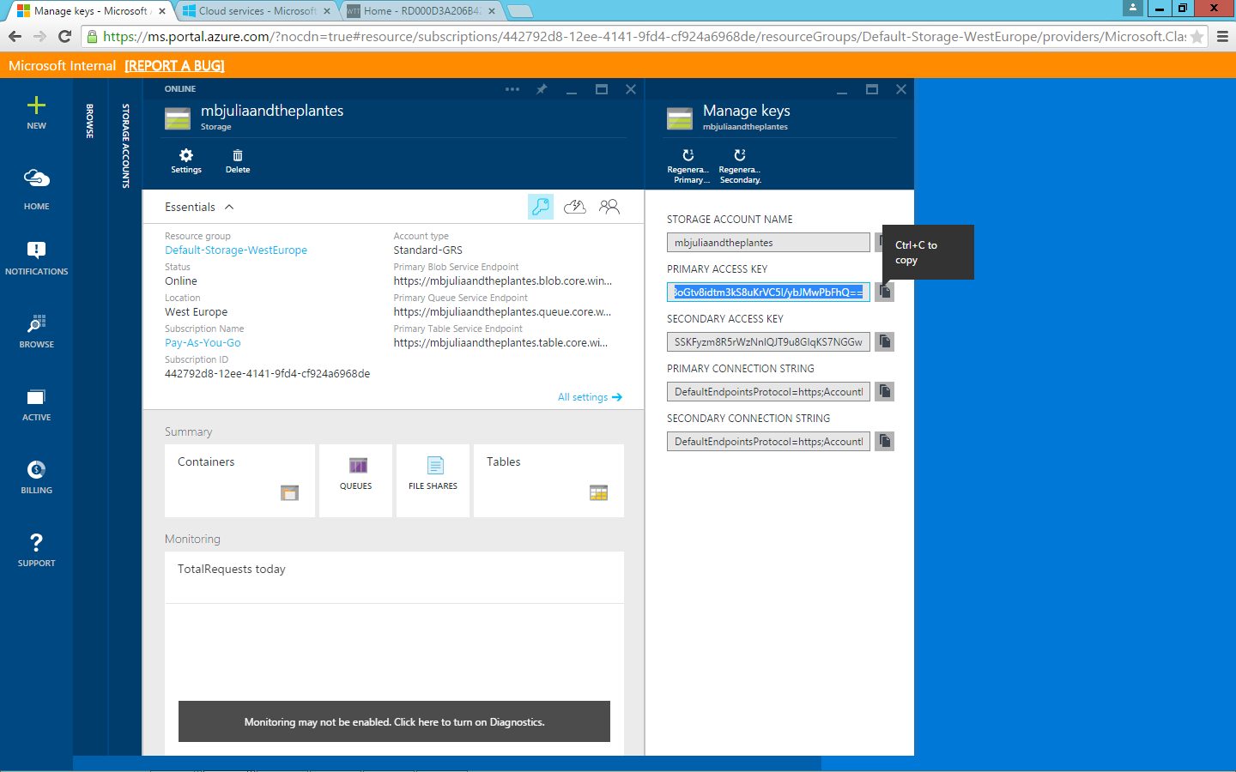

**Figure 5** Copy the primary storage access key from Azure Portal

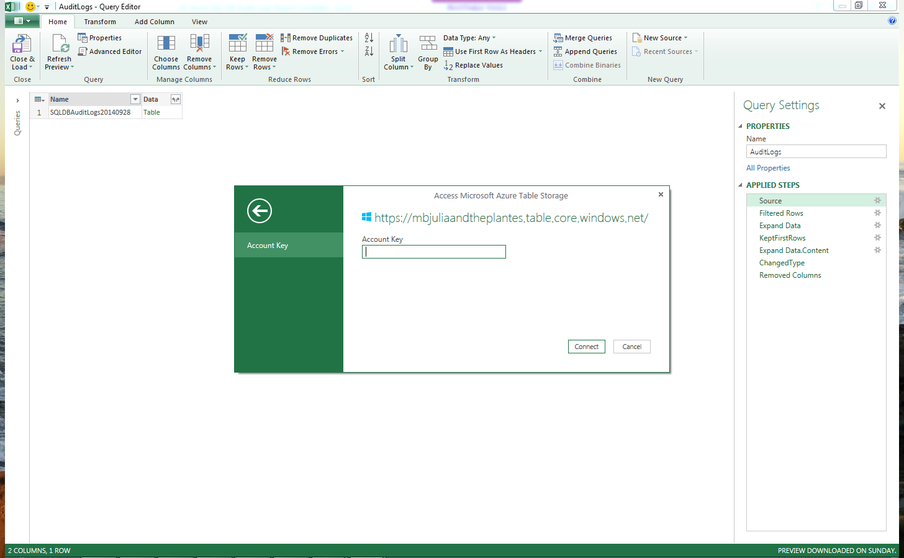

**Figure 6** Paste the primary storage access key

1. Paste the Primary Access Key in Access Microsoft Azure Table Storage
2. Click **OK**.
3. At the top left, click **Close & Load**.

**Note:** If you’ve previously used the demo, use the AuditLogUtility to purge the Azure Storage account audit log table, which will improve load time during the auditing section.

AuditLogUtility.exe <your storage account name> <your storage account primary key>

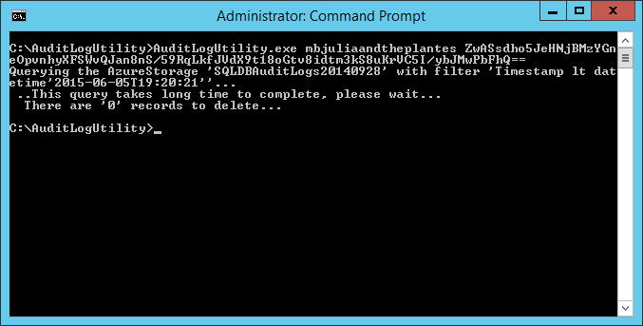

**Figure 7** Use AuditLogUtility to purge the storage account audit log table to improve load time

# Task 1: Purchasing a Ticket

First you will get a feel for the fictitious tenant website by pretending to be a user and purchasing a ticket for an event.

## Task 1 Steps

1. Browse to the Azure Traffic Manager URL (in this example, [*http://XX00julieandtheplantes.trafficmanager.net/*](http://mbjulieandtheplantes.trafficmanager.net/)).
2. To the right of the first event on the website, click **Find Seats**.

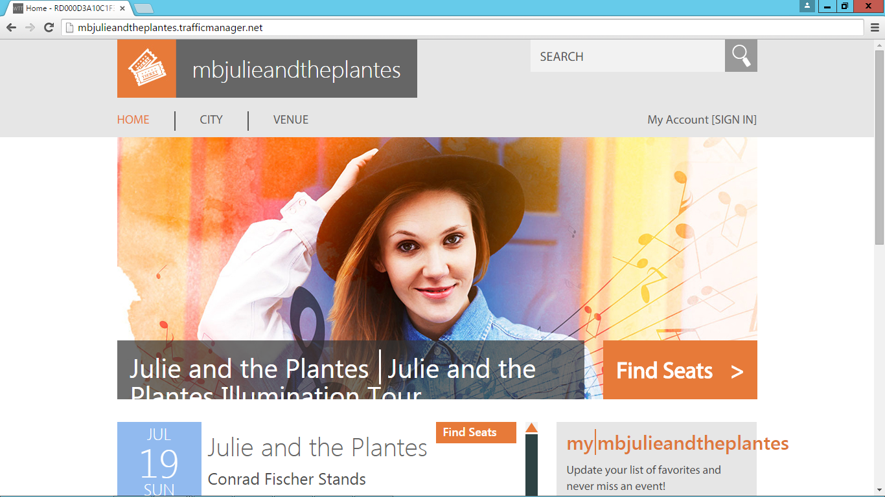

**Figure 8** Purchasing a ticket on the tenant website

1. Click **Sign in to purchase tickets**.

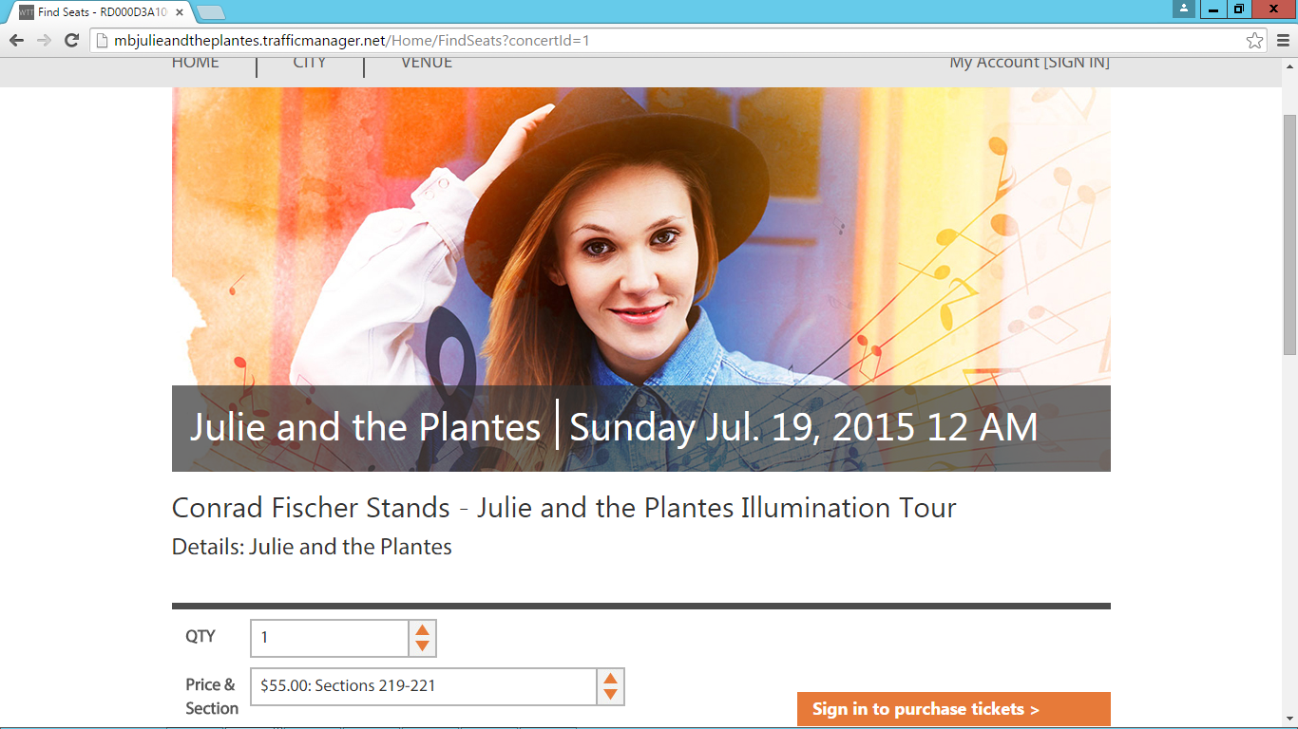

**Figure 9** Sign in to purchase a ticket

1. Either create a new account if you haven’t browsed to the site before, or sign in using an existing account.

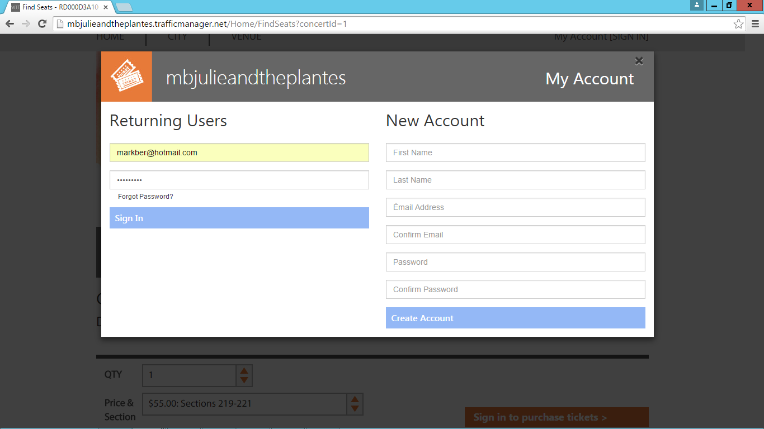

**Figure 10** Sign in with an existing account or create a new account

1. Now that you are signed in, click **Purchase tickets**.

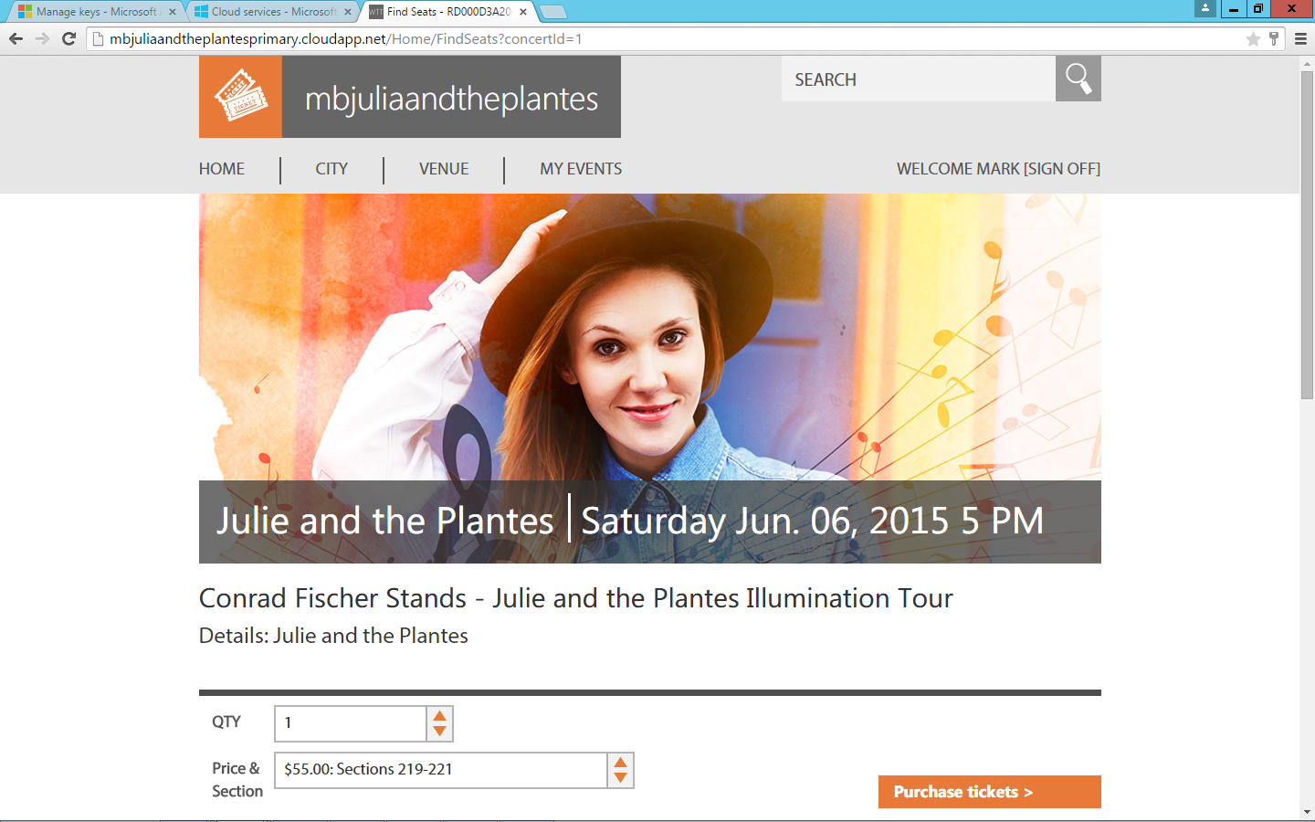

**Figure 11** Select an event for which to purchase a ticket

1. Click **Purchase Now**.

**Note:** Payment information is not required.

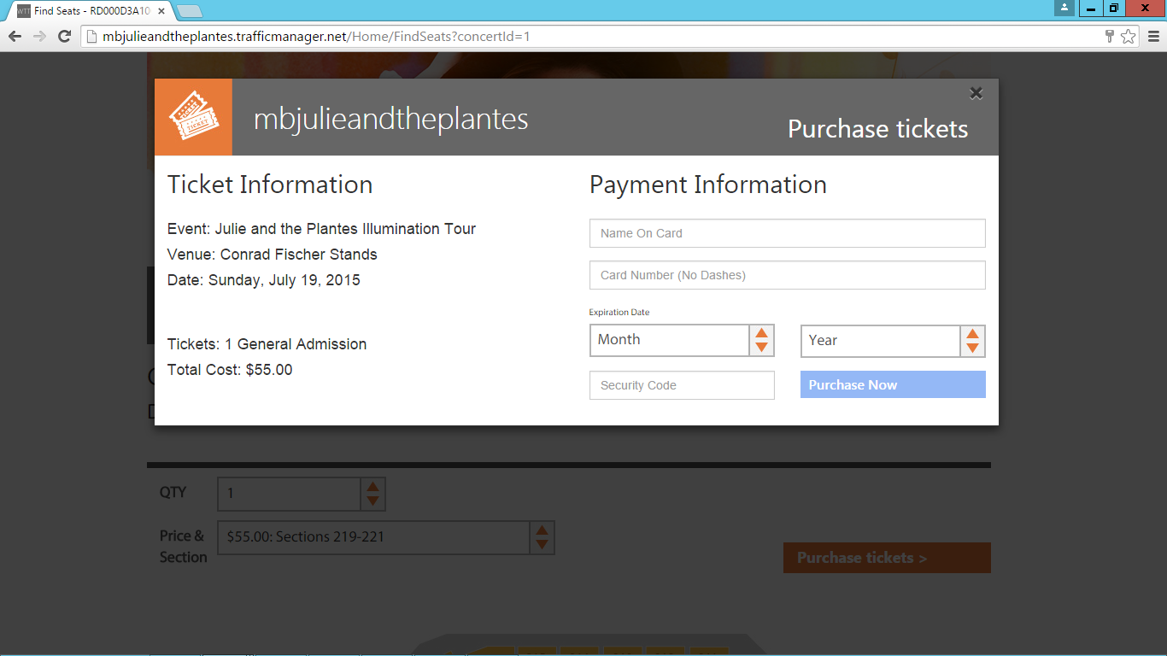

**Figure 12** Purchase tickets for your event

You should receive a purchase confirmation.

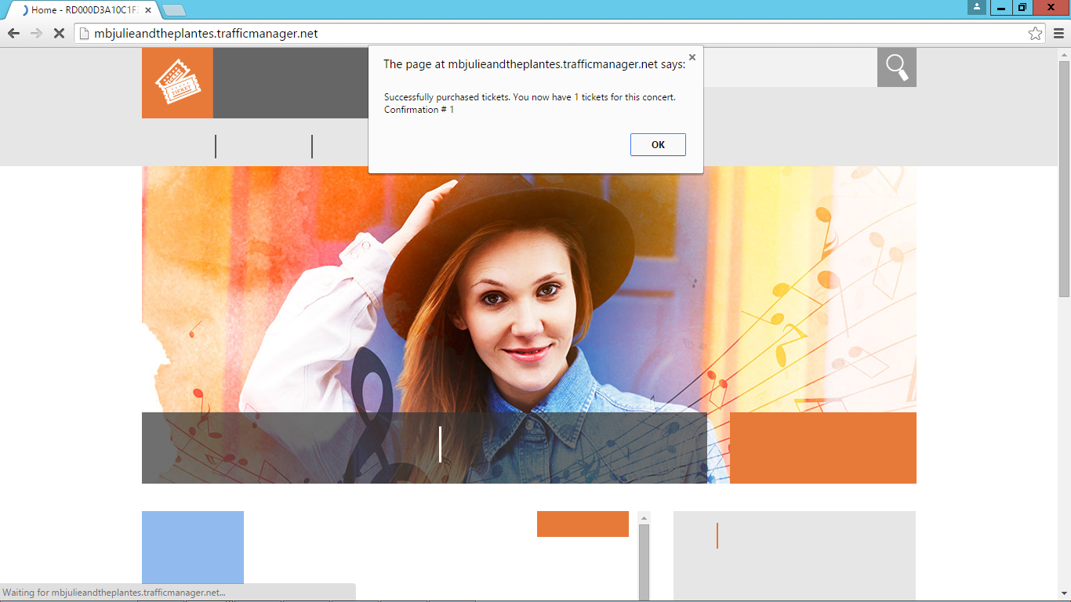

**Figure 13** Confirm your order purchase in the confirmation window

1. Click **OK**.
2. Click the **My Events** tab to verify the purchase.

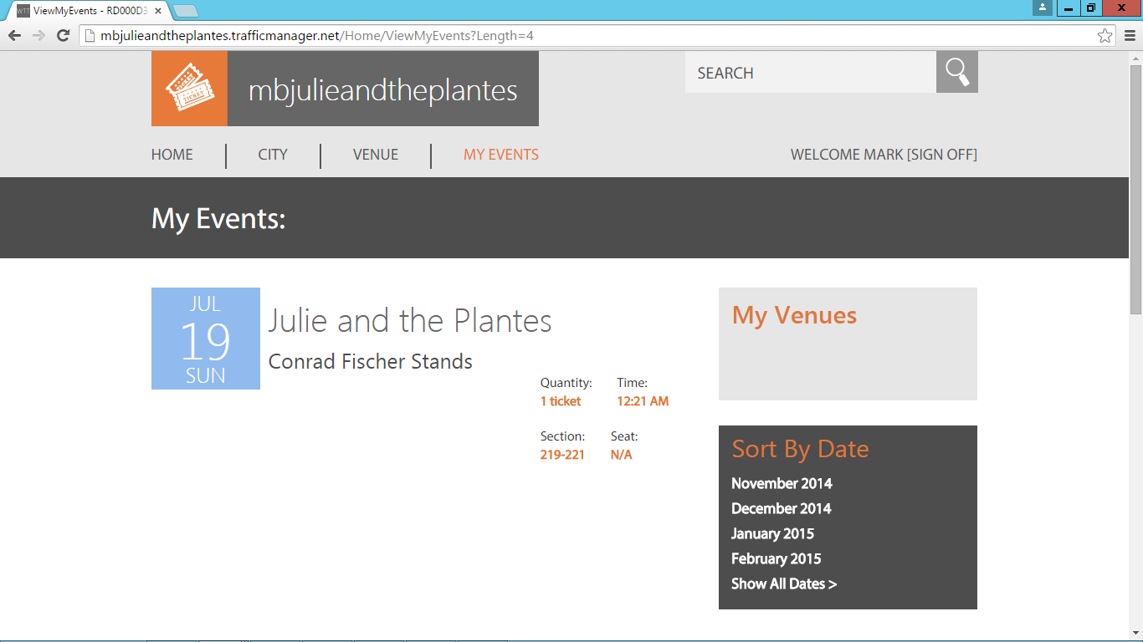

**Figure 14** Verify your purchase on the website

1. Review the event you just purchased.

Now that you have a high-level feel for the tenant website, you are ready to examine the various Azure SQL Database features that power the website.

# Task 2: Creating a Database

Now you will learn how to create a new database in Azure SQL Database.

1. From **portal.azure.com**, at the top left, click **+ New**.
2. Click **Data + Storage**.
3. Click **SQL Database**.
4. In the **Name** field, type **Customer2**.
5. Under **Server**, select the primary database server (in this example, *XX00julieandtheplantesprimary.database.windows.net*).

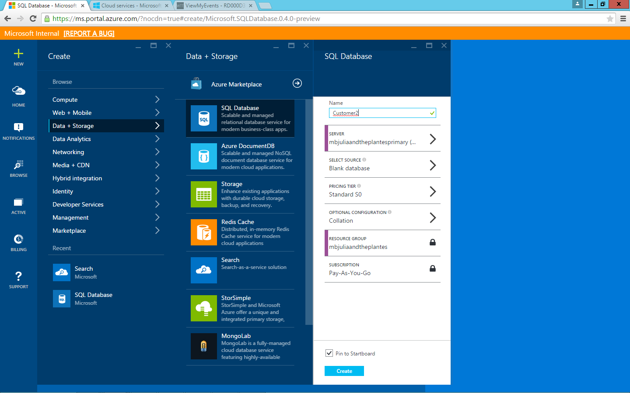

**Figure 15** Create a new database in Microsoft Azure SQL Database

1. Click **Create**.
2. If you selected the **Pin to Starboard** check box, the Starboard (homepage) will appear and a tile with your Customer2 database will be added and will reflect the status.

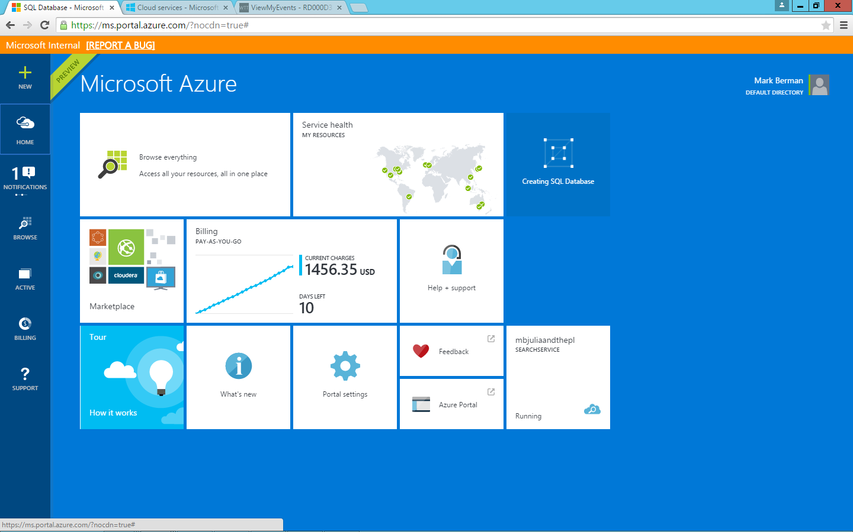

**Figure 16** Check to see your database pinned to the homepage if you selected **Pin to Starboard**

1. Once the database is created, you’ll be taken to the database overview automatically. Here you can view graphs that reflect the resource utilization and connection information, in addition to being able to change the pricing tier and other related settings.

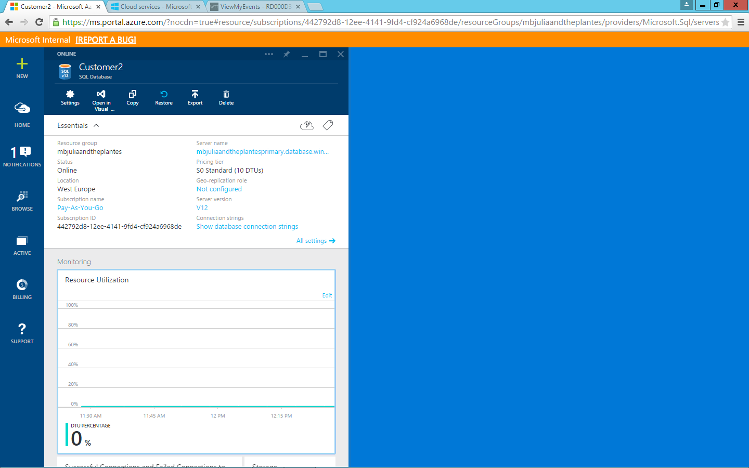

**Figure 17** View the details of your new database in the database overview

# Task 3: Vertical Scaling

Julie and the Plantes is anticipating sell-out crowds for upcoming events, and the website might require increased capacity to handle demand. In this task you will:

* Simulate some load using the load generator, and then show the spike in resource utilization with the current size of the database instance.
* See how easy it is to scale up by changing the size of an instance (in this case, from Basic to S0) and how quickly the change is implemented.
* Re-run the load generator, and then show how the increased capacity has significantly improved the site’s ability to handle a spike in ticket sales.

One of the benefits of Azure SQL Database is the ability to scale up and down as needed, with zero impact to uptime.

## Task 3 Steps

To demonstrate a task where an event has just gone on sale and many users purchase tickets at the same time, we have a load generator that can simulates a spike in demand.

1. To start the load generator, open the LoadGenerator folder, and then double-click **LoadGenerator.exe**.
2. Insert the primary database server (in this example, *XX00julieandtheplantesprimary.database.windows.net*).
3. Select the first **Event** from the list, which will correspond to ConcertId 1, select **Ticket Level**, and then select **Customer**.
4. For the purposes of this lab, the same event used in the previous section was chosen.
5. In the **Tickets To Purchase** field, enter **10000**.
6. In the **Bulk Purchase** field, enter **80**.
7. Click **Start**.

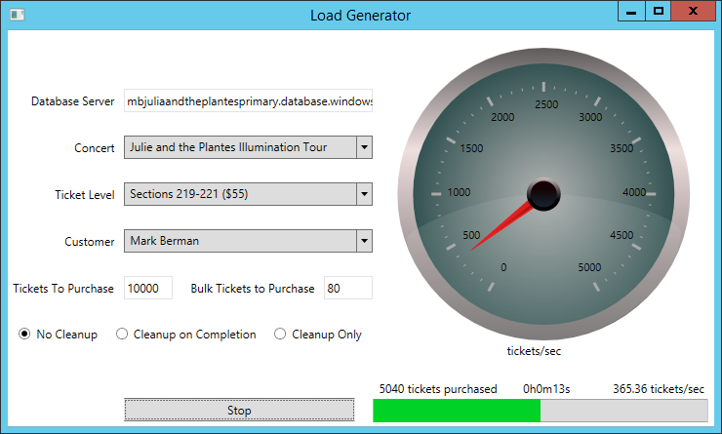

**Figure 18** Simulate ticket purchases

As you can see, we just simulated a real-world task where 10,000 tickets were purchased, and the database was able to handle a rate of around 365 tickets per second.

**Note**: The number of tickets/second will vary depending on the values you specified in the load generator and the network from which you ran the test.

1. Switch to the Azure portal, expand the Azure SQL Database blade, and then select **Customer1** on the primary database server (in this example, *XX00julieandtheplantesprimary.database.windows.net*).

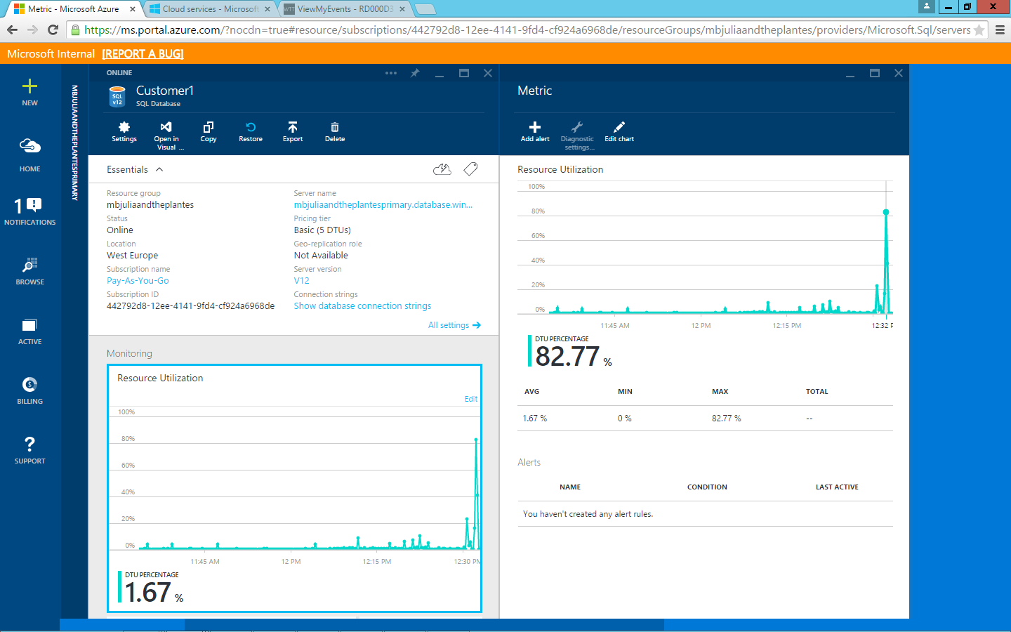

**Figure 19** Verify the resource-utilization spike from the load generator

Within a minute or so, you should notice a spike in the resource-utilization chart. CPU usage spiked over 80 percent, which would obviously cause a problem if there were multiple events that went on sale at the same time.

**Note:** You could optionally create an alert that would trigger once the CPU utilization reaches a certain threshold.

The database was initially configured using the Basic pricing tier, which the previous test shows would not be enough capacity to handle an even larger spike or multiple concurrent events.

Basic would not be used for a real-world ticket purchasing website, but is used in this lab scenario primarily to make it easy to show a spike in CPU utilization and to demonstrate how easy it is to scale up on demand.

1. In the **Customer1 Database** summary pane, scroll down to **Pricing tier**.
2. Click **Pricing tier**.

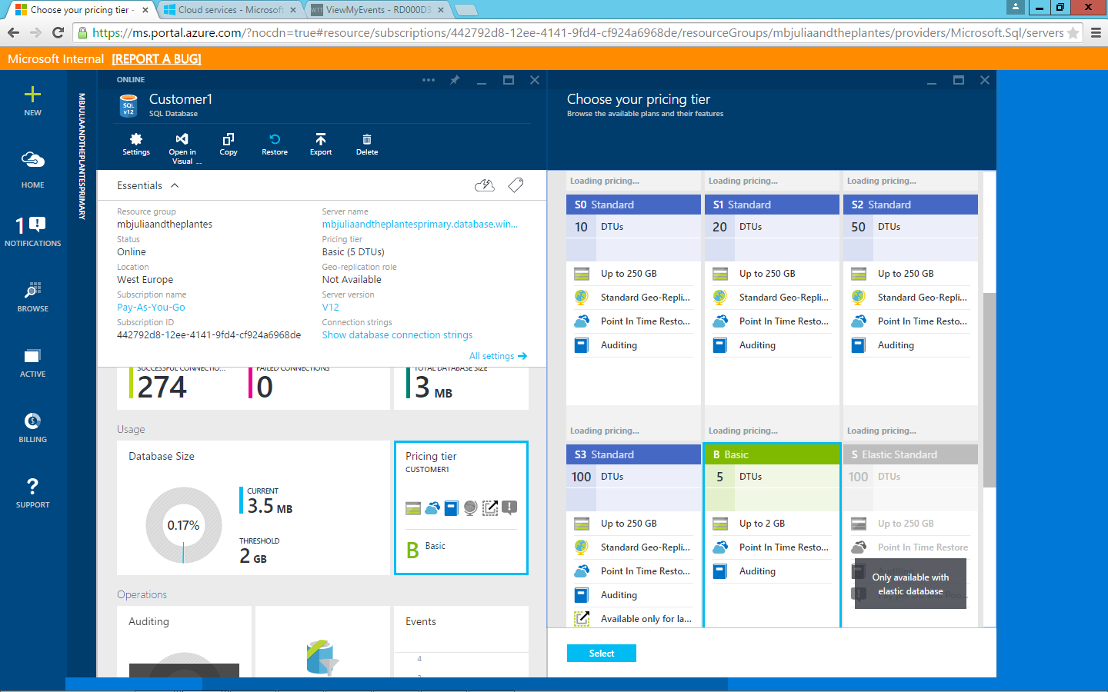

**Figure 20** Upgrade the database to one with higher capacity

Azure SQL Database makes it easy to scale up as needed with the click of a button.

1. Click **S0 Standard**.
2. Click **Select**.

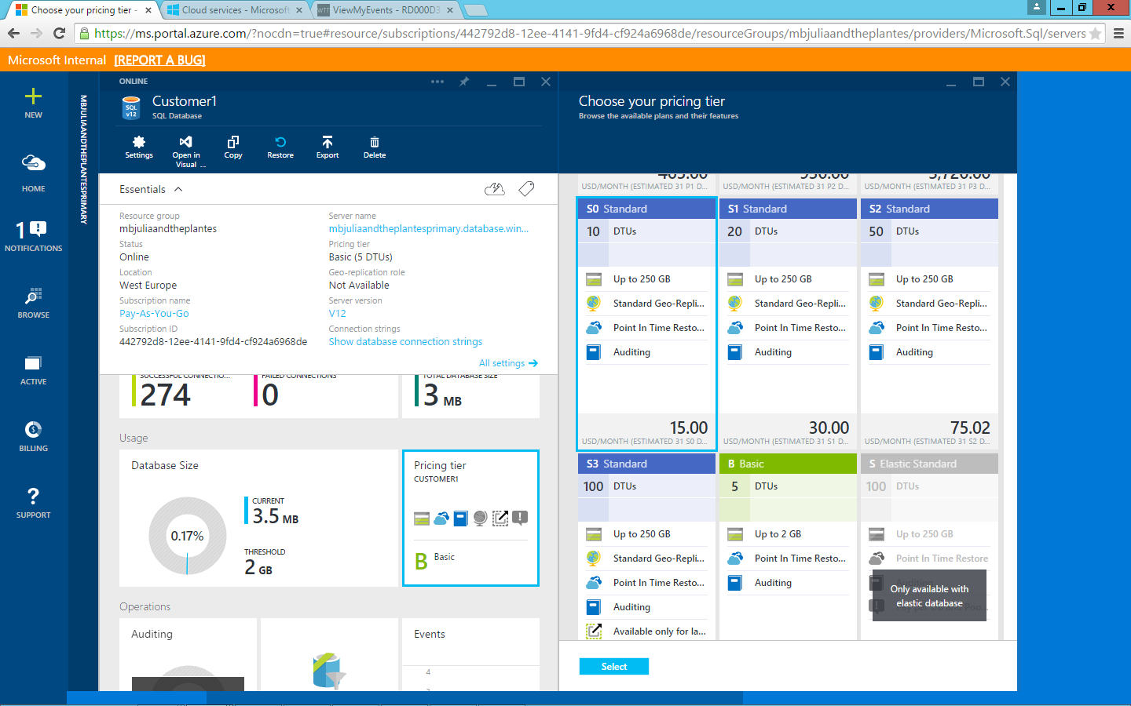

**Figure 21** Scale up a database with greater capacity (measured in database throughput units [DTUs])

Within a few seconds, the Basic pricing tier is upgraded to the S0 tier, and the allotted capacity has effectively doubled from 5 database throughput units (DTUs) to 10 DTUs. DTUs are based on a simple, blended measure of CPU, memory, reads, and writes, and they provide a convenient means of describing the relative capacity of the performance levels of different Azure SQL Database SKU pricing tiers.

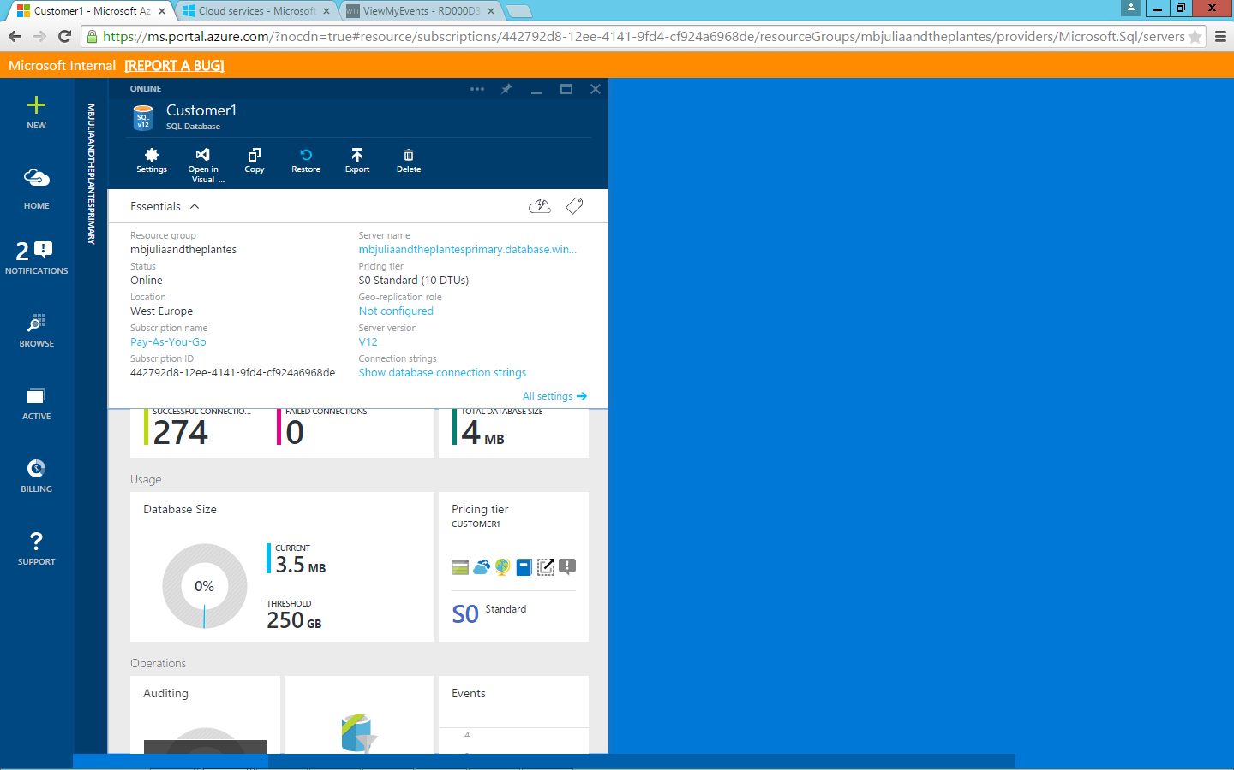

**Figure 22** Verify that the database upgraded to a high-performing pricing tier

Now that we’ve upgraded the capacity, let’s see how our application scales with the same load.

1. Return to the load generator.
2. Insert the primary database server (in this example, *XX00julieandtheplantesprimary.database.windows.net*).
3. Select the first **Event** from the list, which will correspond to ConcertId 1, select **Ticket Level**,and then select **Customer**.
4. For the purposes of this lab, choose the same event as used previously.
5. In the **Tickets To Purchase** field, enter **10000**.
6. In the **Bulk Purchase** field, enter **80**.
7. Click **Start**.

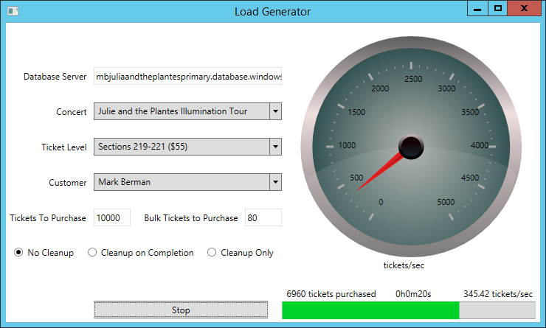

**Figure 23** Run the load generator again to see how the higher-performing pricing tier compares

As you can see, we just simulated another real-world task where 10,000 tickets were purchased, but the tickets per second results look pretty much the same.

1. Switch back to the Azure portal.
2. Make sure that you have the **Summary** pane open for the Customer1 database on the primary database server (in this example, *XX00julieandtheplantesprimary.database.windows.net*).
3. Within a minute or so, you should notice a spike in the resource-utilization chart from the LoadGenerator. Notice that this time the database CPU usage spikes to around 40 percent, which demonstrates that the added capacity is already providing a benefit.

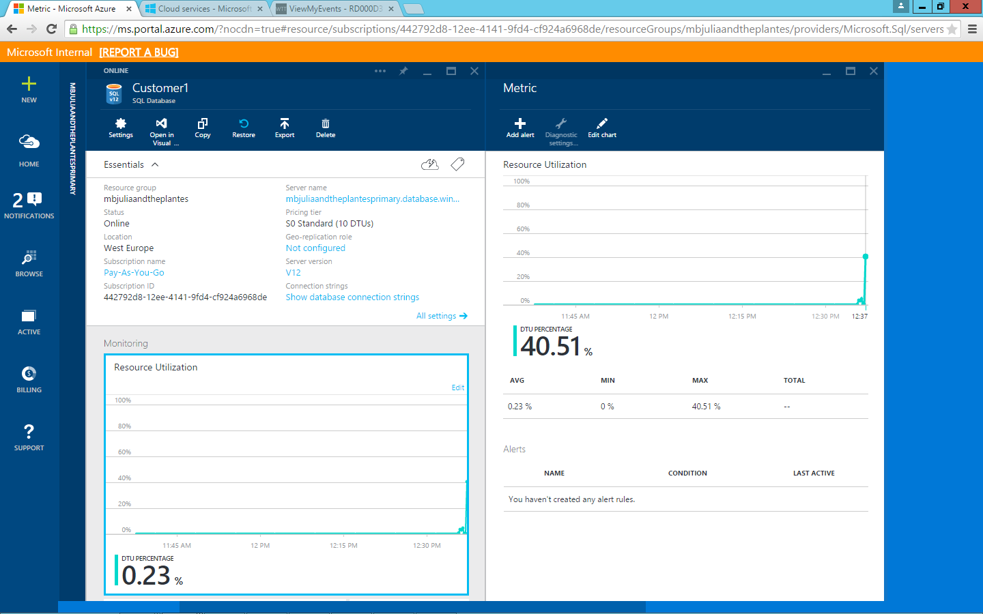

**Figure 24** Verify that the higher-performance pricing tier is better able to handle the simulated customer load

Beyond scaling up individual databases, you will next see how to let Azure SQL Database help customers dynamically scale groups of databases to meet changes in demand, rather than having to manage this manually.

# Task 4: Azure SQL Database Elastic Database Pools

In addition to scaling up individual databases to higher-performance pricing tiers (which we experienced in Task 3), often the exact demands of a database are not known, and managing the individual capacity of these databases isn’t efficient. This is especially familiar for SaaS providers such as the one in this lab, which might have hundreds or even thousands of different tenant databases, each with its own unique mix of performance demands, which rarely coincide.

1. From **portal.azure.com**, click **Browse**.
2. Click **SQL servers**.
3. Select the primary database server (in this example, *XX00julieandtheplantesprimary.database.windows.net*).
4. Click **Add pool**.

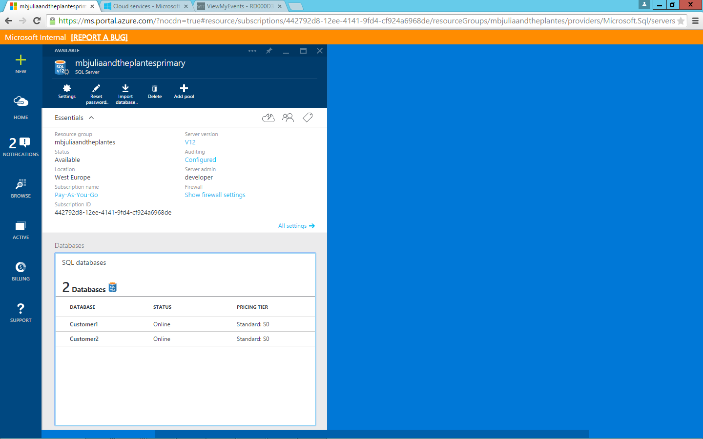

**Figure 25** Add a database pool from the database detail screen

1. Accept the Preview terms (if not already accepted).
2. Click **Add Databases**.
3. Select **Customer1** and **Customer2**.

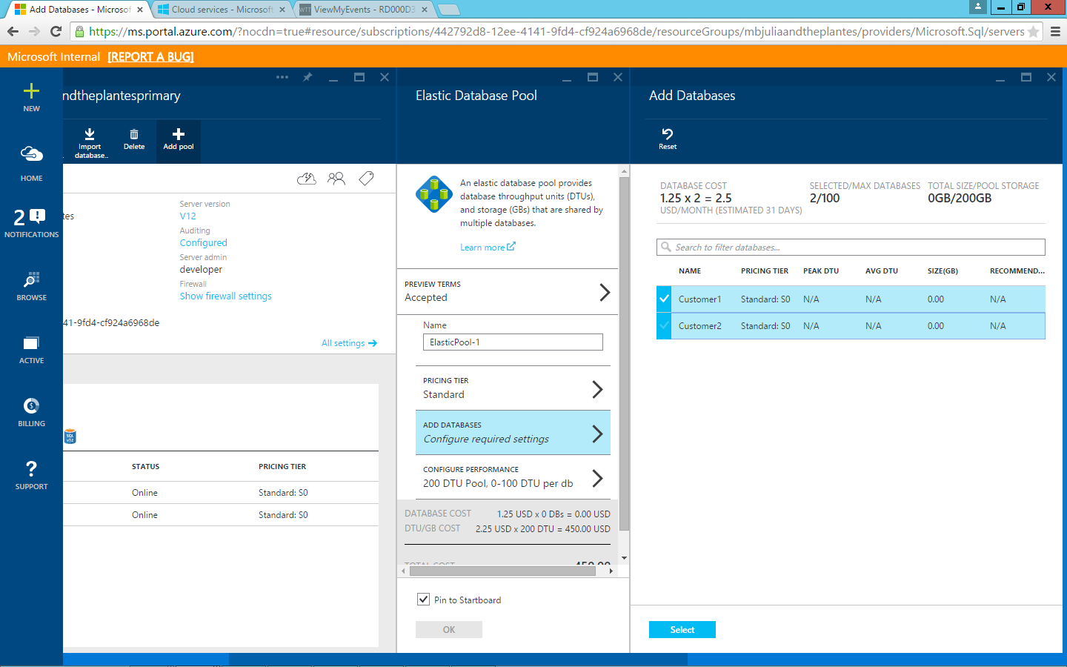

**Figure 26** Add the Customer1 and Customer2 databases to the pool

1. Click **Select**.
2. Click **OK**.
3. If you select the **Pin to Starboard** check box, the Starboard (homepage) will appear and a tile with your ElasticPool-1 will be added and will reflect the status.

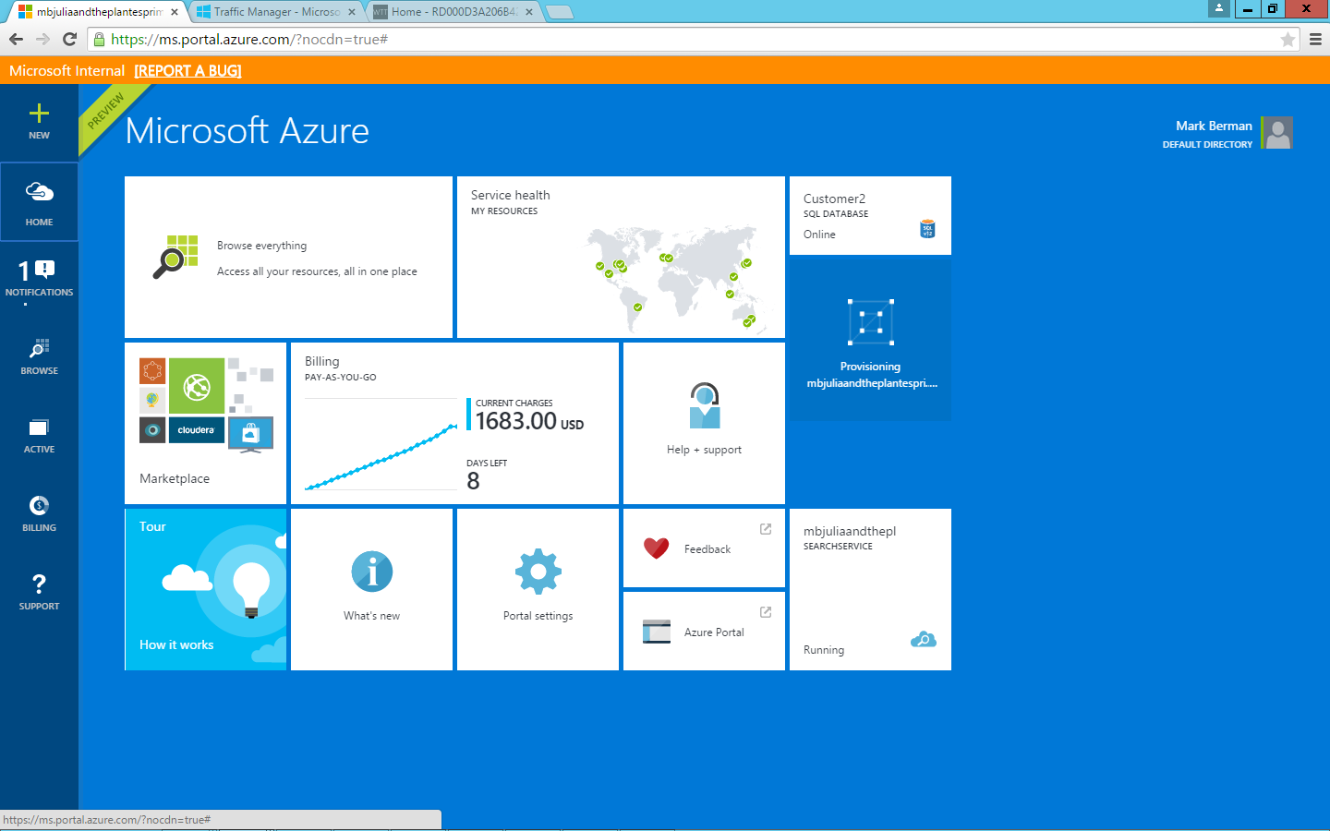

**Figure 27** View your elastic database pool on your homepage if you selected Pin to Starboard

1. Once created, you’ll be taken to the ElasticPool-1 overview automatically, where you can view graphs that reflect the resource-utilization and connection information, in addition to being able to change the pool size, add additional databases, and set other related settings.

It will take a couple of minutes for your databases to be added to the pool.

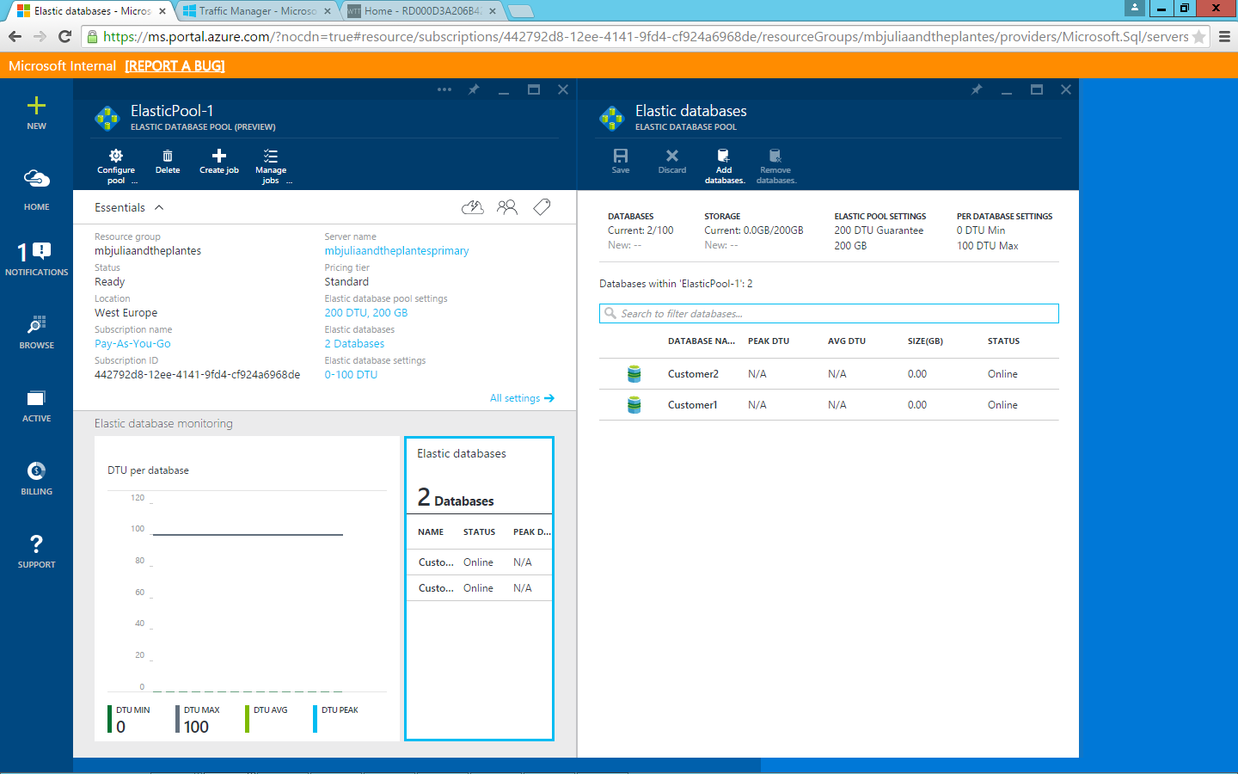

**Figure 28** View details of your pool from the ElasticPool-1 summary

1. The Customer1 and Customer2 databases were previously set to S0 (10 DTUs). The max pool setting that was created by default for this new ElasticPool is 100 DTUs, which means any of the databases in this pool can now spike to 100 DTUs, but their capacities won’t need to be managed individually.
2. To see this in effect, open the LoadGenerator, type the primary database server’s name (in this example, *XX00julieandtheplantesprimary.database.windows.net*), select the first **Event** from the list, which will correspond to ConcertId 1, click **Ticket Level**, provide the user name that you previously created, and then change the **Tickets To Purchase** value to 20000 and the **Bulk Tickets to Purchase** value to 500.

**Note**: The LoadGenerator.exe.config defaults to the Customer1 TenantDbName. In case you’d like to test another database in the future, this value will need to be changed.

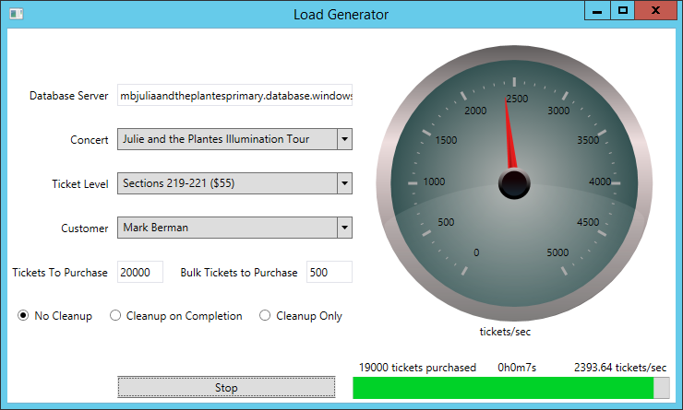

**Figure 29** Simulate load for the elastic database pool using the load generator

1. Click **Start**.
2. Notice how many thousands of tickets were purchased per second.
3. Return to **portal.azure.com** and to the ElasticPool-1 elastic database pool.
4. Click the **Customer1** database.
5. Notice in the resource-utilization chart that the max utilization was about 20 percent, yet the number of tickets per second increased over six times (this value will likely vary depending on the values you specified in the load generator and the network from which you ran the test).

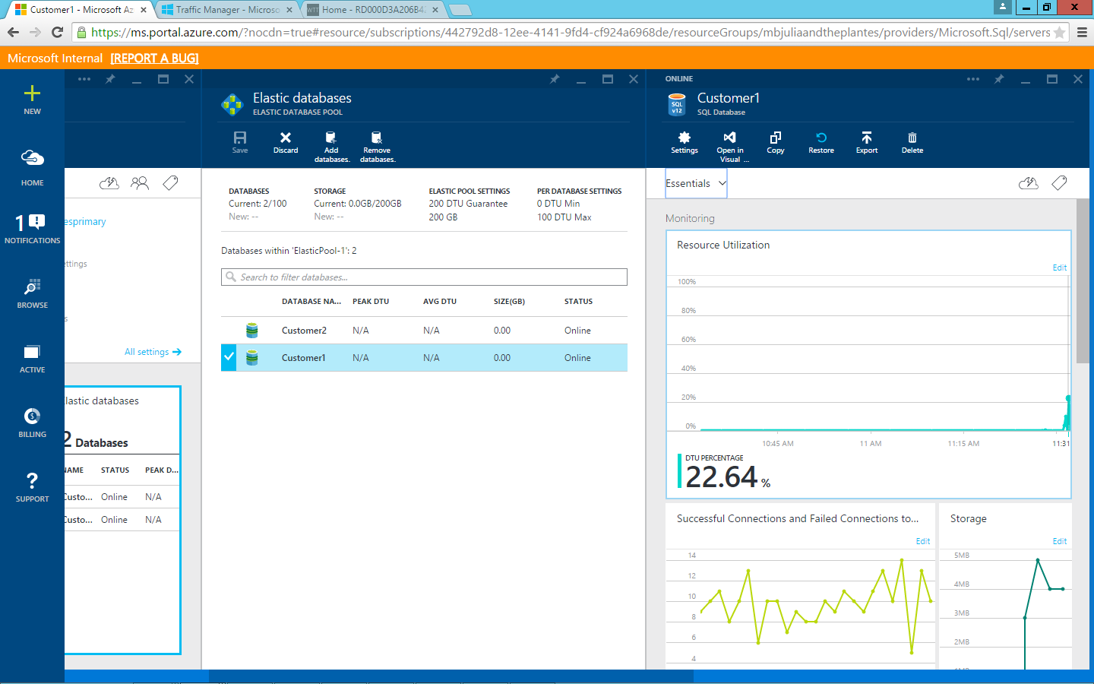

**Figure 30** Note the small increase in resource-utilization even under greater load

1. Notice also in the ElasticPool-1 resource-utilization chart that the pool is barely affected by this spike in usage.

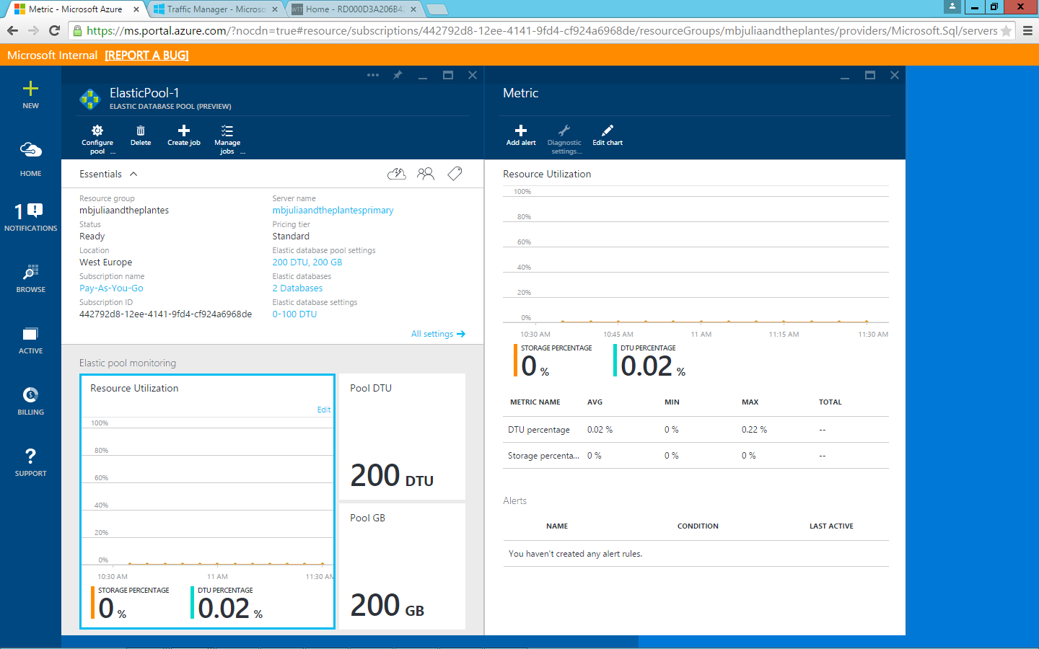

**Figure 31** Note that the spike in usage barely impacts the elastic database pool as a whole

# Task 5: Auditing (Optional)

Auditing can be used to keep track of infrastructure changes made to the environment, in addition to database-related issues such as failed logon attempts. In this task you will:

* Enable and set up auditing for a specific database in the Azure portal.
* Simulate a task to highlight the benefits of auditing:
  + Delete one of the concert events.
  + See how this effectively deletes all events associated with that concert.
* Use the auditing dashboard in an Excel template to drill down into the auditing events and examine who deleted the event and at what time.

In addition to being able to provide excellent scale-up and scale-out capabilities, Azure SQL Database also helps database administrators gain insights into infrastructure-related issues as and when they happen through events that can be used to drill down further to determine root cause.

## Task 5 Steps

1. Switch back to the tenant website.
2. Click the **My Events** tab.
3. Notice the one event that you previously purchased.
4. Click **Sign Off**.

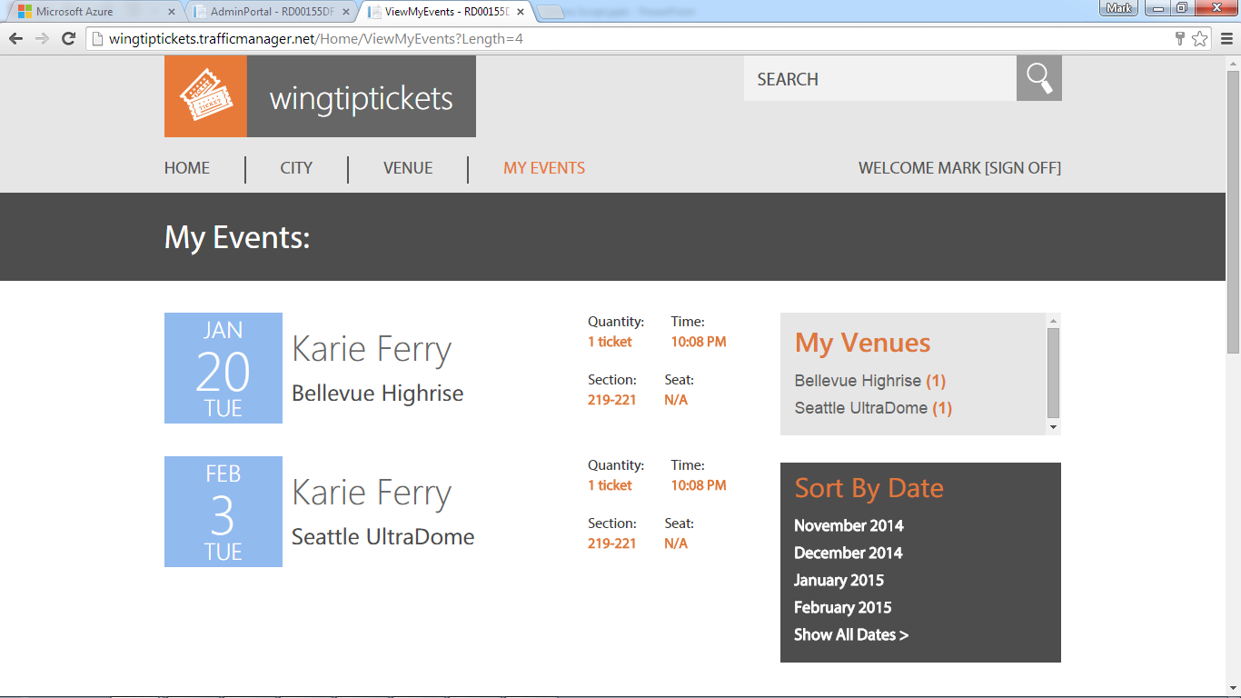

**Figure 32** Sign out from the tenant website to sign in as an administrator

1. Click **Sign In**.

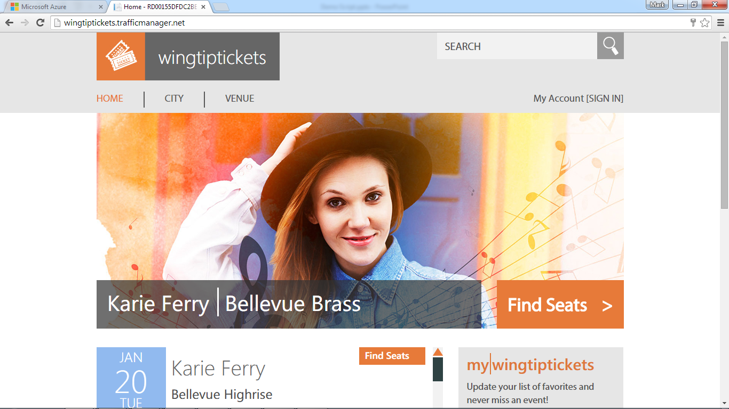

**Figure 33** Sign in as an administrator to make changes to events

1. Sign in using the administrator credentials:

* **admin@admin.com**
* **P@ssword1**

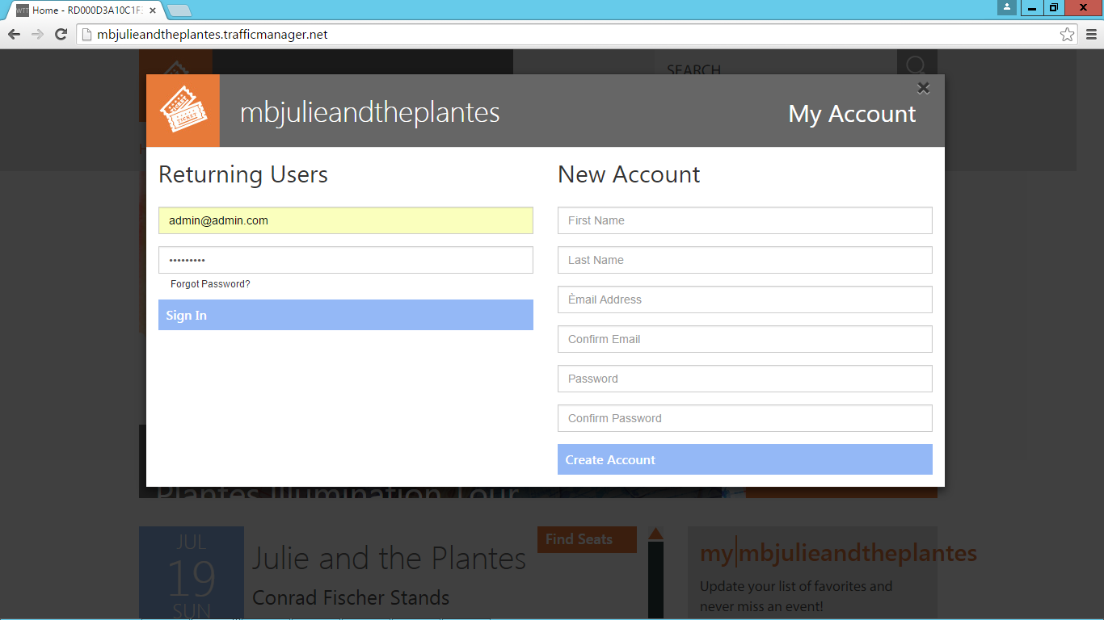

**Figure 34** Enter your administrator credentials

1. Click the **Admin** tab.

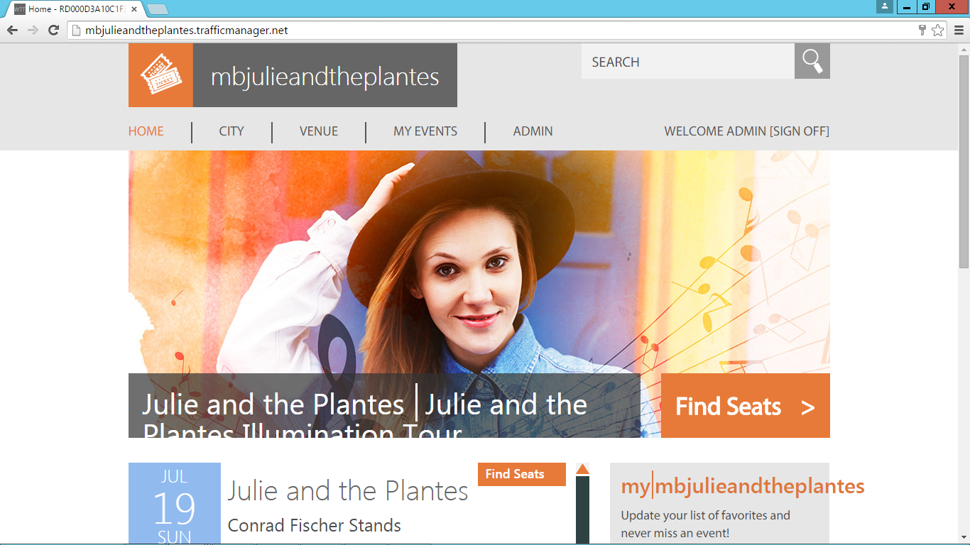

**Figure 35** Go to the Admin tab in order to delete an event

1. In the **City**, **Venue**, **Event**, and **Artist** drop-down menus, select the values that match those of the event for which you bought tickets in Task 1.
2. Verify that this event is the same event for which you purchased tickets in Task 1.
3. Click **Delete Event**.

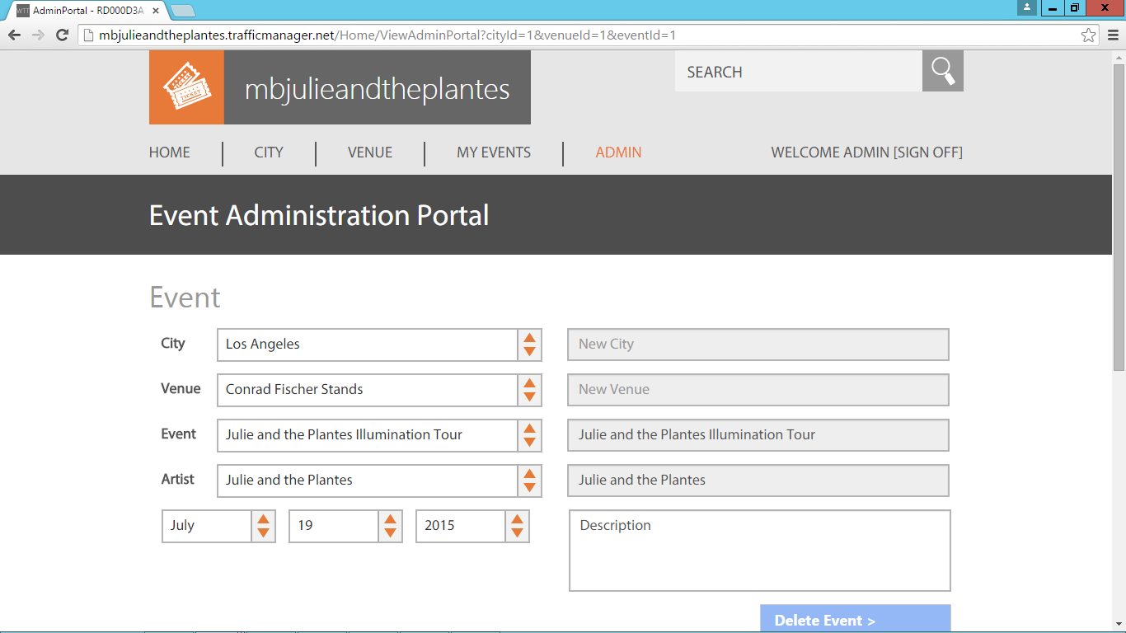

**Figure 36** Delete the event in order to see the deletion in auditing

1. At this point, you should receive a notification that the event has been deleted. Make a note of the event ID, in this example, this is 1. Click **OK**.

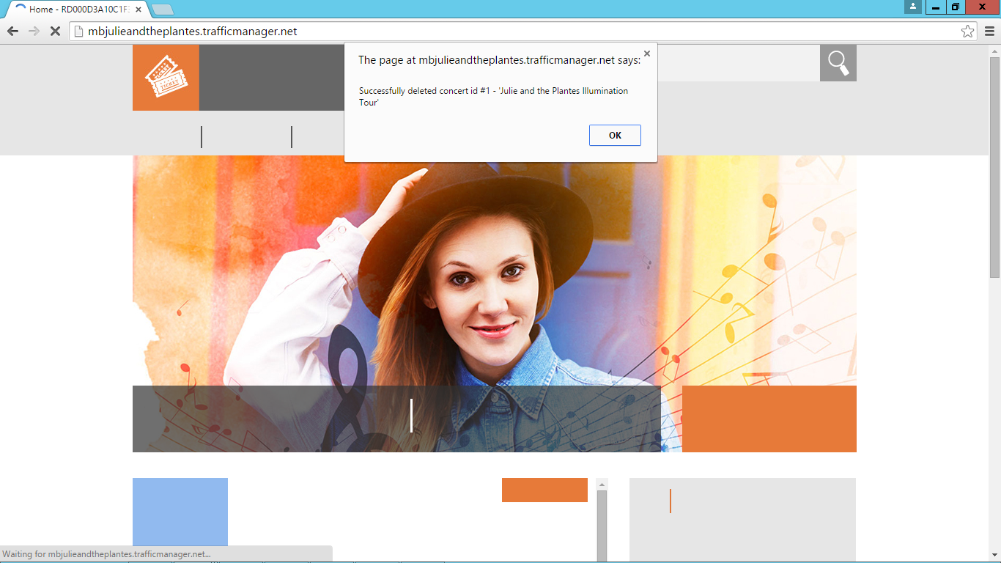

**Figure 37** Click OK once you see confirmation that the event has successfully deleted

1. Click **Sign Off**.
2. Click **Sign In**.

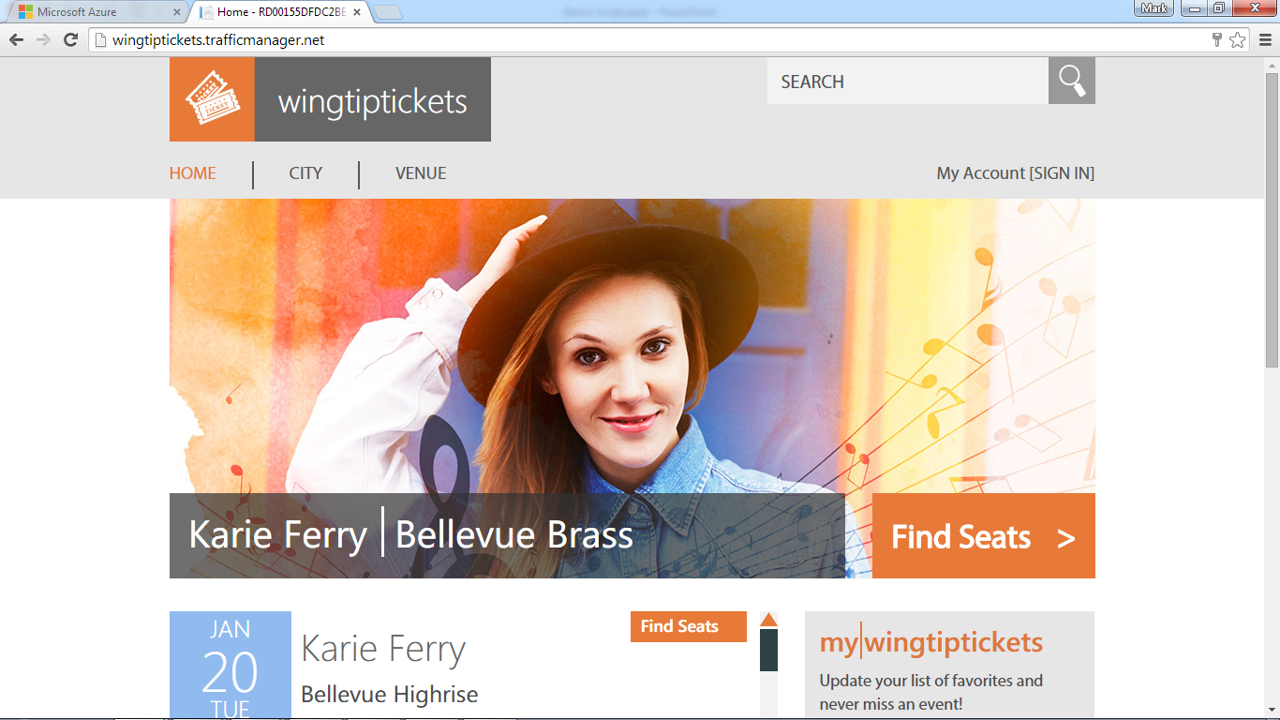

**Figure 38** Sign out again in order to sign in as a user

1. Sign in using the account you previously created.



**Figure 39** Sign in to the tenant website using the credentials you previously created

1. Click the **My Events** tab.

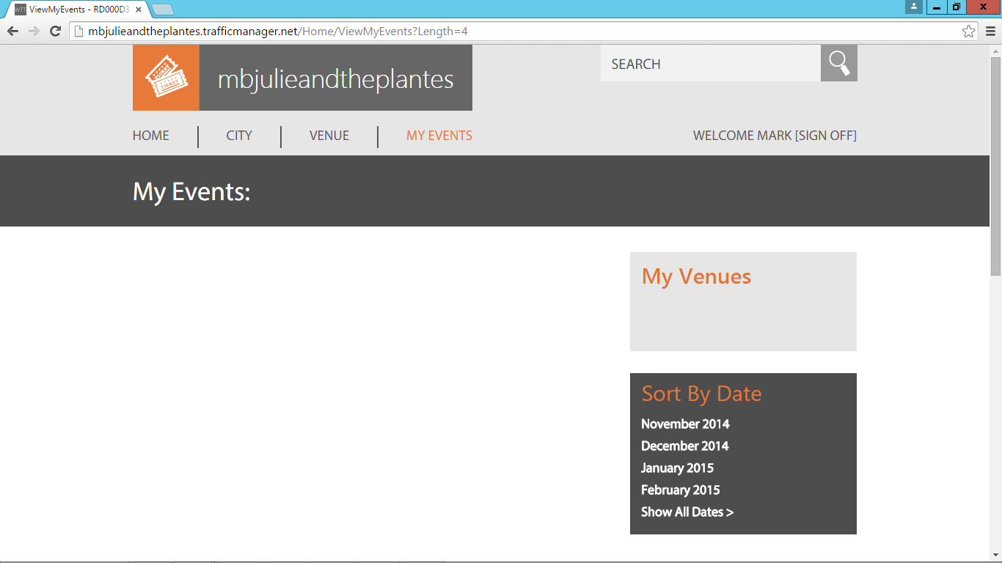

**Figure 40** Go to the Events tab to see the missing event

Notice that the event for which you previously purchased tickets is now missing.

1. Switch back to the Azure portal.
2. Browse to the **Customer1 SQL Database**.
3. Click the **Customer1 Database** on the primary database server (in this example, *XX00julieandtheplantesprimary.database.windows.net*).
4. In the **Summary** pane, scroll down to the **Operations** tile.

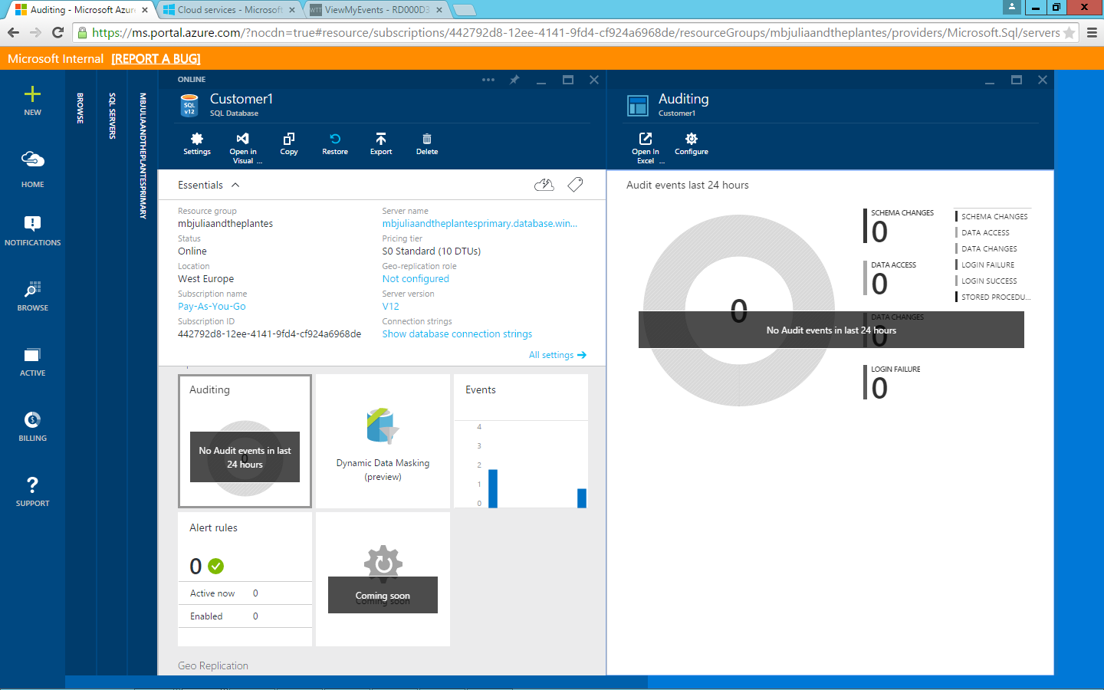

**Figure 41** Open the Auditing pane from the Operations tile in the Microsoft Azure portal

1. Click **Auditing**.
2. At the top of the **Auditing** pane, click **Configure**.

Auditing can be enabled by specifying which events to capture and in which Azure Storage table to store those.

For the purposes of the lab, auditing has already been enabled.

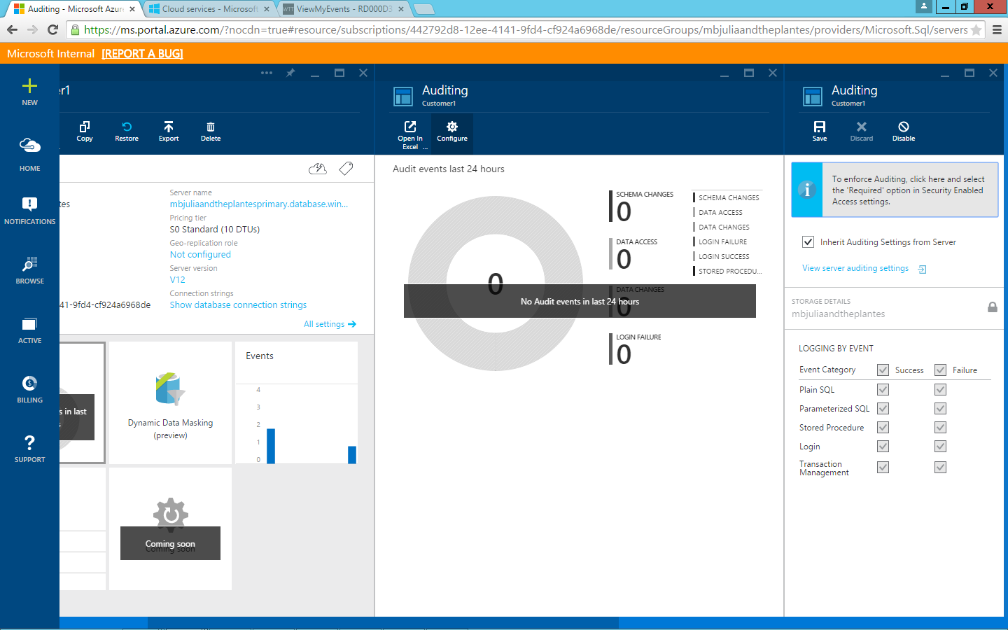

**Figure 42** Notice that auditing has already been enabled to expedite the lab

In the pane with the auditing events graph, notice the Open in Excel button.

For the purposes of the lab, please use the Excel template that was included with this HOL, as it should already be connected to the Azure Storage table in Task 0, Steps 4–14.

1. Open the **01-Azure SQL DB Audit Logs Report Template** Excel template.

Make sure the **Workbook Queries** pane displays on the right. If not, from the **Power Query** menu, click **Show Pane** if usingExcel 2013, or, if using Excel 2016, from the **Data** menu, click **Show Queries**.

1. Right-click **AuditLogs**.
2. Wait 5–10 minutes, and then click **Refresh**.

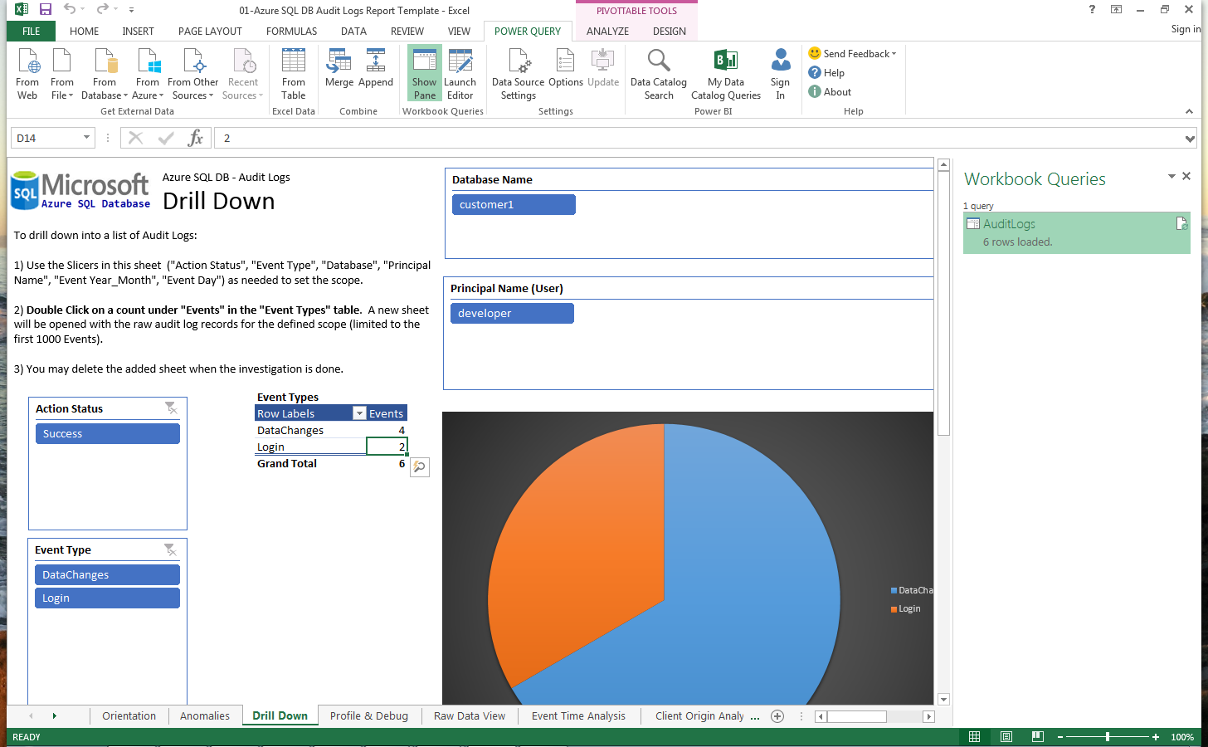

**Figure 43** Refresh the spreadsheet to populate it with the latest records from your table

The Excel template should be connecting to the Azure Storage account (in this example, *XX00julieandtheplantesstorage*).

The query should show how many rows have loaded once the refresh is completed.

1. Make sure the **Drilldown** worksheet is selected.
2. To the right of **DataChanges**, double-click the count (in this example, **4**).

A new worksheet will load, populated with all rows related to data changes.

1. Notice the delete event that corresponds to the event that was deleted from the admin page. In this example, this is ConcertId 1.

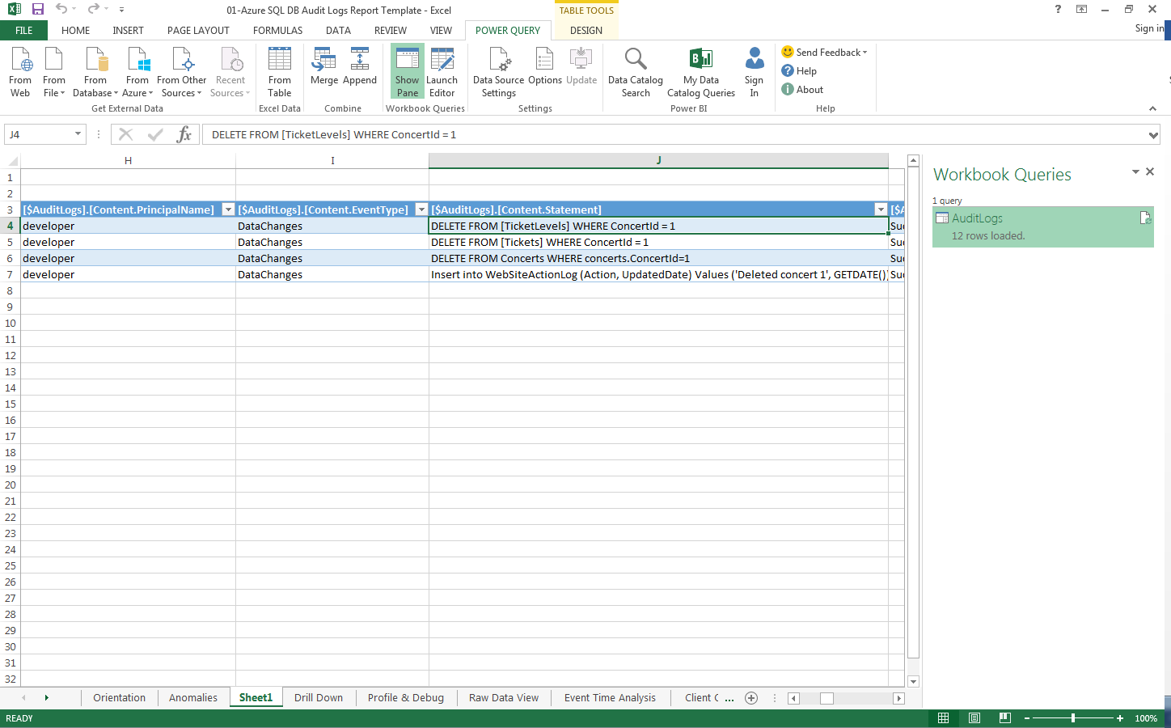

1. Review the time that this took place.

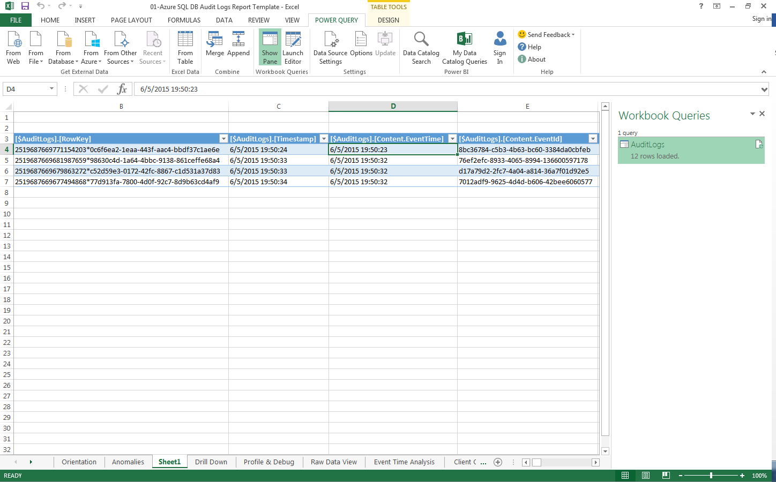

**Figure 45** Notice that the time matches up with the deletion you did at the start of this section

Audit analysis shows that a concert event was deleted. In the next task, you will use point-in-time restore to restore the missing concert event.

# Task 6: Point-in-Time Restore

In Task 5, you walked through how Azure SQL Database helps database administrators gain insights into infrastructure-related issues as and when they happen through events that can be used to drill down further to determine root cause.

Based on the analysis, it looks like an event was deleted. To resolve this issue, you will use point-in-time restore to restore the related database, Customer1.

In addition to seeing how easy it is to restore a database to a specific point in time, from the tenant website you will also see that the deleted concert event restores along with previously purchased tickets.

## Task 6 Steps

1. If you did *not* complete the audit section, complete steps 1–15 of Task 5 before proceeding.

**Important:** Unless you delete a concert event in Task 5, steps 1–15, you will have nothing to restore in this section.

1. Switch to the Azure portal.
2. Browse to the **Customer1** Azure SQL Database.
3. Click the **Customer1** database on the primary database server (in this example, *XX00julieandtheplantesprimary.database.windows.net*).

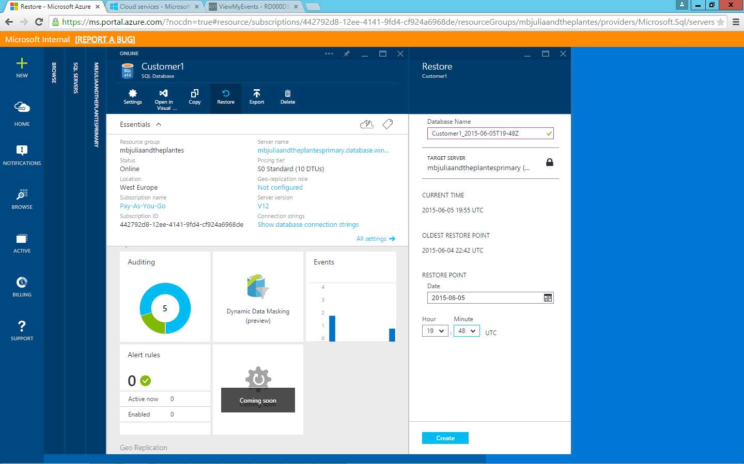

**Figure 46** Return to the Customer1 database in order to restore the deleted event

1. Click **Restore**.
2. Change the restore-point time to two minutes before the delete event occurred according to the audit log.
3. Click **Create**.

The Customer1 database begins restoring.

Once restored, the Customer1 database status changes to Online.

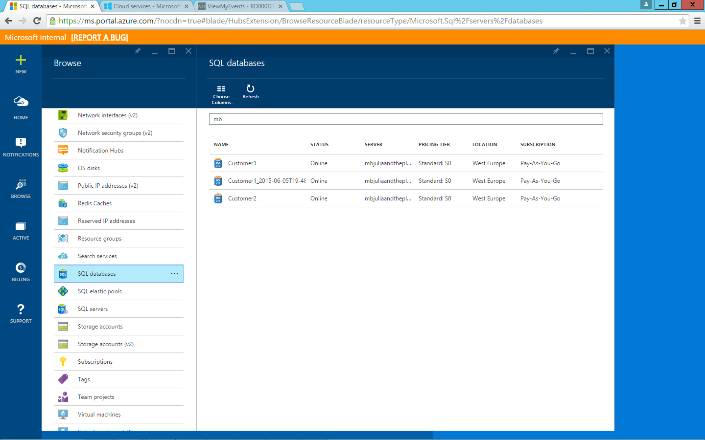

**Figure 47** Customer1 database restore

1. Switch to SQL Server Management Studio (SSMS).
2. Click the primary database server(in this example, *XX00julieandtheplantesprimary.database.windows.net*).
3. Click **Refresh**.
4. Review the newly restored Customer1 database.

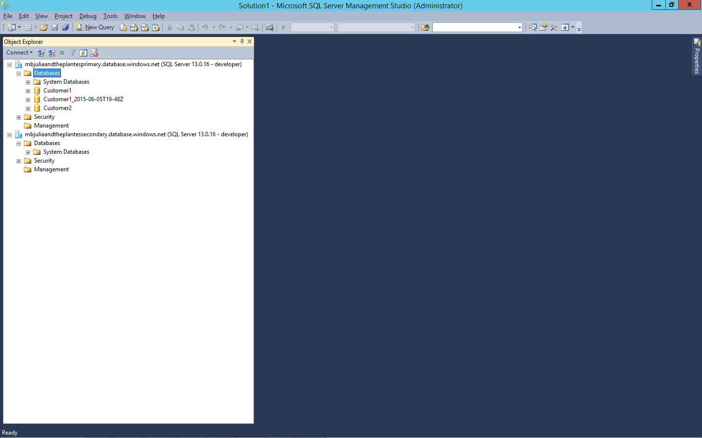

**Figure 48** Verify that your database is back online in SSMS

1. Within the primary database server (in this example, *XX00julieandtheplantesprimary.database.windows.net*), expand **Databases**, expand the newly restored **Customer1_[date] Database**, and then expand **Tables**.
2. Right-click the **dbo.Concerts** table, and then select **Script Table As** > **Select To** > **New Query Editor Window**.
3. Execute the script by clicking the Execute button.

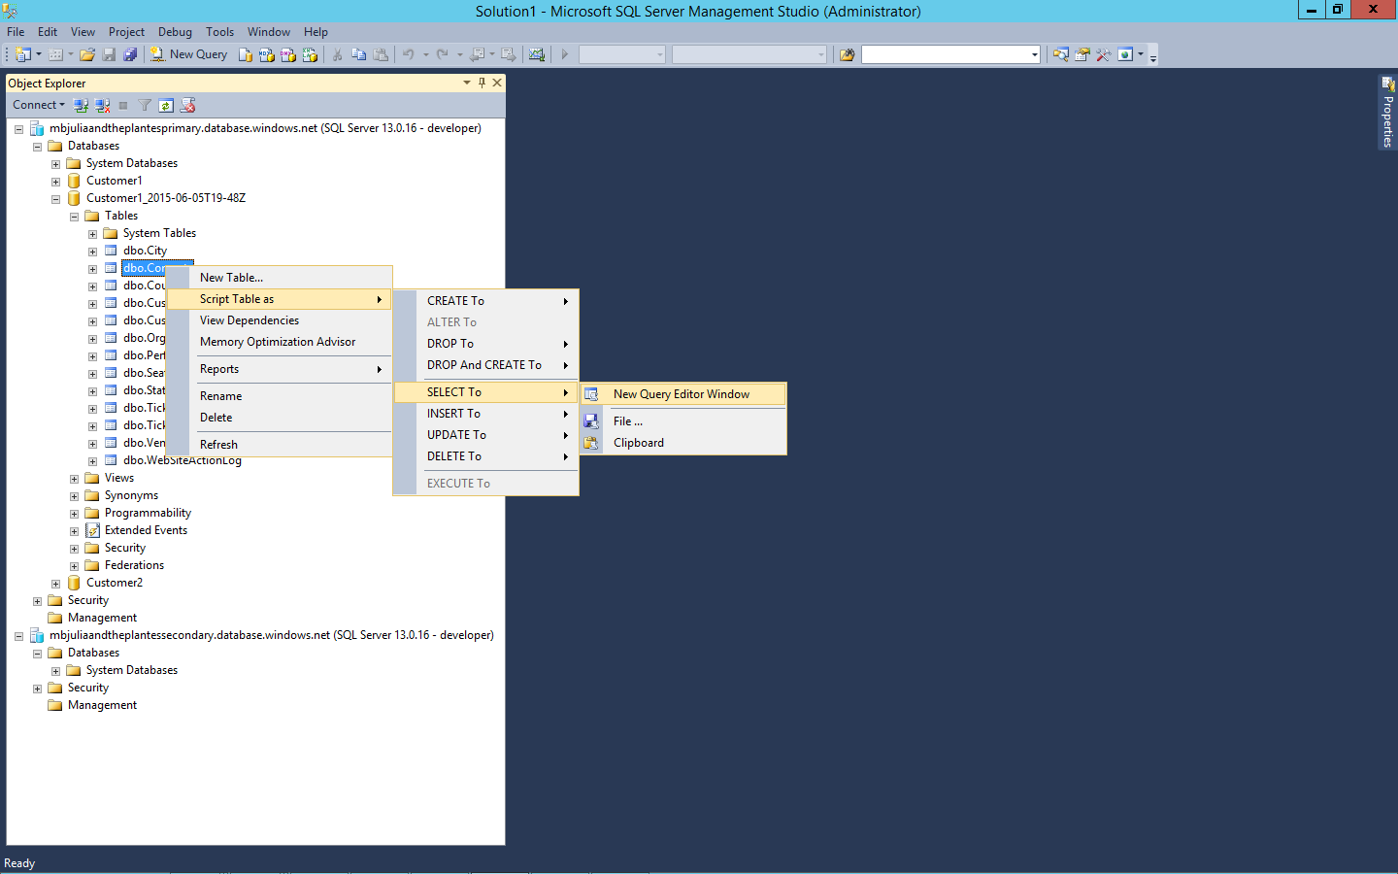

**Figure 49** Perform a query against the Concerts table in order to verify that the event is restored

Notice the previously deleted event, in this example ConcertID 1, is now restored.

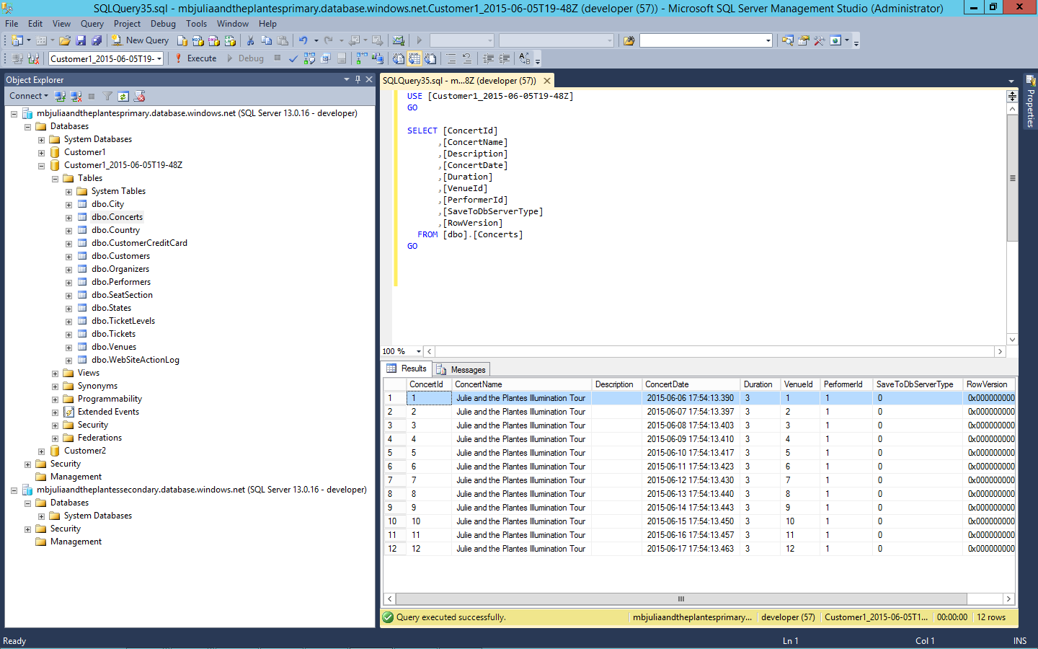

**Figure 50** Notice the previously deleted event is now restored

1. Right-click the **dbo.Tickets** table, and then select **Script Table As** > **Select To** > **New Query Editor Window**.

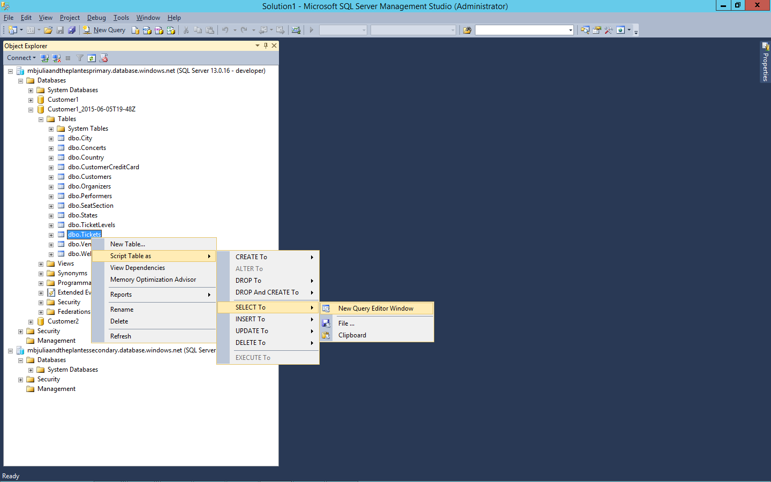

**Figure 51** Query the tickets-sales records to verify that they have been restored

1. Modify the T-SQL to filter only tickets for the event that you deleted. In the **SQLQuery** field, delete the automatically generated SQL query and type the following, replacing the 1 with the correct ConcertID from your environment:   
   select * from [dbo].[Tickets] where ConcertID = 1

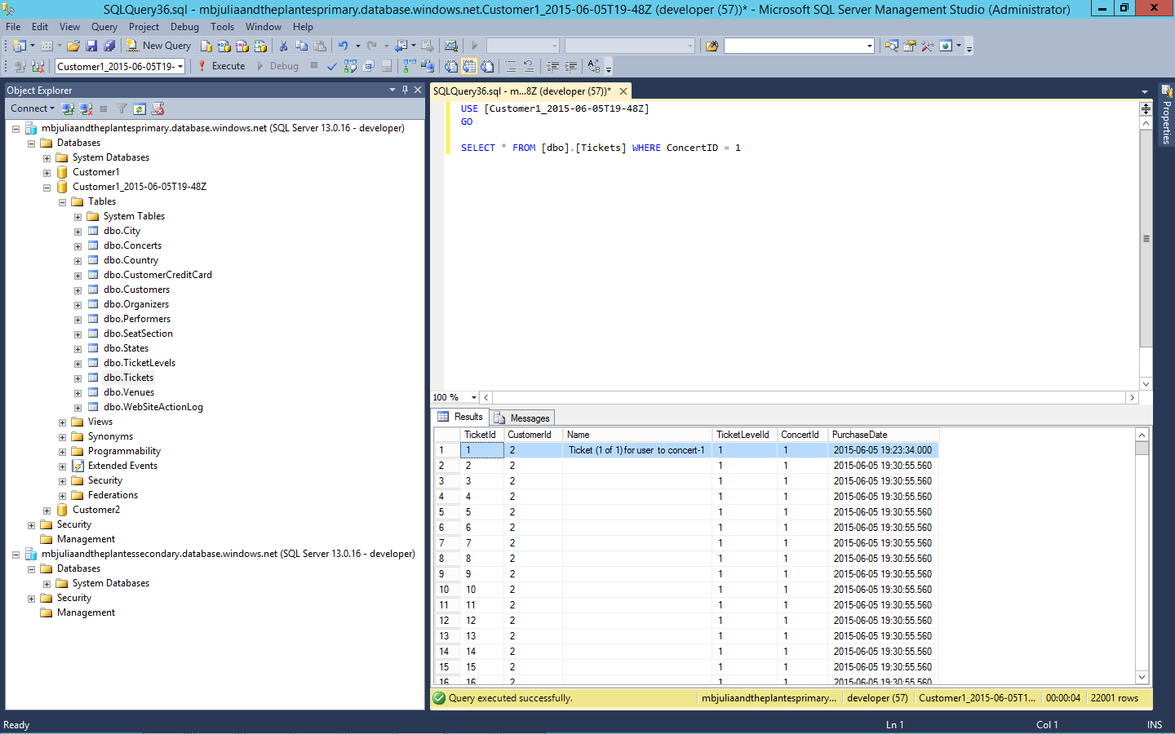

**Figure 52** Verify that you have successfully restored the ticket that you previously purchased

1. Review the ticket you previously purchased.

Now that we have successfully restored the Customer1 database, we now need to replace the current live version of the database.

1. Switch back to the Azure portal.
2. Browse to the **Customer1** database.
3. Click the **Customer1** database on the primary database server (in this example, *XX00julieandtheplantesprimary.database.windows.net*).
4. To the right of the row, click **…** (the three-dot ellipses).
5. Click **Delete**.

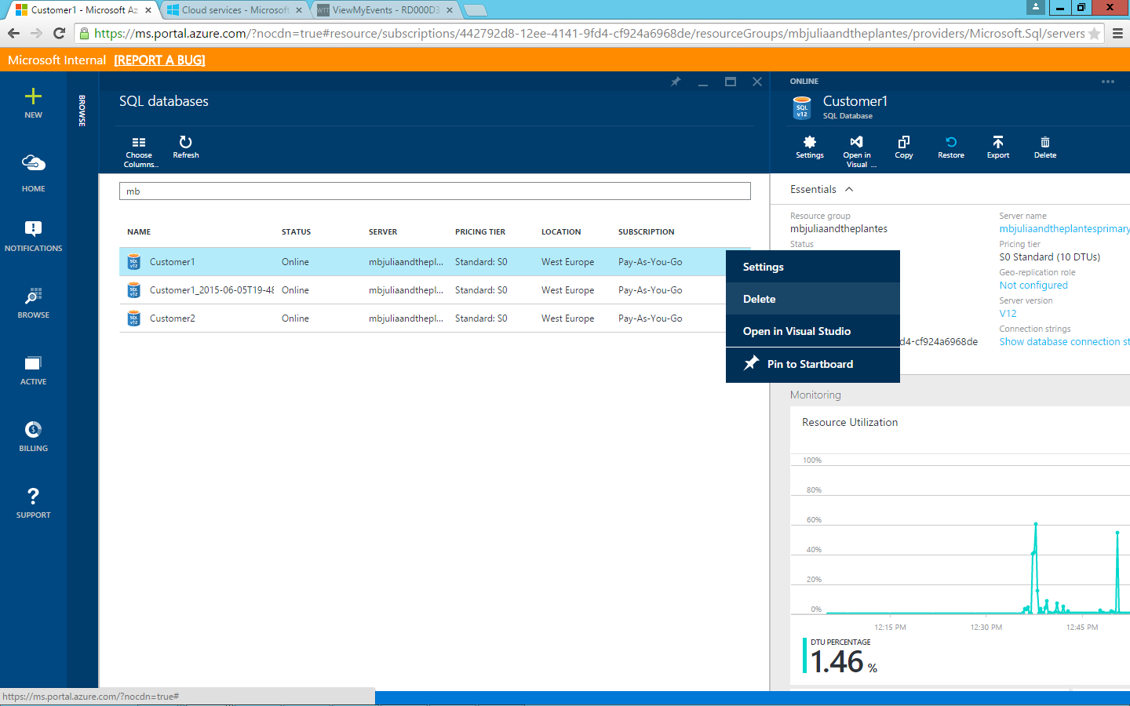

**Figure 53** Delete the live version of the Customer1 database

1. Verify the Customer1 database has now been deleted.

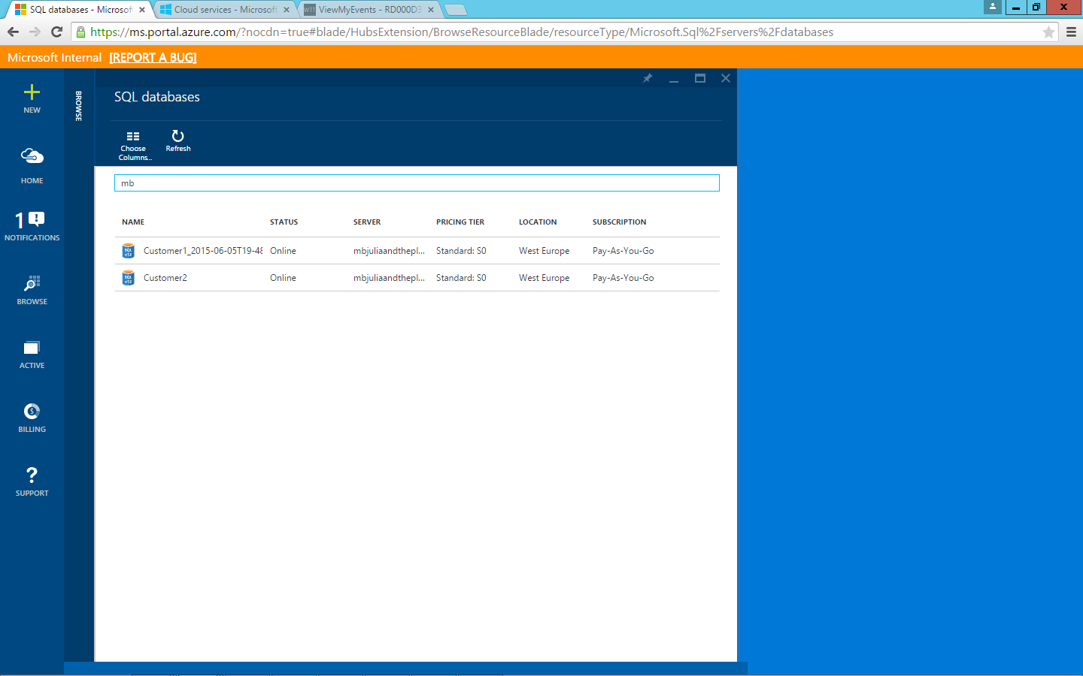

**Figure 54** Verify in the Microsoft Azure portal that the Customer1 database has been deleted

1. Switch back to SQL Server Management Studio.
2. Click the primary database server (in this example, *XX00julieandtheplantesprimary.database.windows.net*).
3. Click **Refresh**.
4. Notice that the Customer1 database has been deleted.

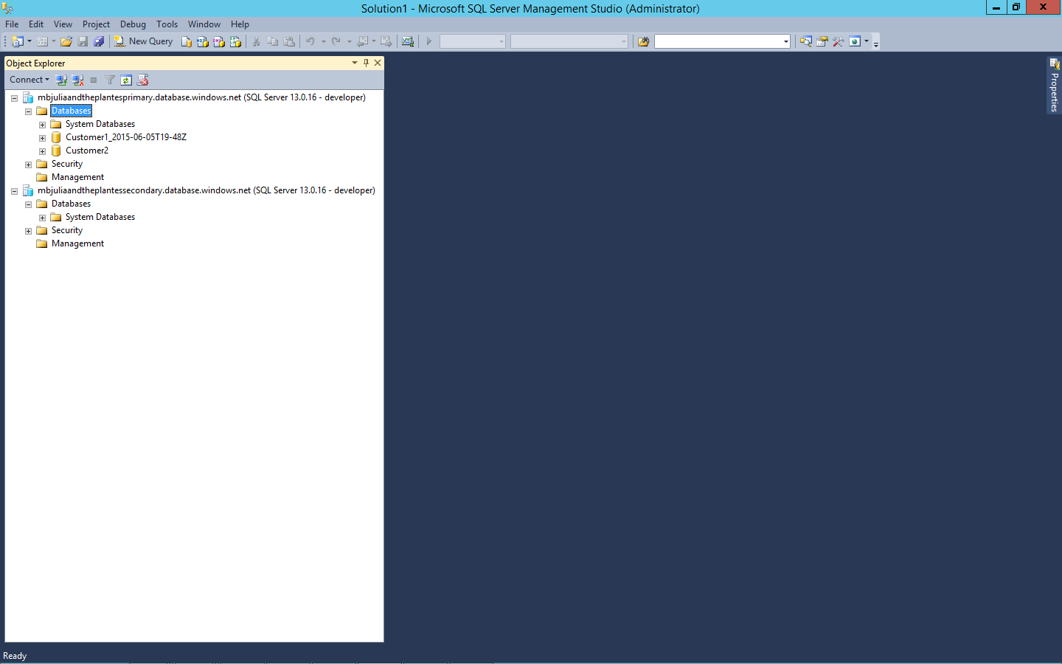

**Figure 55** Verify in SSMS that the Customer1 database has been deleted

1. Right-click **Customer1_*[date]***.
2. Click **Rename**.
3. Delete everything after Customer1.
4. Press Enter.

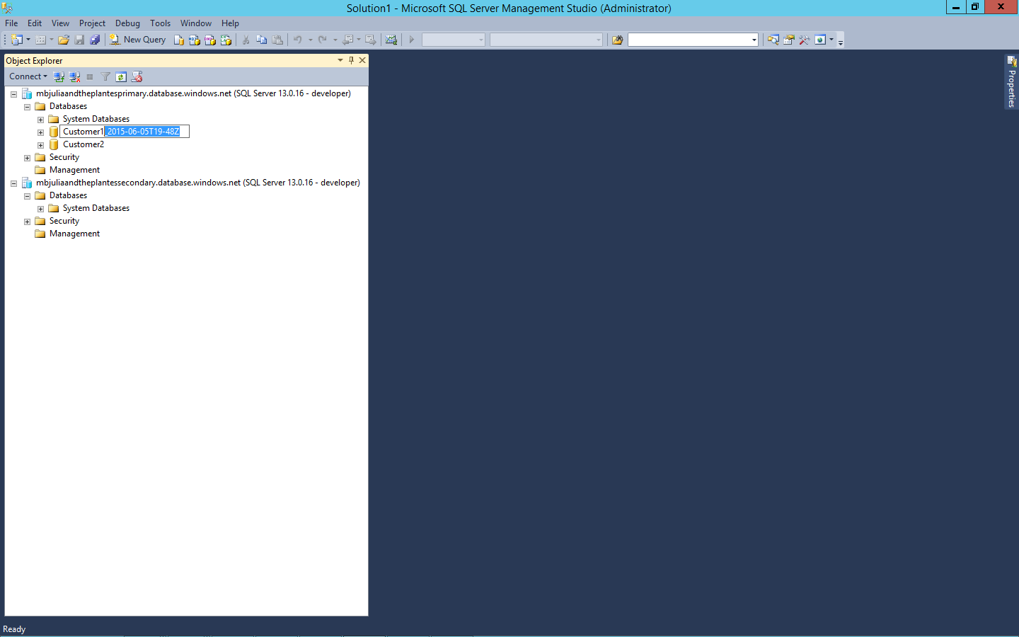

**Figure 56** Rename the restored Customer1 database in SSMS in order to promote it to the production version

1. Verify **Customer1_*[date]*** has been renamed to **Customer1**.

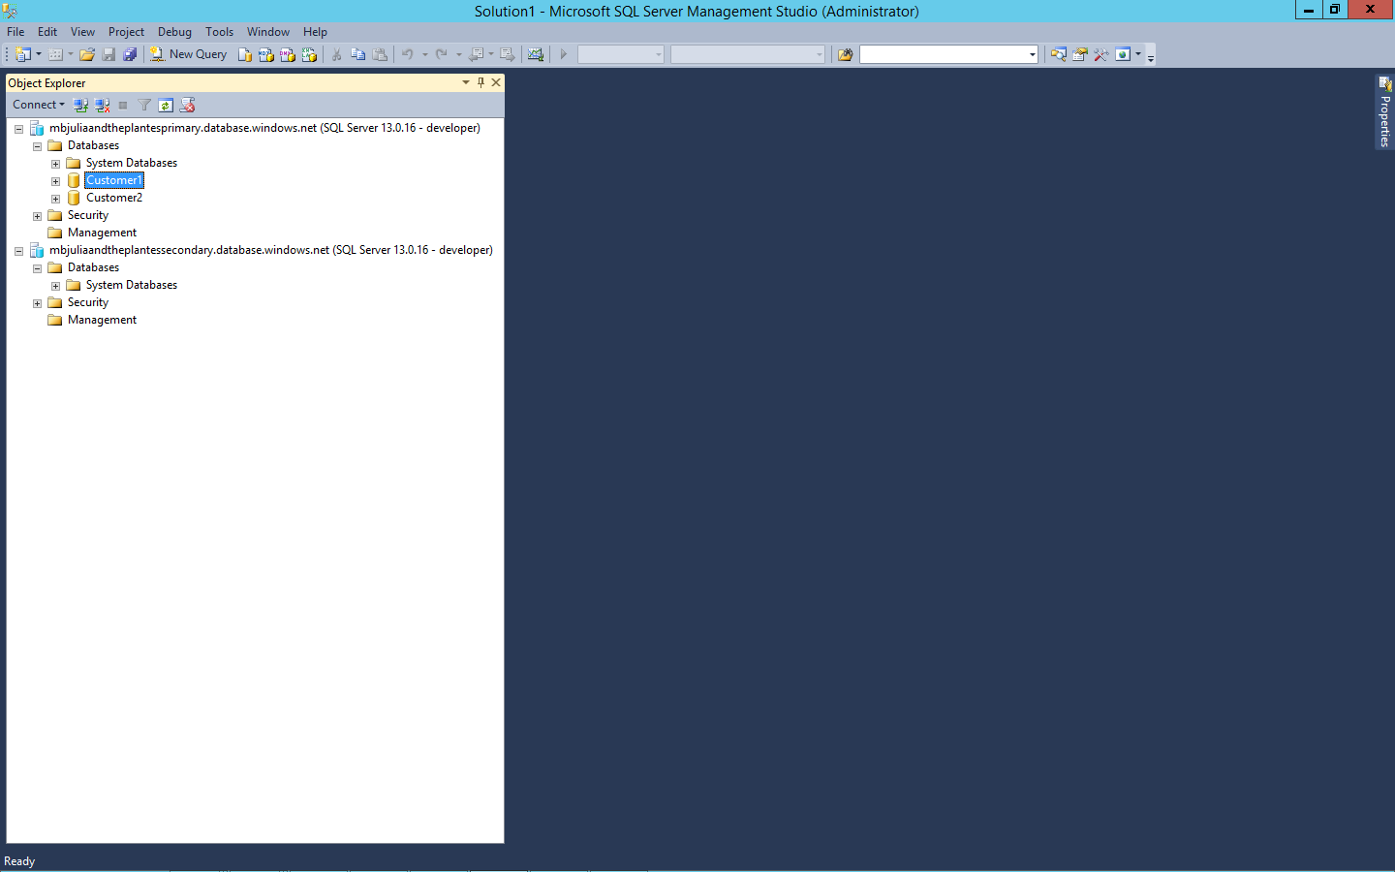

**Figure 57** Verify that the restored version of Customer1_[date] no longer appears in SSMS

1. Switch back to the Azure Traffic Manager website.
2. Refresh the Azure Traffic Manager website.



**Figure 58** Refresh the tenant website in order to access the restored database

1. If you’re not still signed in, sign in using the credentials you previously created.



**Figure 59** Sign in to the website using your user credentials

1. Click **My Events**.



**Figure 60** Verify your restored purchased ticket is visible under the My Events tab on the tenant website

1. Verify the deleted ticket has now been restored.

Point-in-time restore is great for localized, one-off mistakes. But what about broader server/datacenter failures? In the next task you will explore how Azure SQL Database geographic disaster recovery can help protect vital database workloads from regional disasters and outages.

# Task 7: Geographic Disaster Recovery

In the previous task, you walked through how to resolve a mishap by restoring a database using point-in-time restore. But sometimes greater catastrophes happen, and Azure SQL Database provides capabilities to recover from geographic disasters.

In this task, you are going to simulate a datacenter failure and see how active geographic replication can be used to keep a secondary environment on hot standby. In this task you will:

* See how easy it is to set up a geo-replicated secondary from the Azure SQL Database portal and view its status by using an interactive map.
* Explore how Azure Traffic Manager can be used to detect a failed website and redirect traffic to a hot standby in another datacenter.
* Initiate a failover of the website, and show how Azure Traffic Manager detects that the site has failed and redirects traffic to the hot standby to limit interruption.
* [Optional] Simulate a database-server failover by stopping replication to the secondary databases, effectively promoting the secondary to the primary.

From the tenant website, you will also see how everything continues to work once Azure Traffic Manager reroutes requests to the passive tenant site (which will then be active, and the database secondary will become the primary).

## Task 7 Steps

1. Switch back to the Azure portal.
2. Browse to the **Customer1** database.
3. Click the **Customer1** database on the primary database server (in this example, *XX00julieandtheplantesprimary.database.windows.net*).

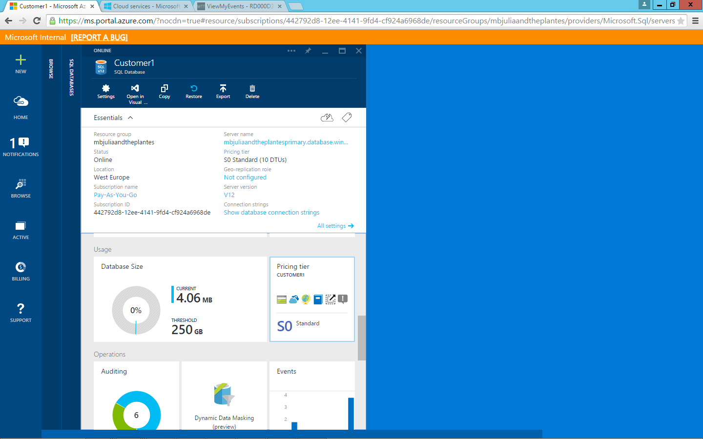

**Figure 61** Select the Customer1 database for geo-replication

You will need to upgrade the database to a premium SKU so as to take advantage of active geographic replication, which allows the secondary to be readable. But first, you will need to remove the database from ElasticPool-1.

1. Browse back to the **ElasticPool-1** elastic database pool.
2. In the ElasticPool-1 summary pane, scroll down to and click **Elastic databases**.

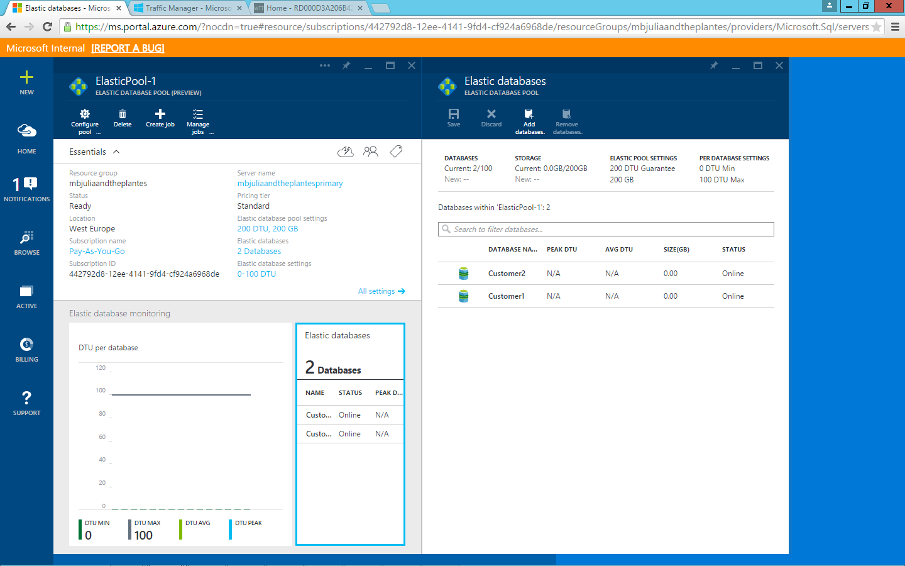

**Figure 62** Open the Elastic databases pane for ElasticPool-1

1. Click to the left of the **Customer1** elastic database to select it.

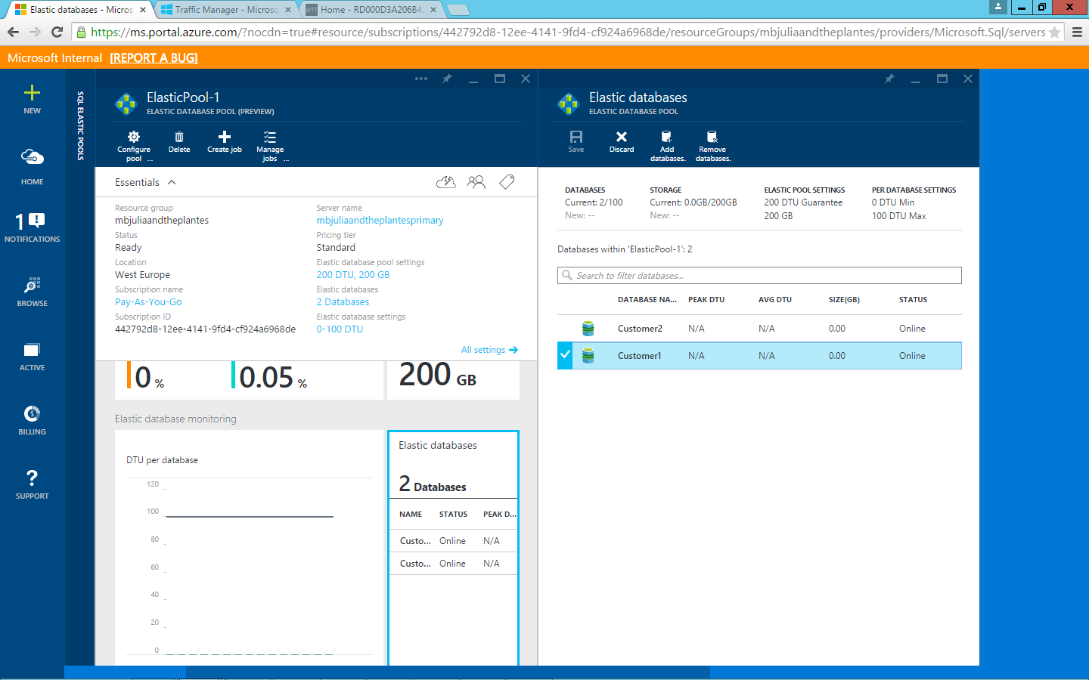

**Figure 63** Select the Customer1 database

1. Click **Remove databases**.
2. Click **Save**.

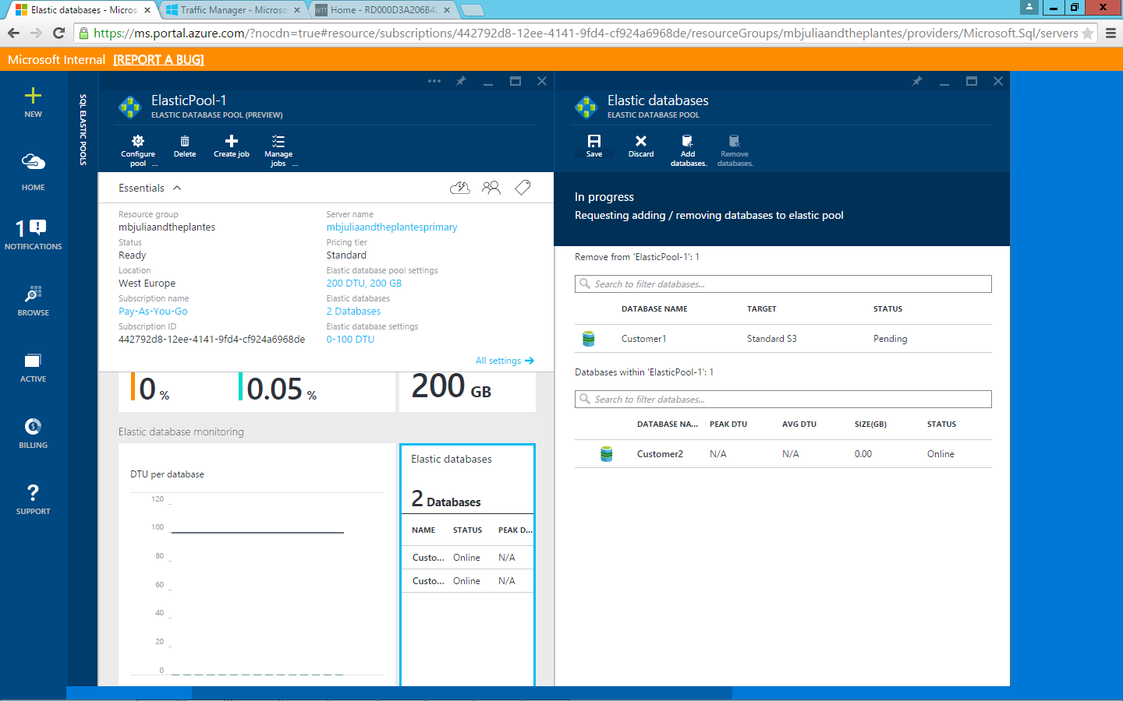

**Figure 64** Save changes to the elastic pool

**Note**: It might take a few minutes to remove the Customer1 database from the elastic pool.

1. Once removed, browse to the **Customer1** database.
2. In the **Customer1** database summary pane, scroll down to **Pricing tier**.
3. Click **Pricing tier**.

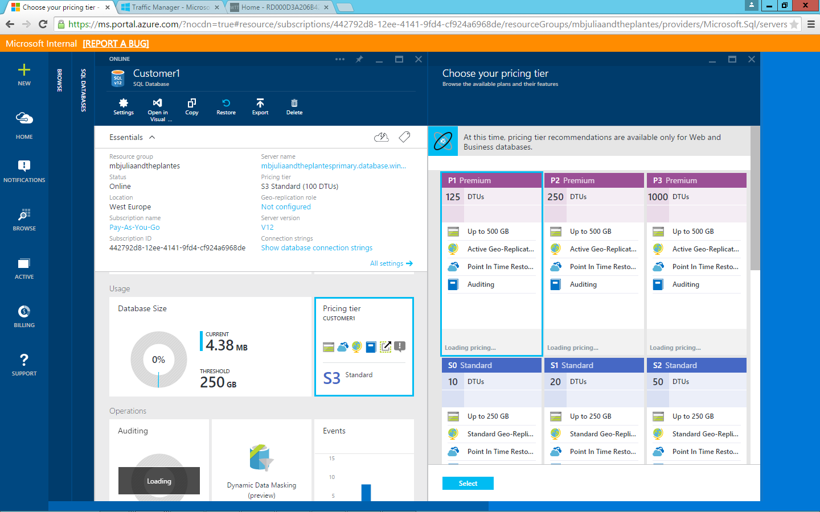

**Figure 65** Change the pricing tier for the Customer1 database

1. Click **P1 Premium**.
2. Click **Select**.

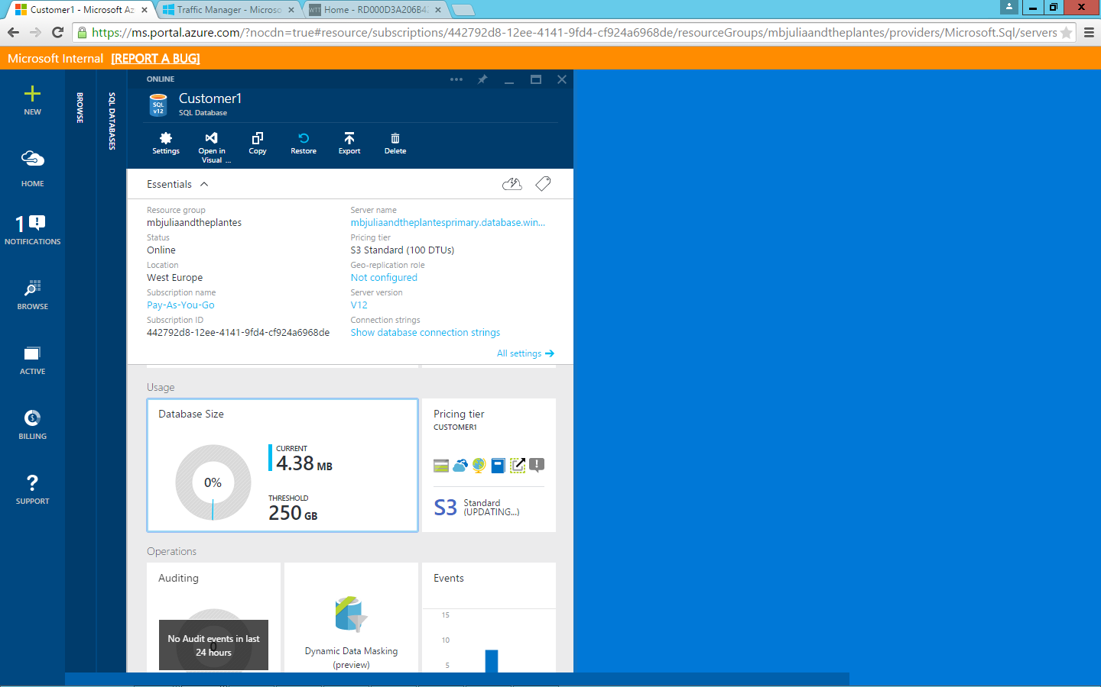

**Figure 66** Updating to the new pricing tier

1. Once completed, in the **Summary** pane of the Customer1 database, scroll down to the **Geo Replication** tile.
2. Click **Configure Geo-Replication**.

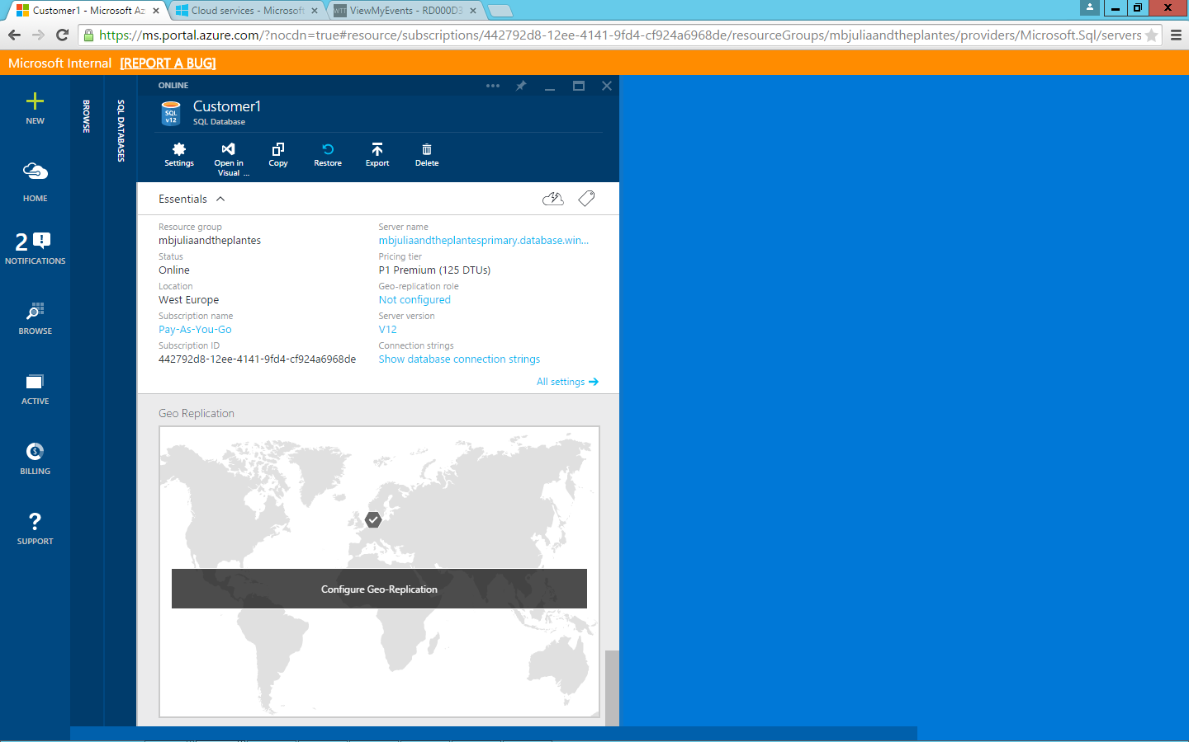

**Figure 67** Select the world map to configure geo-replication for the Customer1 database

1. Select the recommended target region: in this example, because we’re using the West Europe region, the recommended target region is **North Europe**.

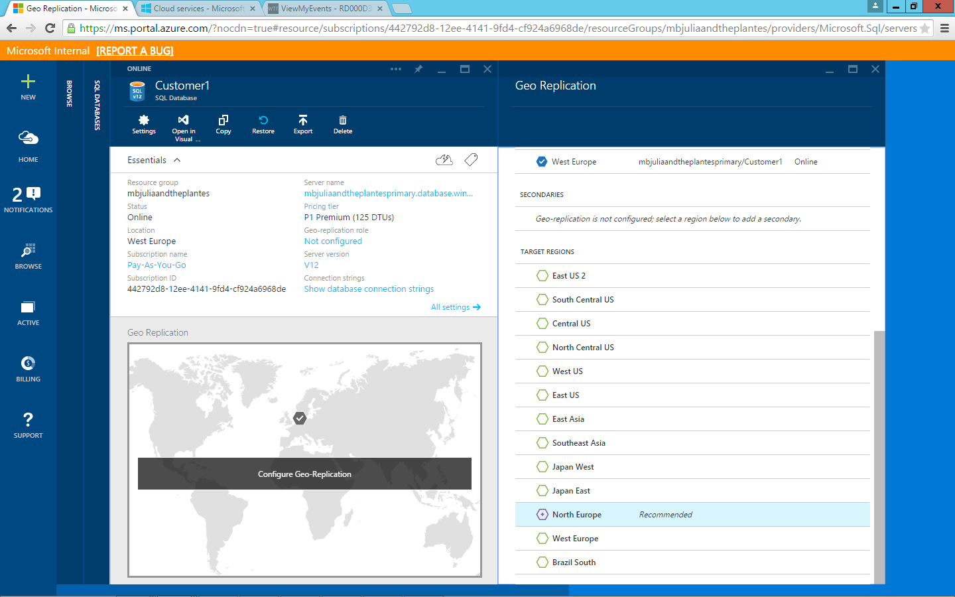

**Figure 68** Select a target region for replication from the list on the right—Azure currently has 17 regional datacenters worldwide

1. Use the existing secondary database server (In this example, *XX00julieandtheplantessecondary.database.windows.net*).
2. Click **Select**.
3. Ensure the replica is set to **Readable**.

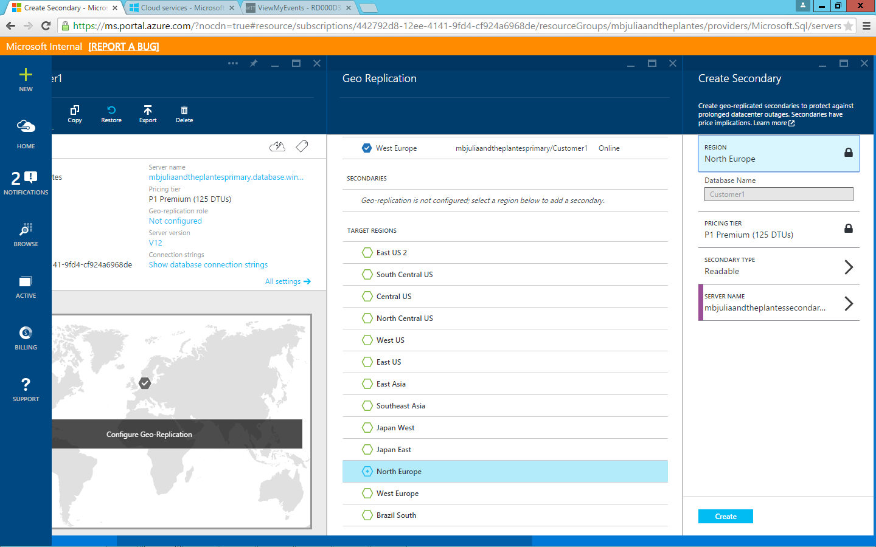

**Figure 69** Make sure that your replica server is set to Readable

1. Click **Create**.

At this point, a dotted line should animate displaying that the replication link is being established between the primary and secondary database servers.

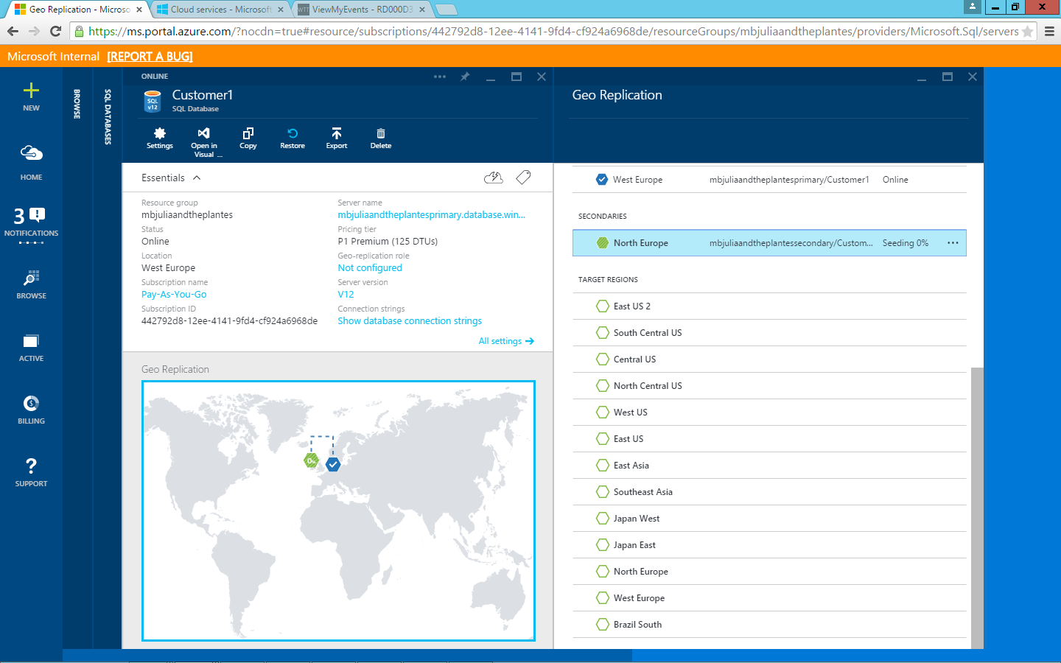

**Figure 70** The animated dotted lines between the two regions on the map indicate that replication is being established

Once the replication link is established and replication has completed, the link should appear solid and there should be checks on both servers.

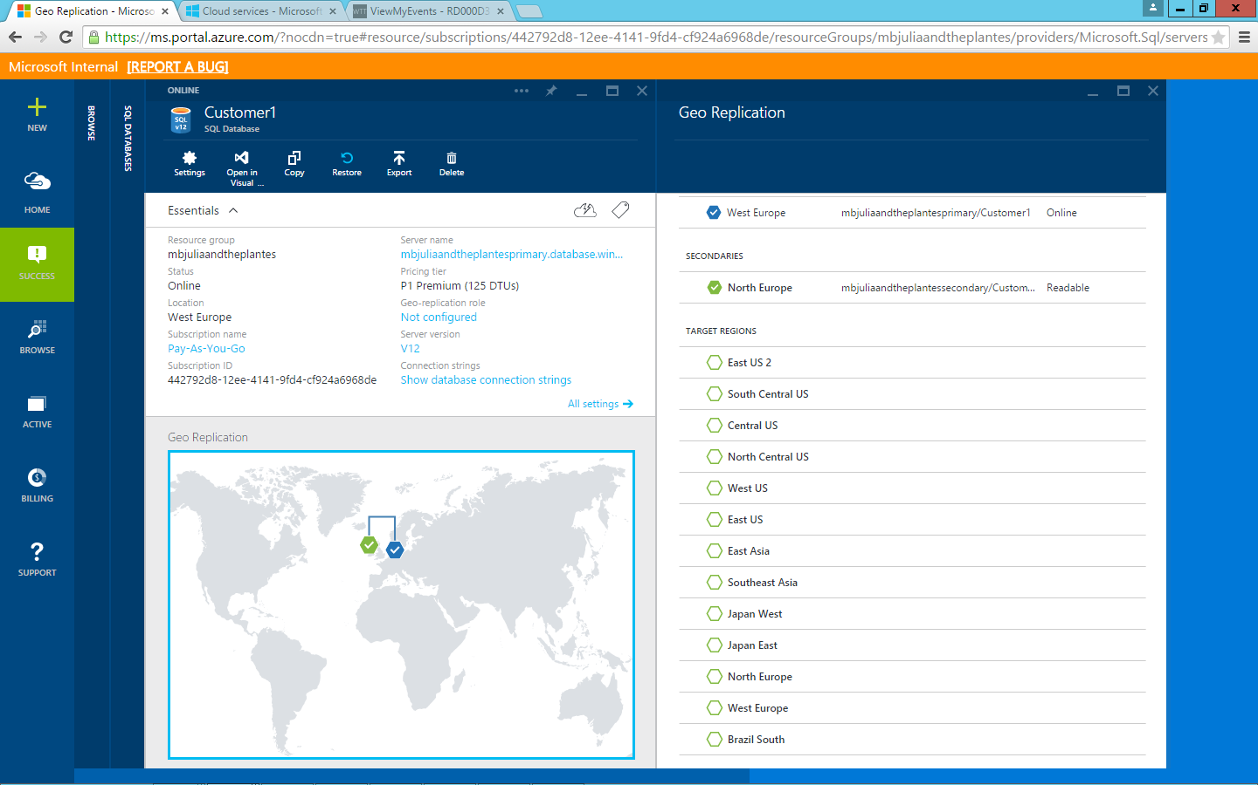

**Figure 71** When the line between the two database servers turns solid, geographic replication is established between them

1. Switch back to the tenant website (in this example, *XX00julieandtheplantes.trafficmanager.net*).
2. Refresh the tenantwebsite.
3. Scroll down to the bottom of the page.
4. Review that PrimaryDbServer = primary database server (in this example, *XX00julieandtheplantesprimary*).
5. Review that SiteHost = primary Azure Web App, which is the destination endpoint to which Azure Traffic Manager is routing all web traffic (in this example, *XX00julieandtheplantesprimary.azurewebsites.net*).

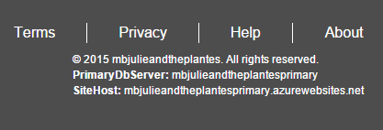

**Figure 72** Note the primary database server and site host for the website

1. Switch back to the Azure portal.
2. At the lower right, click **Azure Portal** to launch the old portal.

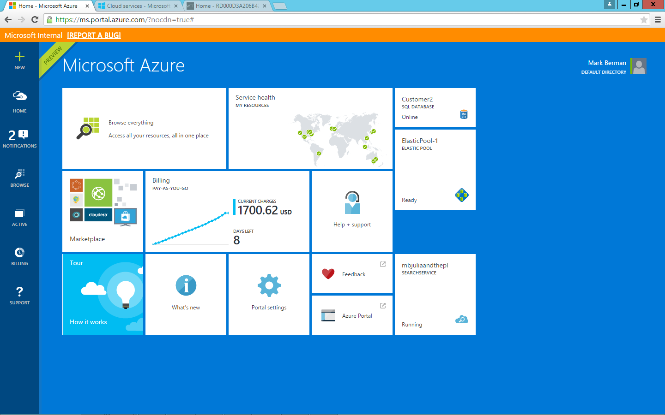

**Figure 73** Switch to the old Azure portal

1. Once the old portal (manage.windowsazure.com) loads, from the left column, click **Traffic Manager**.

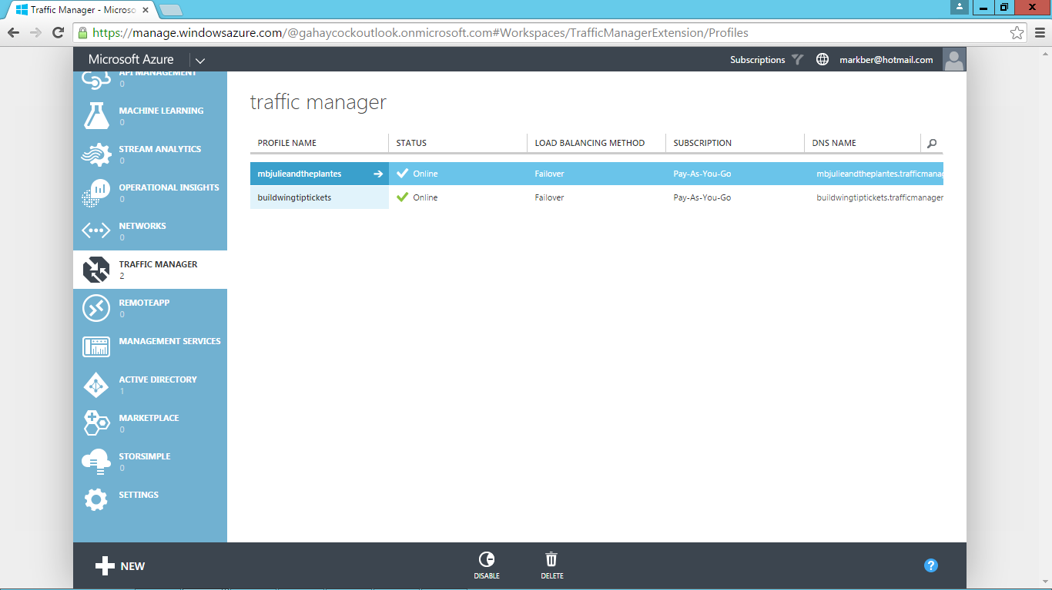

**Figure 74** Go to the Azure Traffic Manager service in the old Azure portal

1. Select the Azure Traffic Manager profile that was created for you (in this example, *XX00julieandtheplantes*).
2. Click **Endpoints**.
3. Notice there are two sites configured:

* Primary Azure Web App
* Secondary Azure Web App

These are configured in failover mode, because each site is mapped 1:1 to its respective database server. For example, primary Azure Web App is mapped to the primary database server and secondary Azure Web App is mapped to the secondary database server.

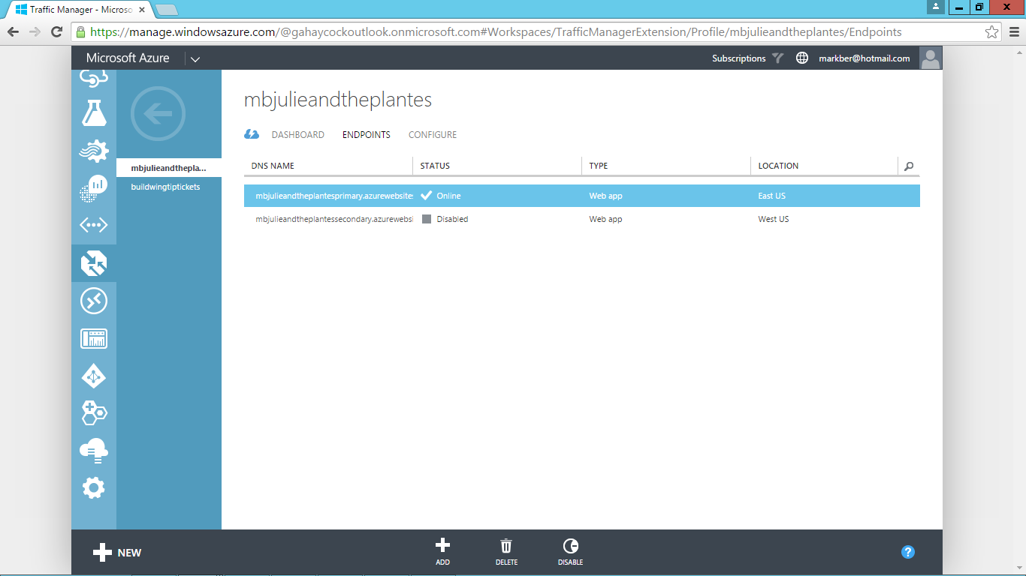

**Figure 75** Note that both the primary and secondary Azure Web App instances are online

The primary reason for this is specifically to address a datacenter disaster.

To simulate a regional outage, you will manually stop the primary Azure Web Appendpoint.

1. Select the primary Azure Web App endpoint (in this example, XX00julieandtheplantesprimary.azurewebsites.net).

From the bottom right, click **Disable**, and then click **Yes** to confirm that the primary Azure Web App endpoint is being disabled.

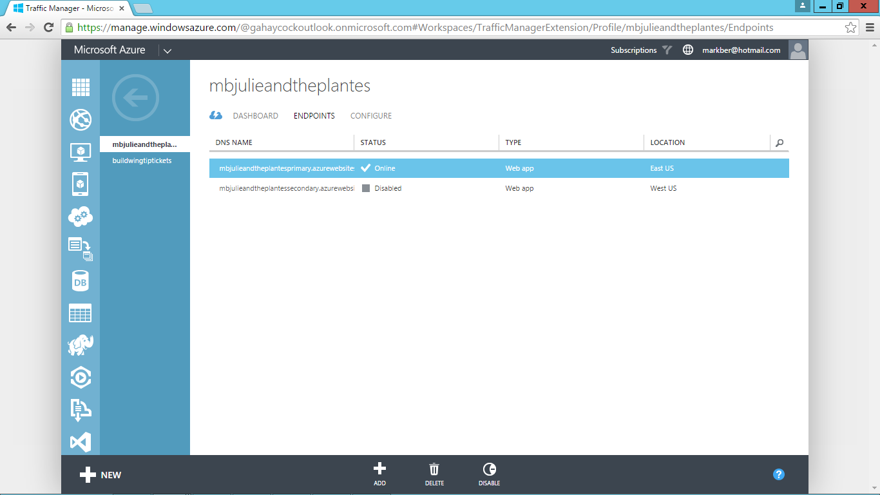

**Figure 76** Simulate an outage by manually disabling the primary Azure Web App endpoint in Azure Traffic Manager

1. Select the secondary Azure Web App endpoint (in this example, XX00julieandtheplantessecondary.azurewebsites.net).

From the bottom right, click **Enable**, and then click **Yes** to confirm that the secondary Azure Web App endpoint is being enabled.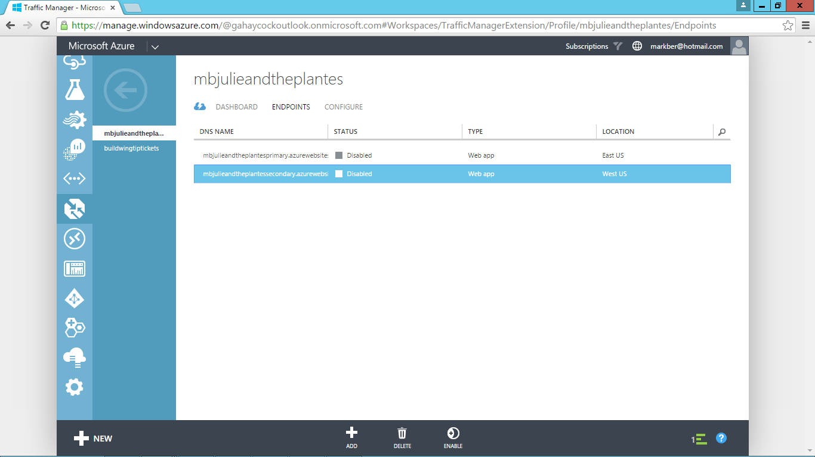

**Figure 77** Verify that the tenant’s primary Azure Web App endpoint is disabled

**Note:** It should take around 30 seconds for Azure Traffic Manager to check the endpoint and set its status to online. You might need to refresh your browser if the status doesn’t update.

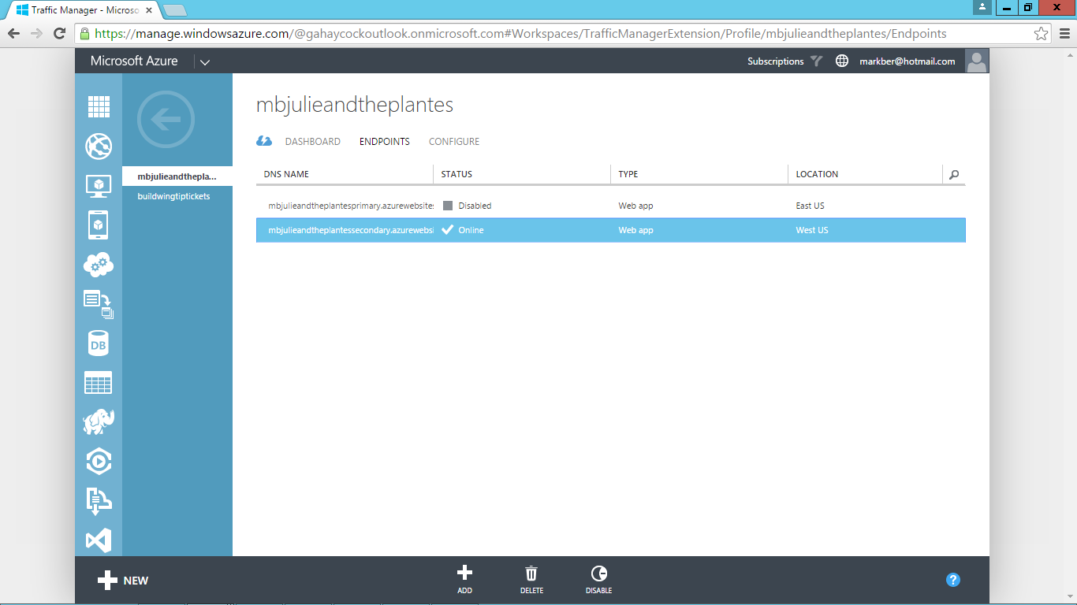

**Figure 78** Secondary tenant Azure Web App website now shows its status as online

1. Return to the tenant’s website (in this example, *XX00julieandtheplantes.trafficmanager.net*).
2. Refresh the page.
3. Scroll down to the bottom.
4. Verify that the failover has taken effect:

* Notice the PrimaryDbServer = secondary database server.
* Notice the SiteHost = secondary Azure Web App.

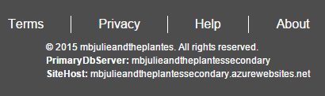

**Figure 79** Note the primary database server and site host for the website are now the secondary server and website

**Note:** Occasionally, browser caching prevents the PrimaryDbServer and SiteHost settings from refreshing, and these will continue to show the primary instead of the secondary, even though the primary endpoint has been disabled. To resolve this, either try closing your browser and opening a new instance or opening a new browser window in private/incognito mode.

1. Click **Sign In**.

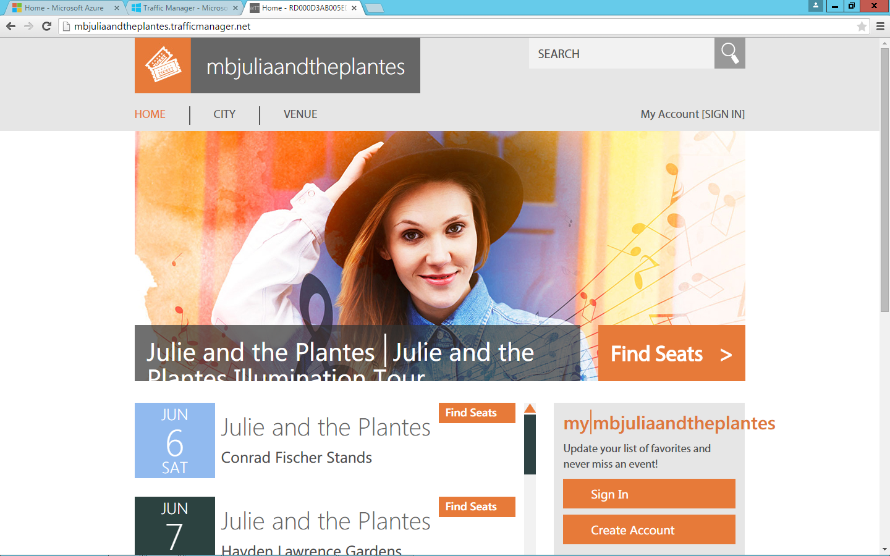

**Figure 80** Sign in to the website to verify that the Customer1 database has replicated from the primary to the secondary database server

1. Sign in using the account you previously created.



**Figure 81** Use your user credentials to sign in to the website

1. Click **My Events**.

Verify that the ticket you previously purchased is still listed under My Events.



**Figure 82** Customer1 database has replicated from the primary to the secondary database server

The ticket purchase now being retrieved by the tenant’s secondary Azure Web App is from the secondary database server, thanks to the active geographic replication.

At this point you could terminate the replication links between the primary and secondary database servers, effectively making the secondary server become the primary as it switches from read-only to read/write.

Alternatively, you could start the primary Azure Web App endpoint in Azure Traffic Manager, stop the secondary Azure Web App endpoint in Azure Traffic Manager, and resume reading and writing to the Customer1 database on the primary database server, while keeping the replication enabled to the secondary database server. For the purposes of this demo, this is the recommended option.

# Task 8: Transparent Data Encryption with Azure SQL Database

Azure SQL Database transparent data encryption (preview) helps protect against the threat of malicious activity by performing real-time encryption and decryption of the database (along with associated backups and transaction log files at rest) without requiring changes to the application, all while being transparent to website users.

1. From **portal.azure.com**, browse to the primary database server (in this example, *XX00julieandtheplantesprimary.database.windows.net*).
2. Select the **Customer1** database.

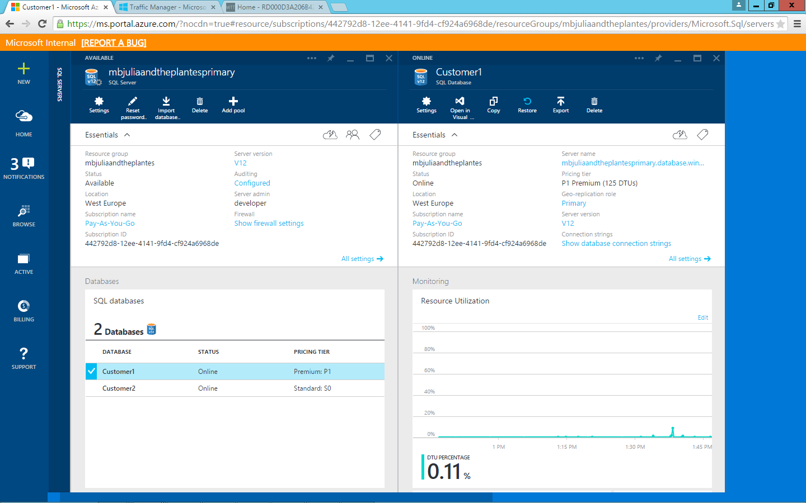

**Figure 83** Open the Customer1 database in order to turn on encryption for it

1. Click **Settings**.
2. Click **Transparent data encryption**.

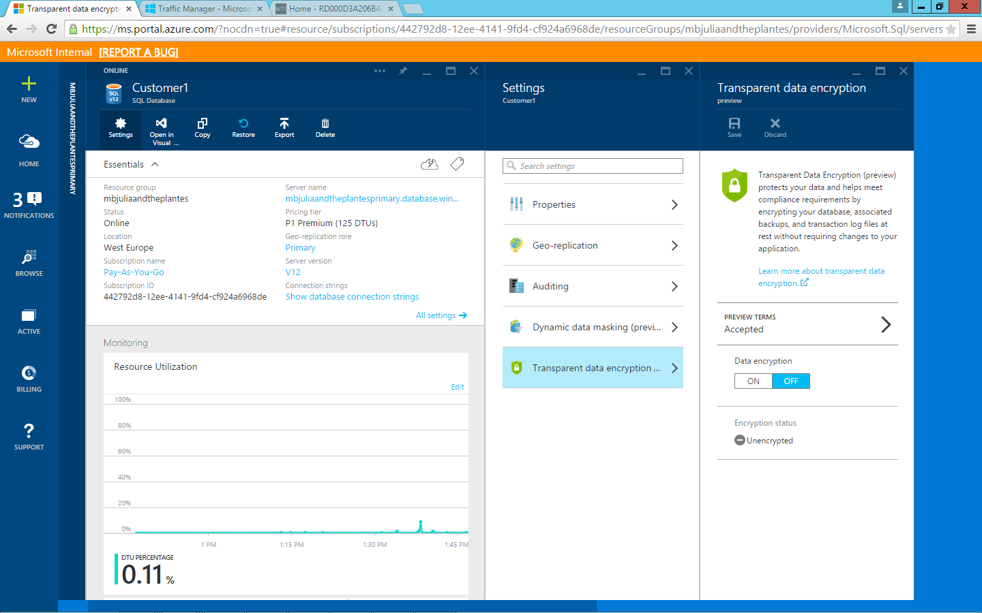

**Figure 84** Open data encryption settings from the Settings pane in the Customer1 database

1. Accept the preview terms.
2. Under **Data encryption**, click **On**.

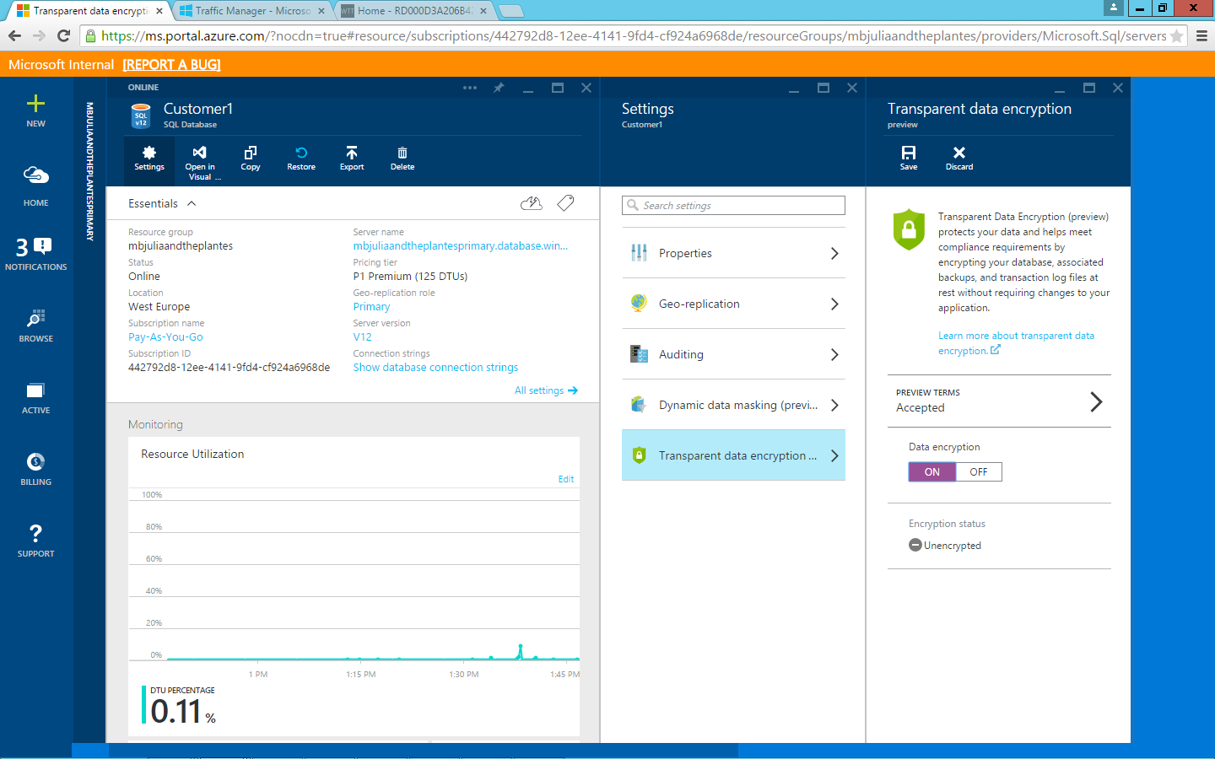

**Figure 85** Turn on data encryption for the database

1. Click **Save**.
2. The encryption status should show the progress encrypting your database. Encryption should take around 1–2 minutes. Once completed, it should look like Figure 86.

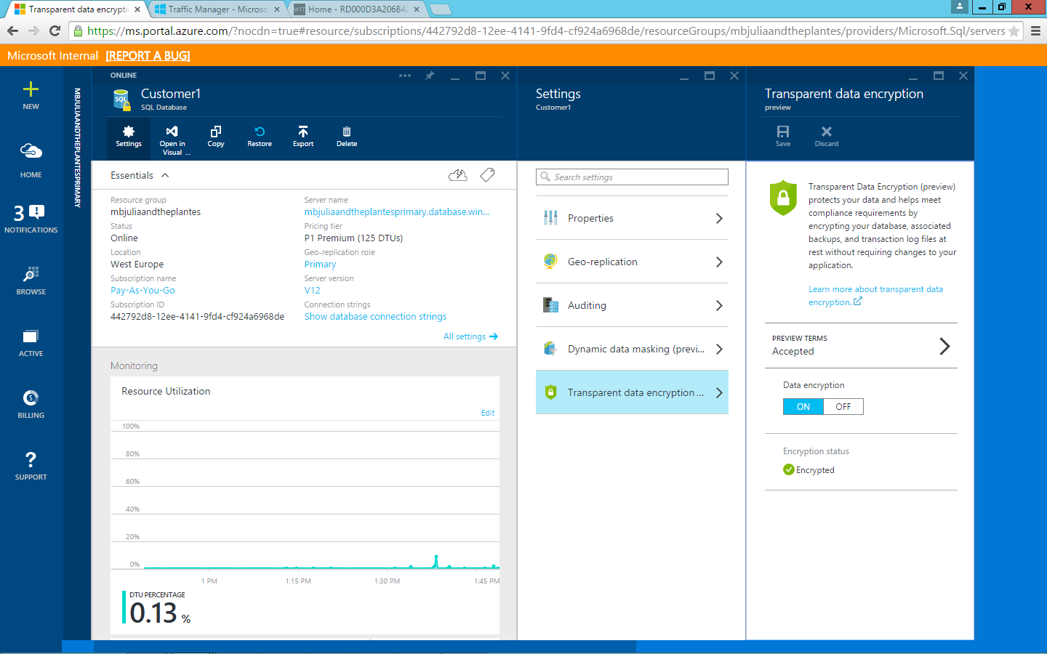

**Figure 86** Customer1 database view with encryption complete

1. Browse to the tenant website, and then notice that the application continues to work without any changes, but that you are now protected.



**Figure 87** Data encryption is completely transparent to website users

1. If you’d like to disable encryption at some point, return back to **portal.azure.com**, browse to the primary database server (in this example, *XX00julieandtheplantesprimary.database.windows.net*), and then select the **Customer1** database.
2. Click **Settings**.
3. Click **Transparent data encryption**.
4. Under **Data encryption**, click **Off**.

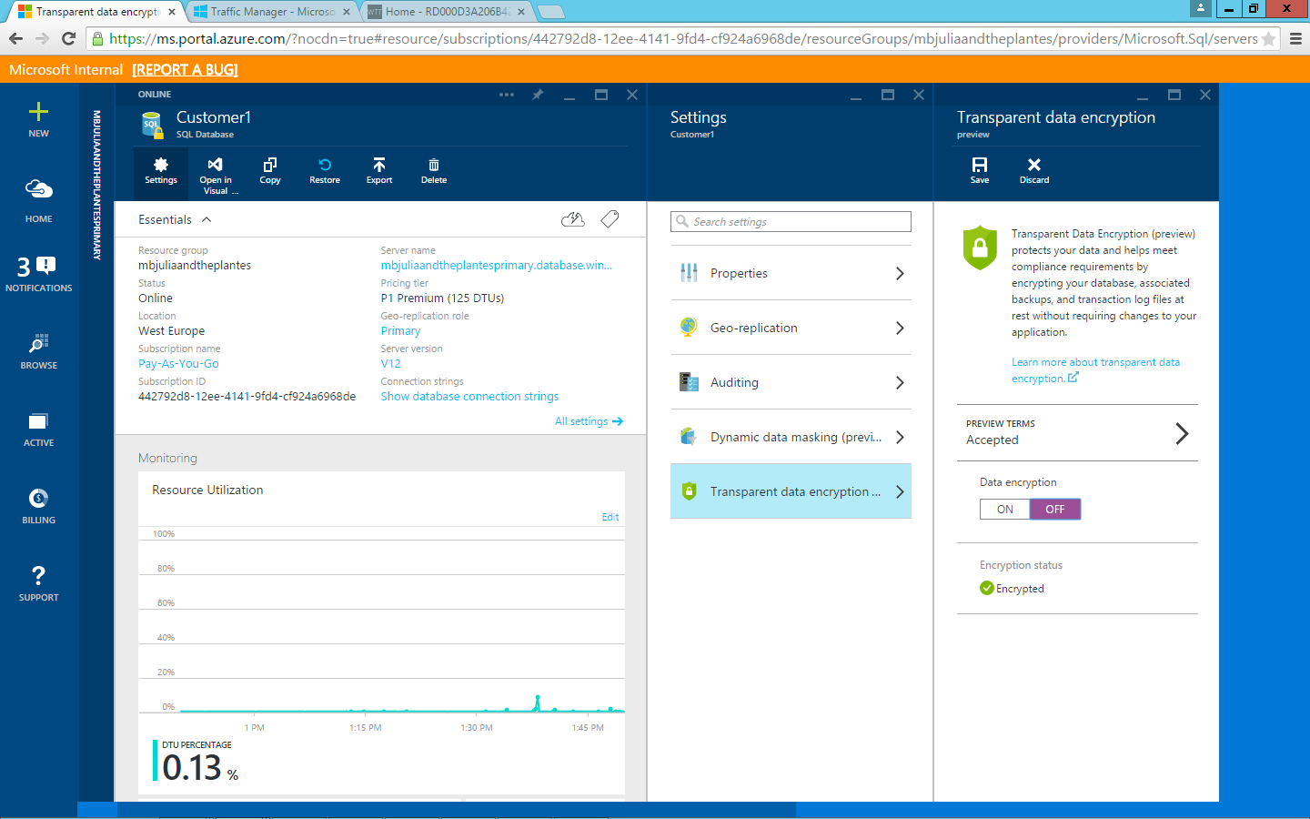

**Figure 88** You can turn off encryption on a database from the same location you turned it on

1. Click **Save**.
2. Once completed, the encryption status should show Unencrypted.

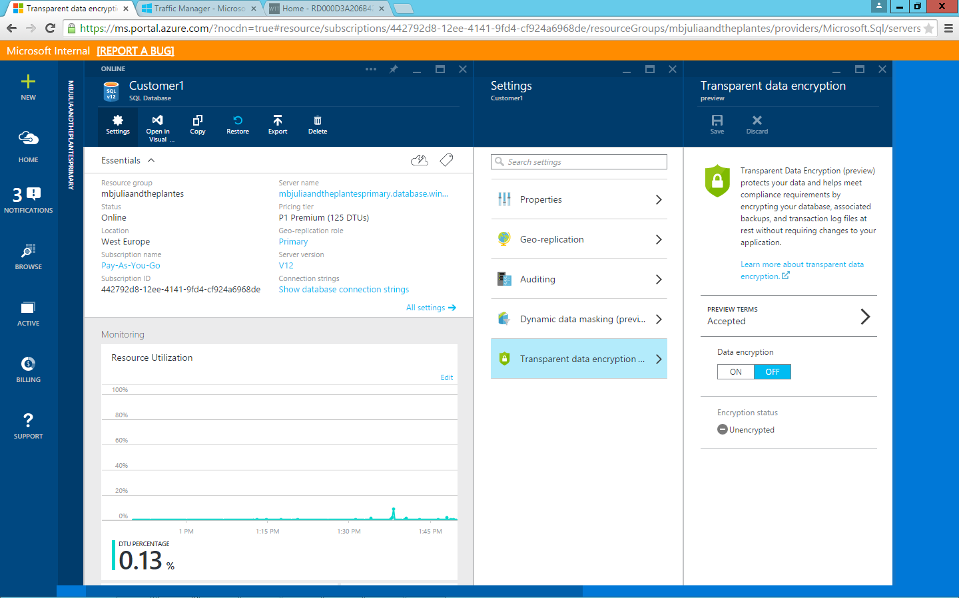

**Figure 89** Verify that the encryption setting for the database is now Unencrypted

# Task 9: Azure Search

Being able to search for matching terms across multiple databases or database tables is crucial for your customers. In this section you will experience Azure Search from the user’s point of view.

## Task 9 Steps

1. Browse to the tenant website (in this example, *XX00julieandtheplantes.trafficmanager.net*).
2. In the **Search** box at the top right, type **detroit**.
3. Notice the suggested autocomplete for a single event.

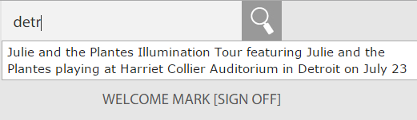

**Figure 90** Azure Search provides users with suggested autocomplete results

1. Click the event, and then click the **Search** button. Note that the result returned reflects the matching event.

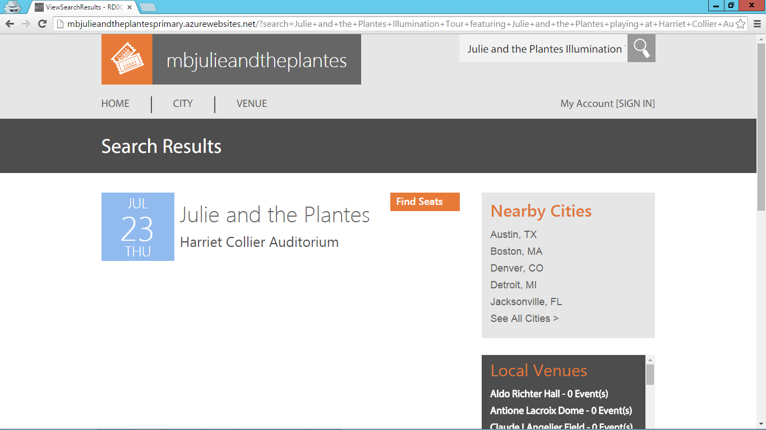

**Figure 91** The result returned reflects the matching event

1. In the **Search** field on the website, type **seattle**.
2. Notice the multiple events that Azure Search suggests for autocomplete on that term.

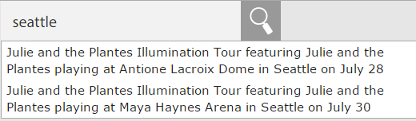

**Figure 92** Azure Search provides users with suggested autocomplete results

7. Press Enter. Note that the result returned reflects the previously suggested events.

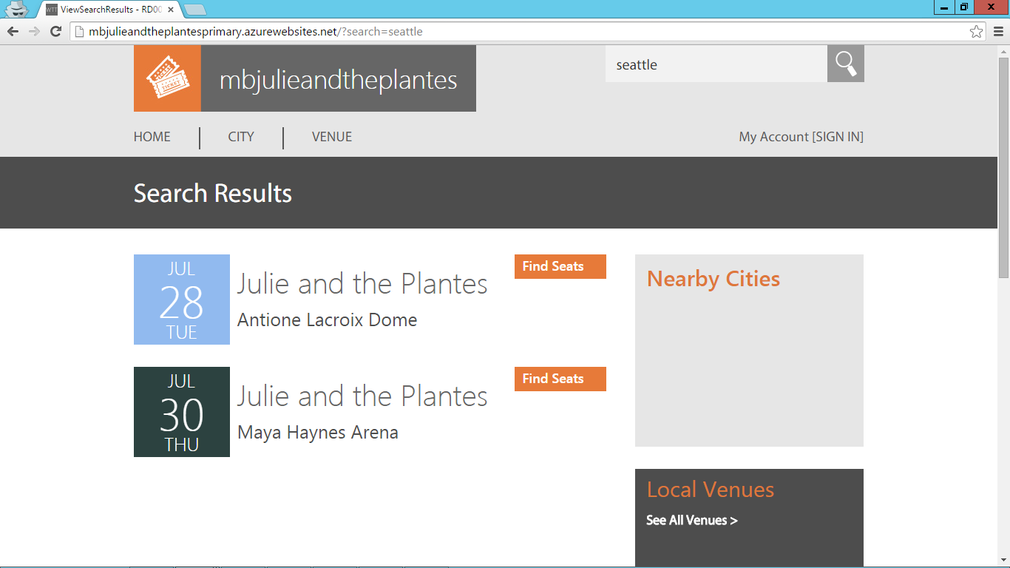

**Figure 93** The results returned reflect the matching events

# Task 10: Azure Search Code Review (Optional)

Using Microsoft Visual Studio, you can see what is going on behind the scenes to make Azure Search work.

## Task 10 Steps

1. From Visual Studio, with the **WingTipTickets solution** open, and within the **Tenant.MVC** project, browse to the **App_Start** folder, and then open **DataConfig.cs**.

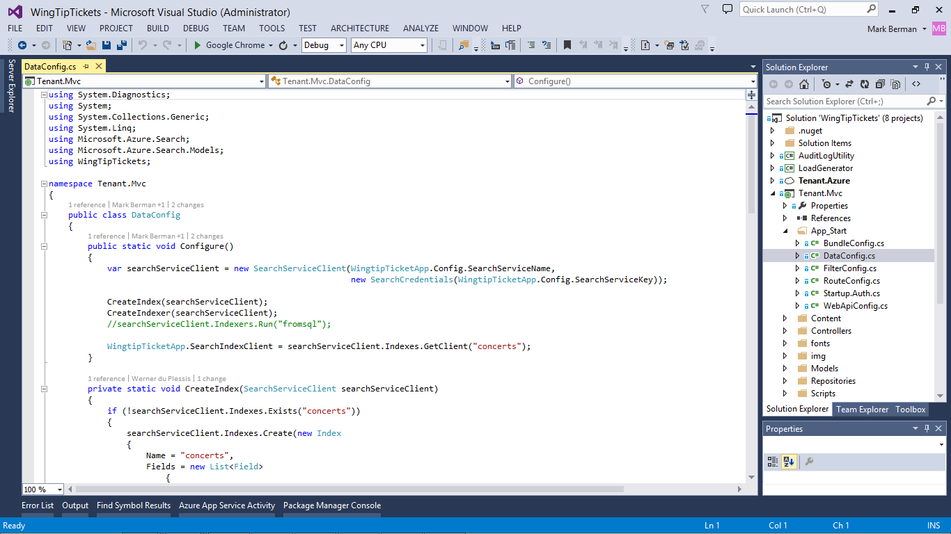

**Figure 94** Open the DataConfig.cs file in Visual Studio

1. Review that the configure method initializes the Azure Search service using the SearchServiceName from web.config, along with the SearchServiceKey.
2. Next notice the CreateIndex method, which creates a new Index called “Concerts.”

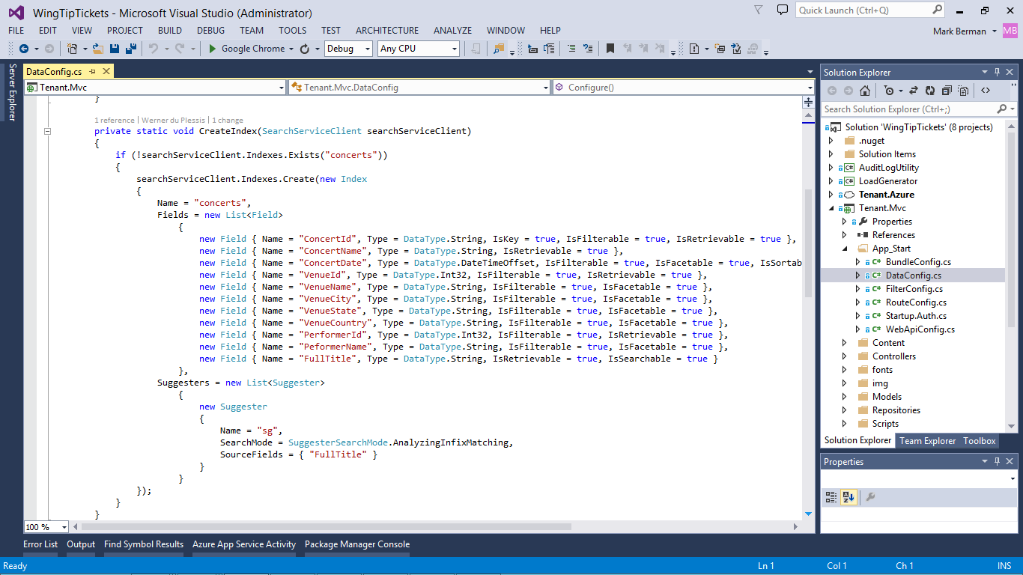

**Figure 95** The CreateIndex method creates the Concerts index

1. Lastly, notice how the CreateIndexer method is used to create a new Azure SQL Database indexer, which will use a view called "ConcertSearch."

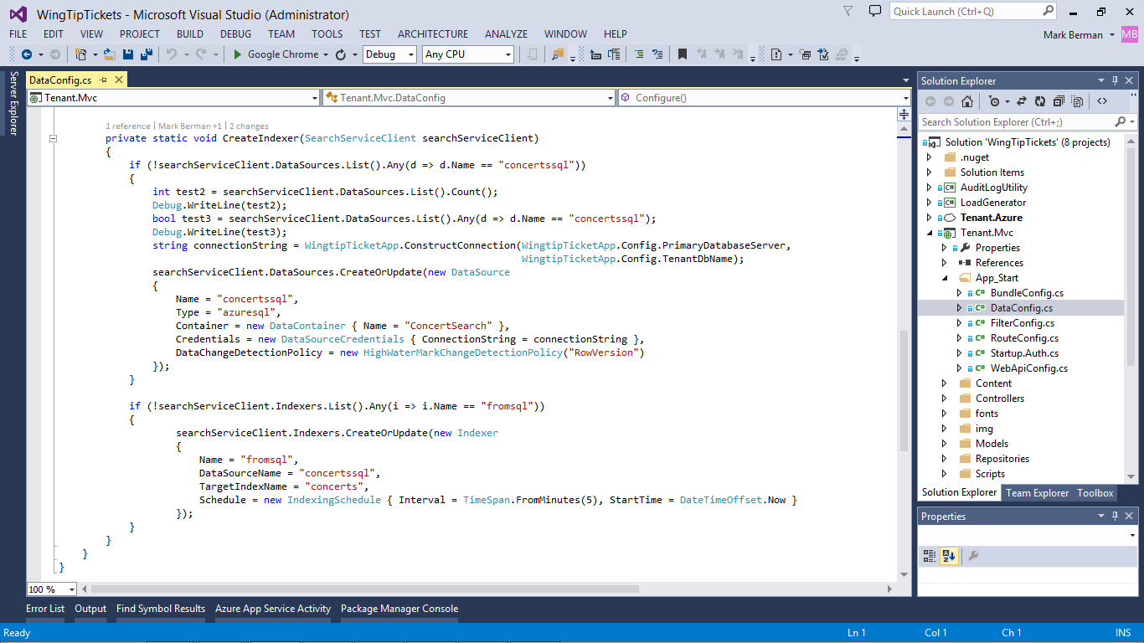

**Figure 96** The CreateIndexer method creates the ConcertSearch Azure SQL Database indexer

1. To see the results of the view, bring up SSMS, expand the **ConcertSearch** **View** under the primary database > Views > right-click, and then select **Edit Top 200 Rows**.

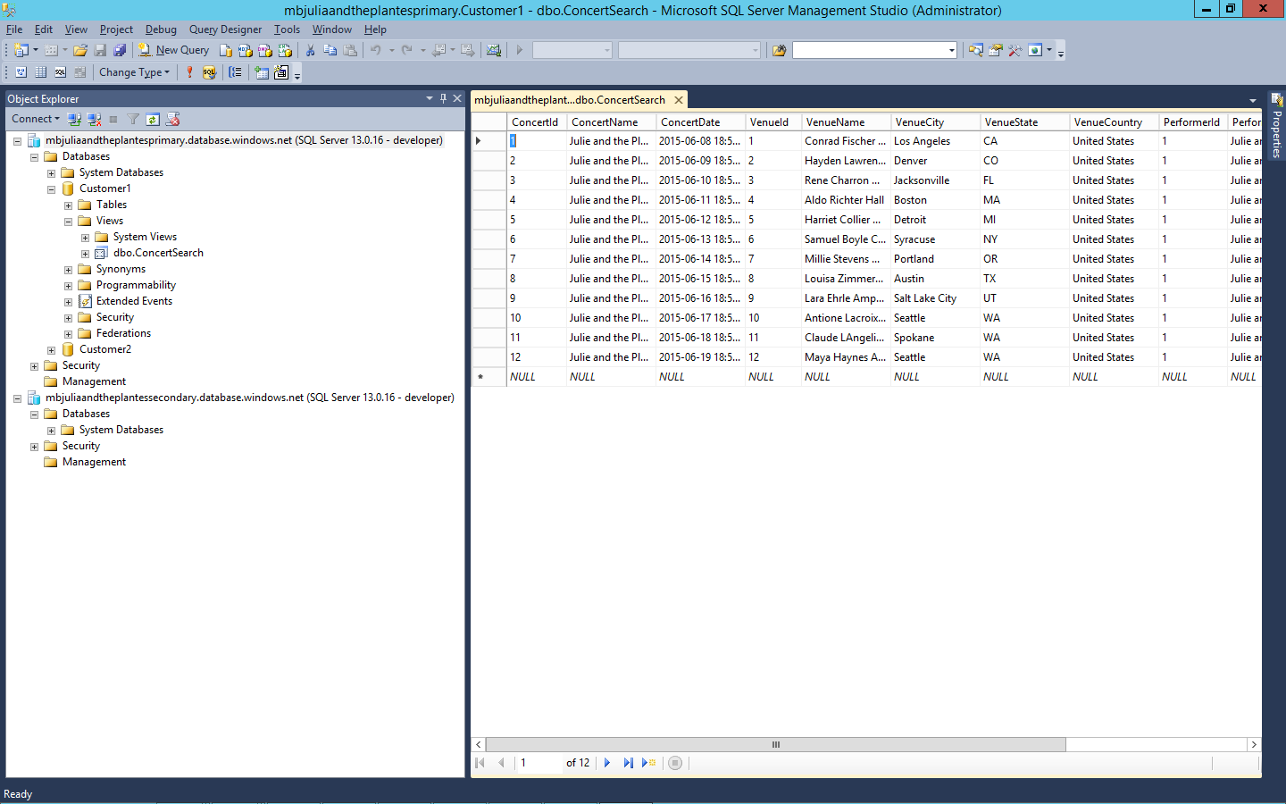

**Figure 97** View the index results directly in SSMS

1. To see the Azure Search service and the related Index in the Azure Portal, click **Browse** > **Search services** under your subscription on the Azure Portal. Notice the Azure Search service that corresponds to the name of your application.

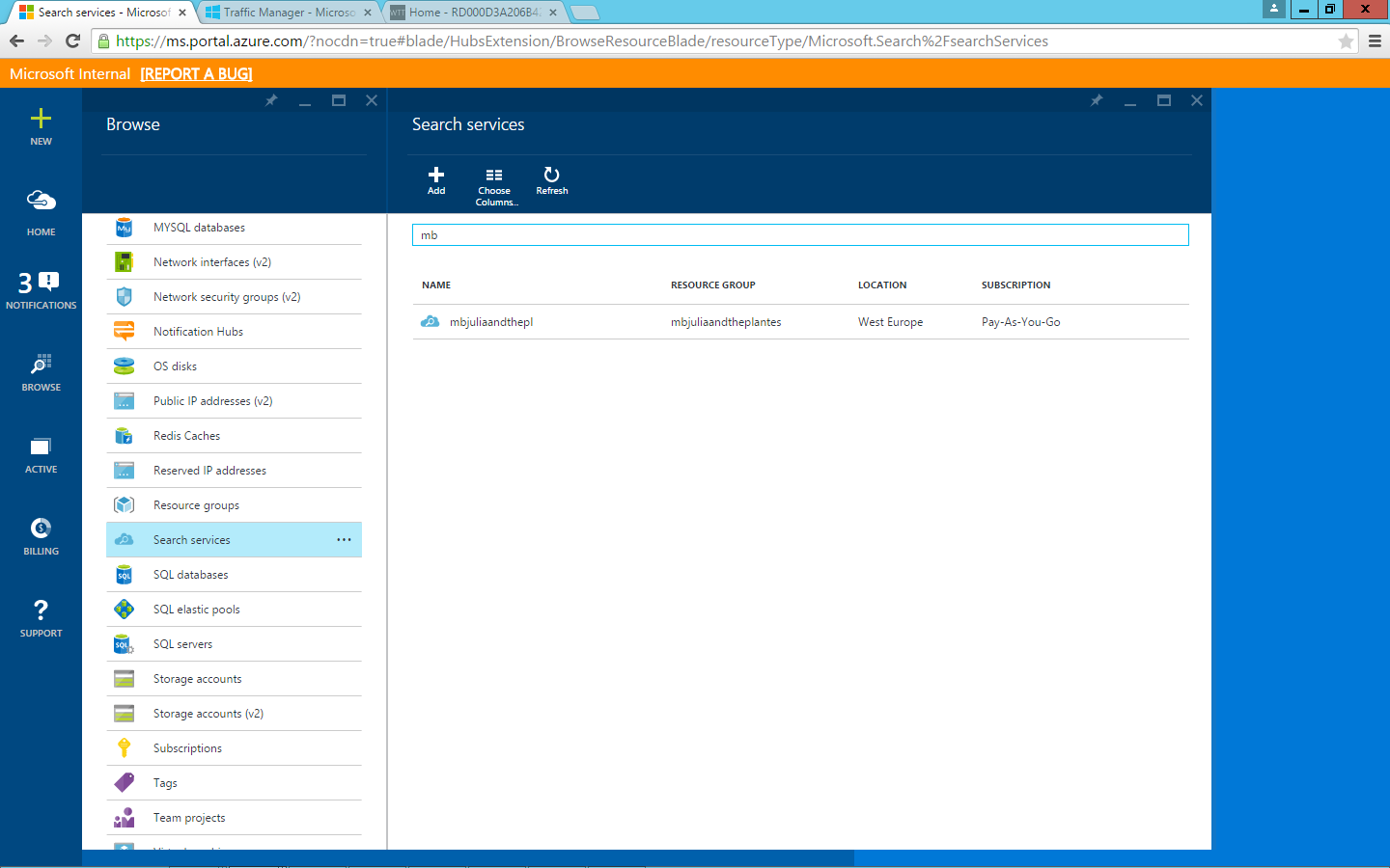

**Figure 98** View the Azure Search service in Microsoft Azure portal

1. Click your Azure Search service, and then review the index Concerts.

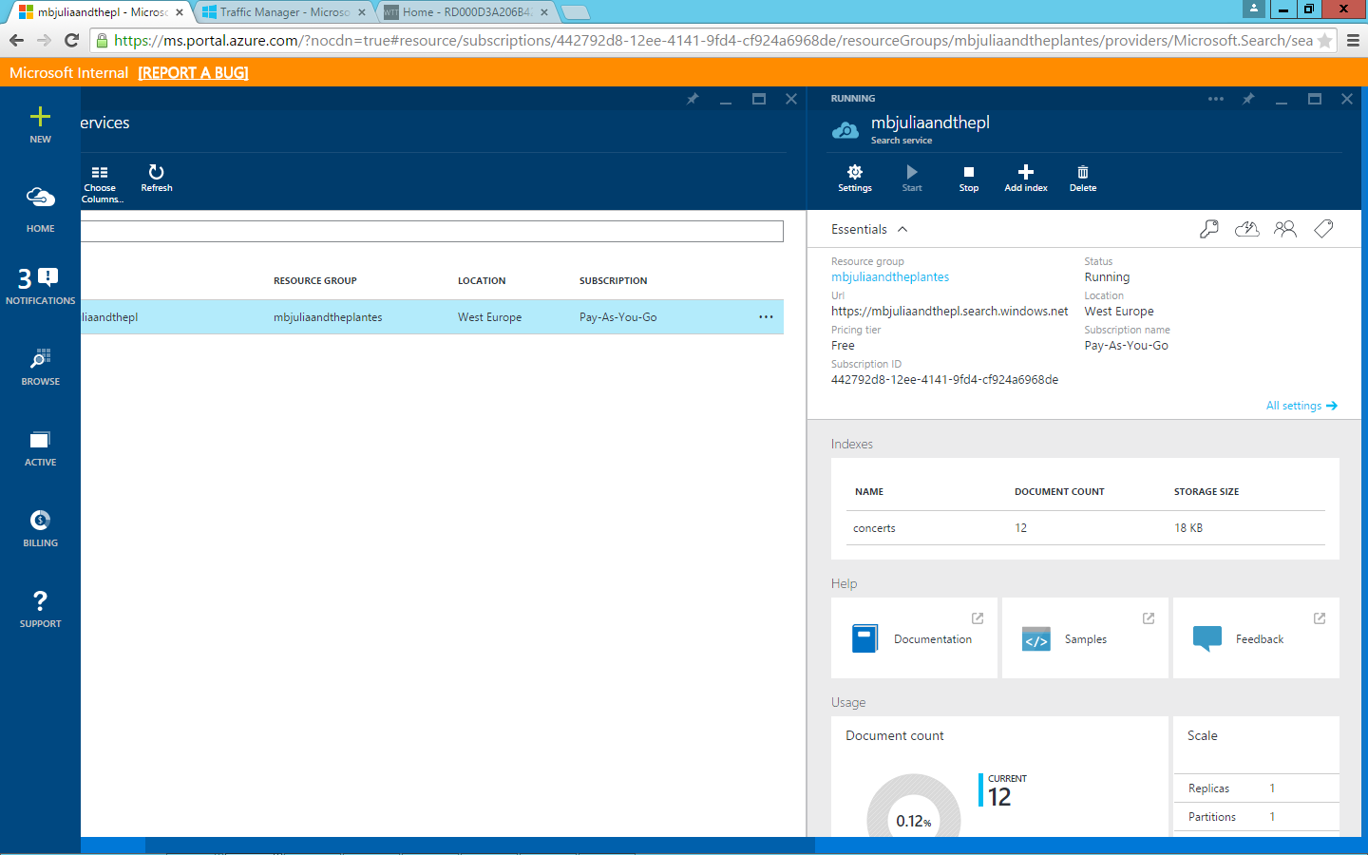

**Figure 99** View the Concerts index in Azure portal

1. Click on the index **Concerts** and notice the fields that correspond to the fields in the CreateIndex method.

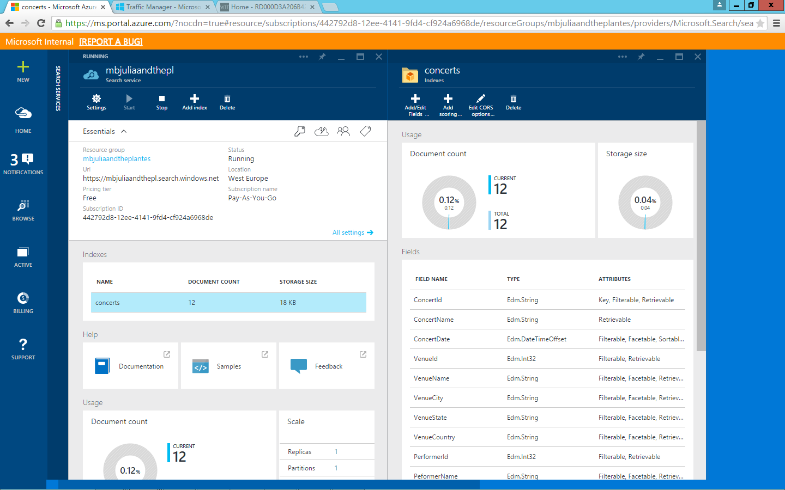

**Figure 100** Fields in the Concerts index correspond to the fields in the CreateIndex method in the DataConfig.cs file

1. To see how this is used, in Visual Studio, browse to the **Controllers** folder, and then open the **HomeController.cs** file. Scroll down to public async **Task<ActionResult> AutoCompleteEvents(*string term*)**. This is what drives autocomplete, which you saw at the beginning of this exercise.

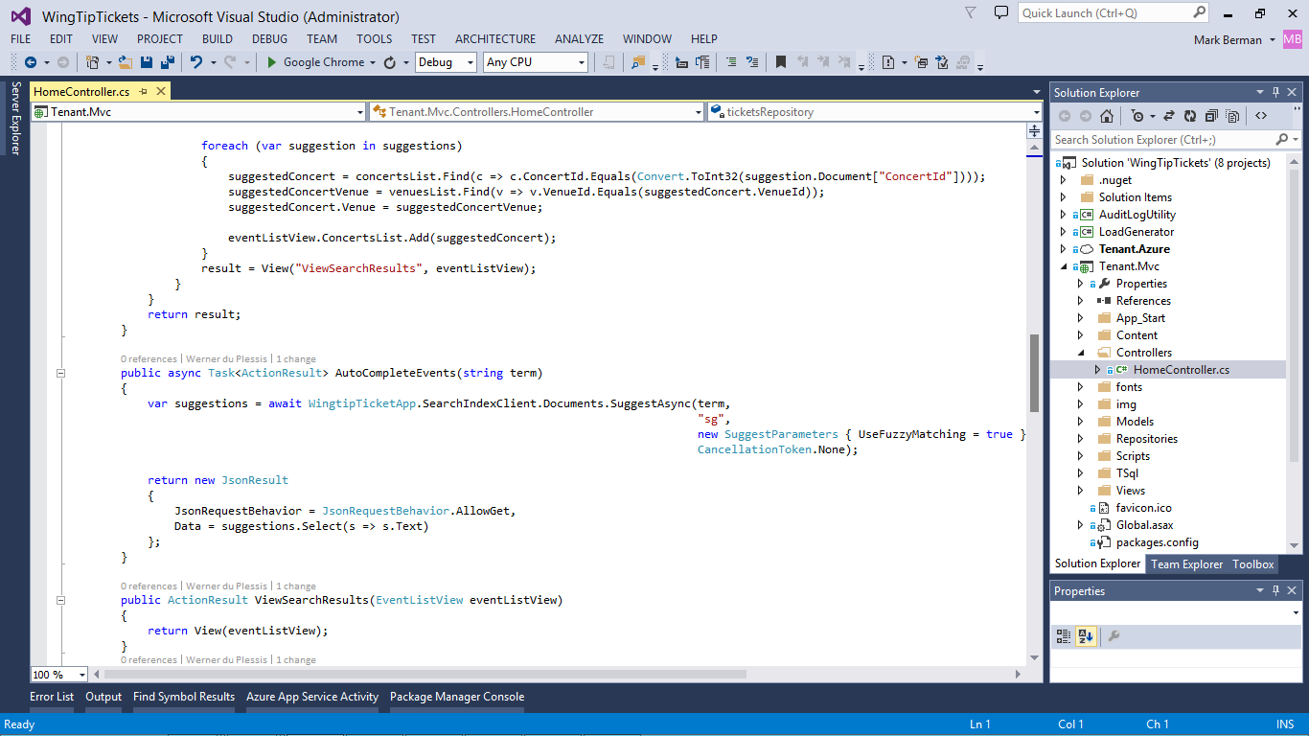

**Figure 101** View the code that powers the autocomplete Azure Search functionality

1. Scroll up to **public async Task<ActionResult> Index()**. Notice that the first “else” statement block is used to match a search result to a single event, returning the result to the "ViewSearchResults" view.

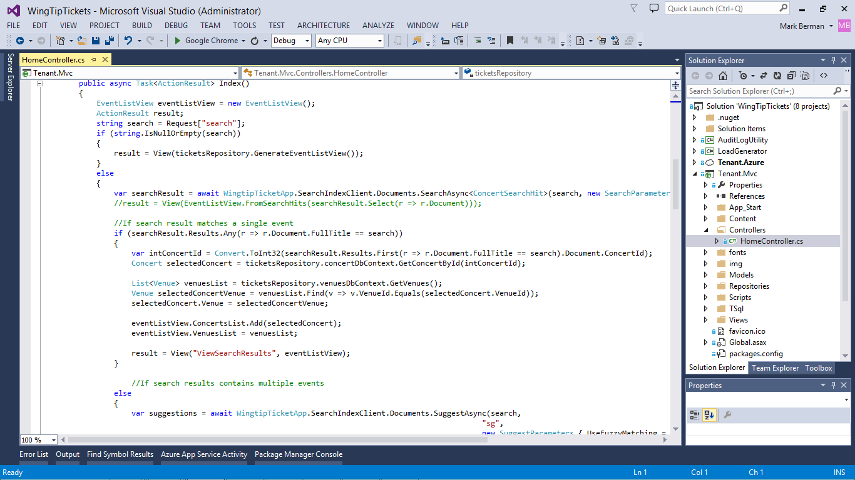

**Figure 102** The first “else” statement of the Task<ActionResult> method returns results that match to a single event

1. Notice that the second “else” statement block is used to match a search result to multiple events, and it also returns the result to the "ViewSearchResults" view.

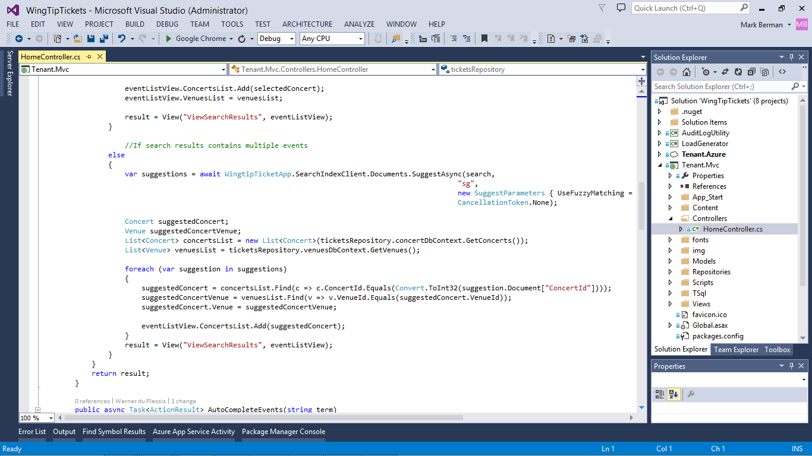

**Figure 103** The second “else” statement of the Task<ActionResult> method returns results that match to multiple events

# Task 11: Azure DocumentDB

Using Azure DocumentDB Studio, you can see what is going on behind the scenes and how Azure DocumentDB create, read, update, and deleted (CRUD) operations work.

## Task 11 Steps

1. Sign in to WingTipTickets traffic manager web appliation using the administrator credentials:

* **admin@admin.com**
* **P@ssword1**

1. Under the **Admin** tab, click **Venue Administration** to add or edit venue info. (You can also add a new venue by clicking **Event Administration** and then going back and choosing **Venue Administration**.)

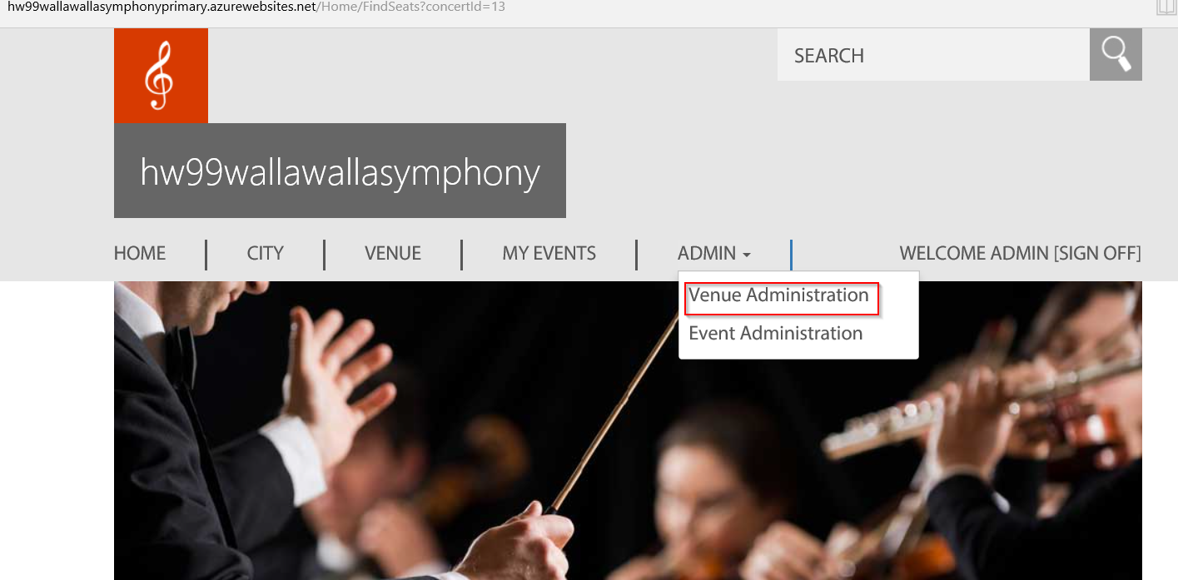

**Figure 104** The Venue Administration tab

1. A list of **Venues** will be displayed, and you can choose to add venue or to edit metadata.

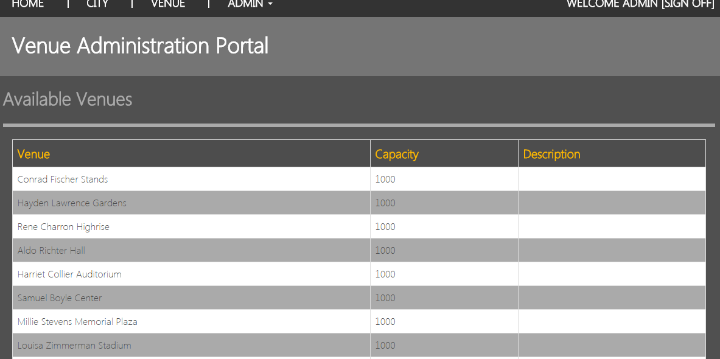

**Figure 105** The venue admin-portal page

1. Click **Add New** to add a Name-Value pair for metadata, or click **Delete** to delete the pair. Click **SaveToDocumentDB** when you are ready to save the record.

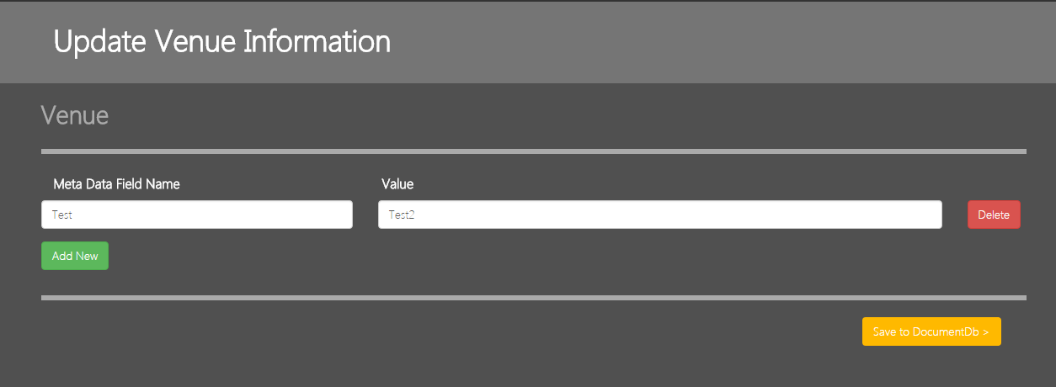

**Figure 106** Venue info-edit page

1. Click the **Venue** tab, scroll to an event that is hosted in the venue selected in step 3, and then click **Find Seats**
2. Venue info is displayed as shown in Figure 107.

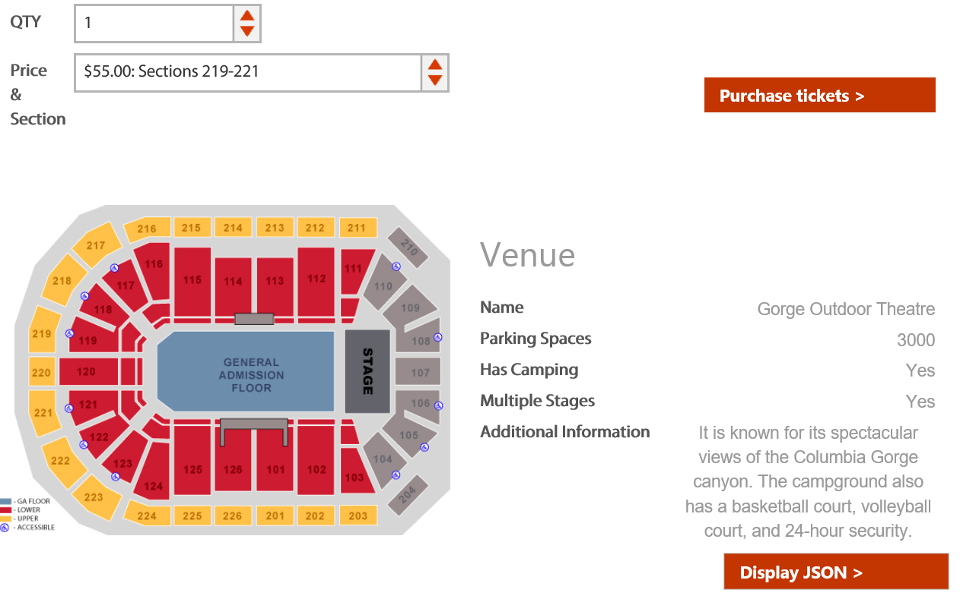

**Figure 107** Venue data-display page

1. Click **Display JSON**. JavaScript Object Notation (JSON) info is displayed as shown in Figure 108.

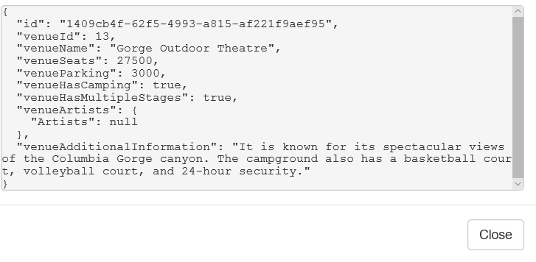

**Figure 108** Venue JSON display

1. Go to <http://portal.azure.com>, sign in with your Azure account used in the WingTipTickets lab, click the **DocumentDB Account** under the WingTipTickets resource, and then choose **Document Explorer**.

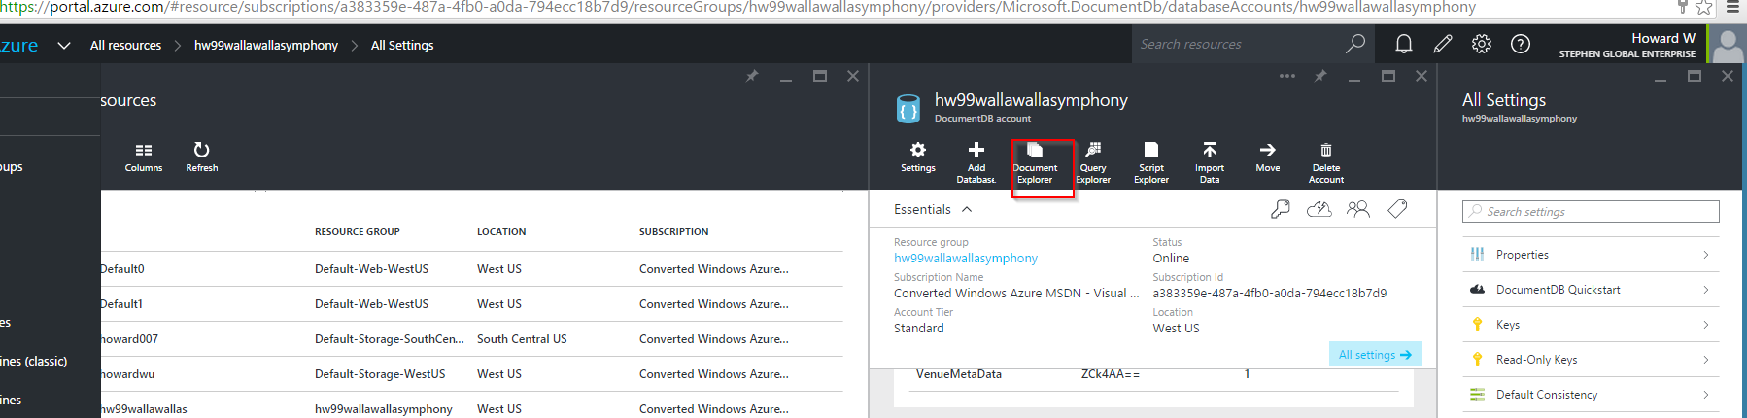

**Figure 109** Azure DocumentDB account page

1. Browse through the database and collection to find the Azure DocumentDB JSON record that you created. You can also use the direct **Create Document** and **Add document** controls from the document explorer.

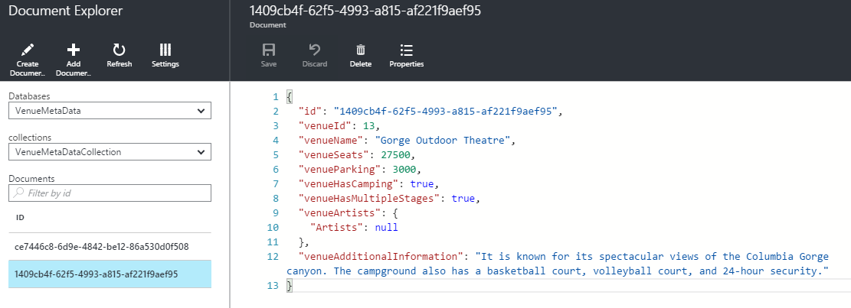

**Figure 110** Azure DocumentDB explorer page

1. Click **Query Explorer**, which lets you query results for Azure DocumentDB by using syntax similar to SQL.

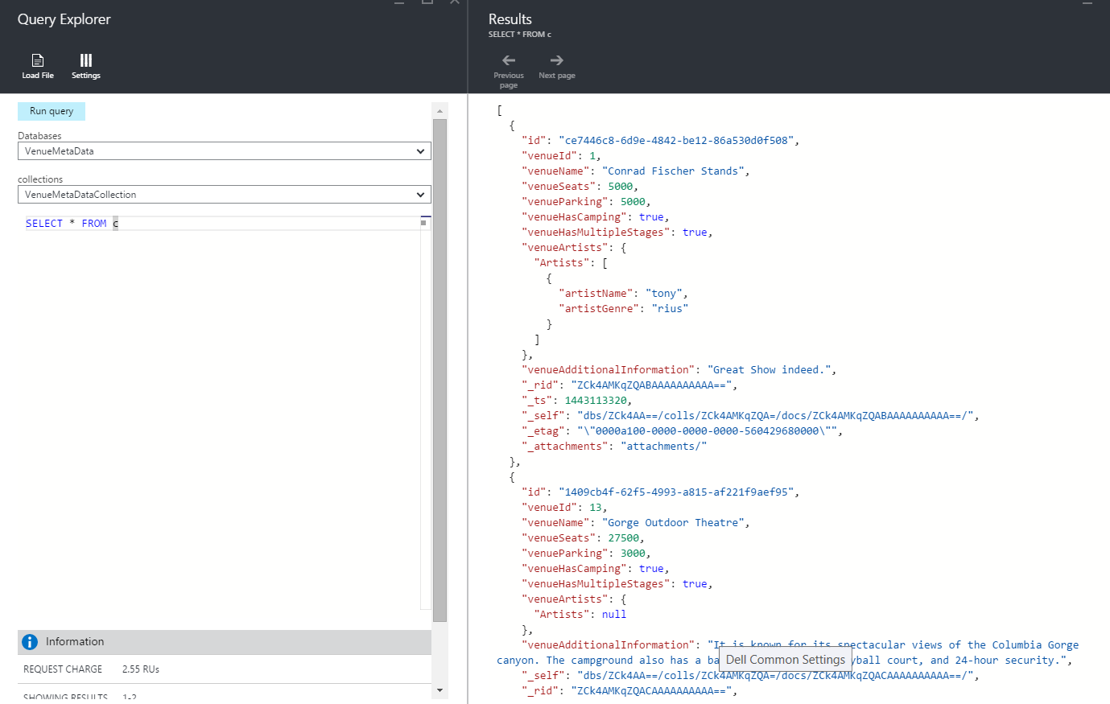

**Figure 111** The query-explorer page

1. Click **Script Explorer**, which enables you to create stored procedure, user-defined functions (UDFs), and other items.

# Task 12: Azure Data Factory

Using Azure Portal and the WingTipTickets application, you will be able to see how Azure Data Factory works.

## Task 12 Steps:

1. Navigate to <https://portal.azure.com>, sign in with your Azure subscription, and then find the data factory that has been created in your subscription (click **Browse** > **Data factories** > ***name of the created data factory***).
2. Once you navigate to the created Azure Data Factory, you should see a screen similar to Figure 112. Click the diagram to see the Personalized Product Recommendation workflow.

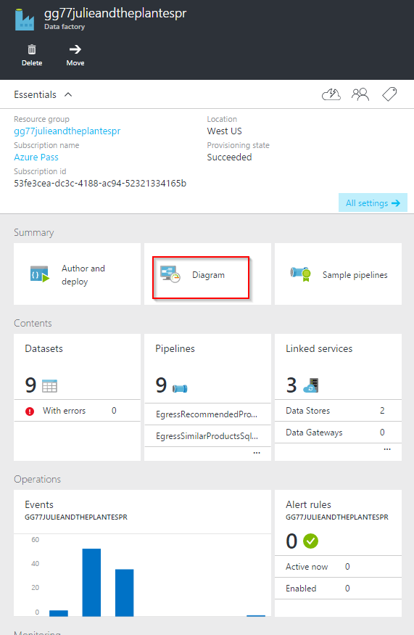

**Figure 112** Azure Data Factory page

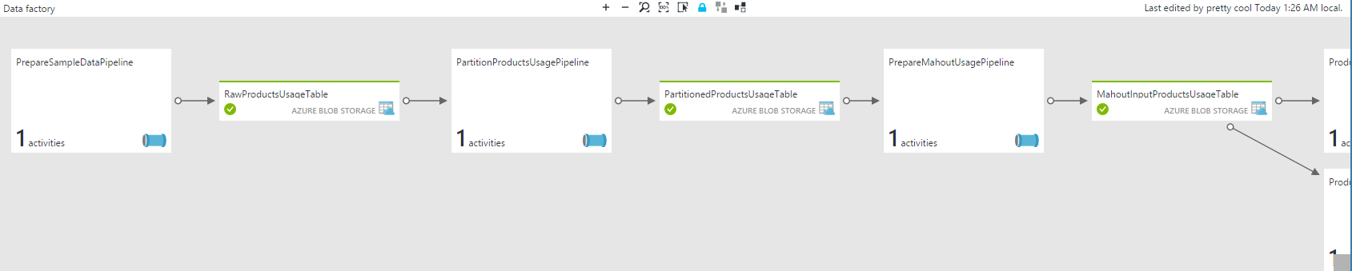

**Figure 113** Azure Data Factory diagram

1. Navigate to the WingTipTickets traffic manager web application that you provisioned, and then click the **Recommendations** tab. By default, the website will showcase the product catalog displaying list of artists and the number of concerts available for each artist on the WingTipTickets website.

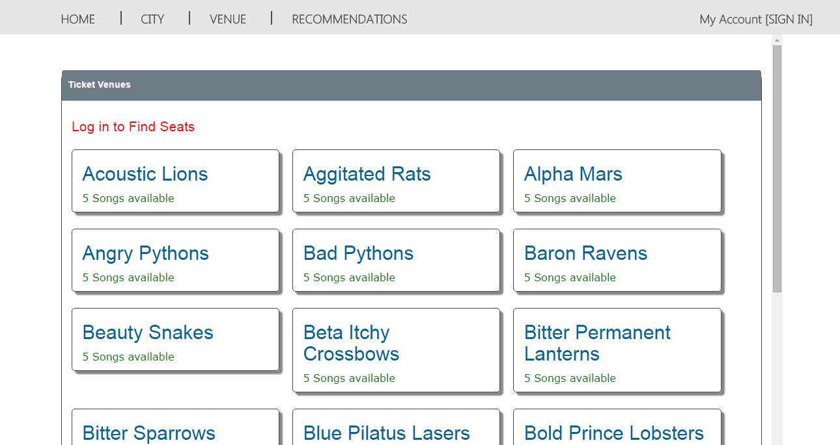

**Figure 114** Recommendation page

1. Navigate to <http://portal.azure.com>, and then sign in with your Azure subscription. You can view product-to-product recommendations on WingTipTickets website once the Azure Data Factory workflow executes successfully. To verify the successful execution of the Azure Data Factory workflow, navigate to your data factory in <http://portal.azure.com>, and then make sure that all the slices corresponding to the last produced dataset in the workflow (for example, ProductsRecommendationSQLTable) have executed successfully (that is, the status displays as “ready”).

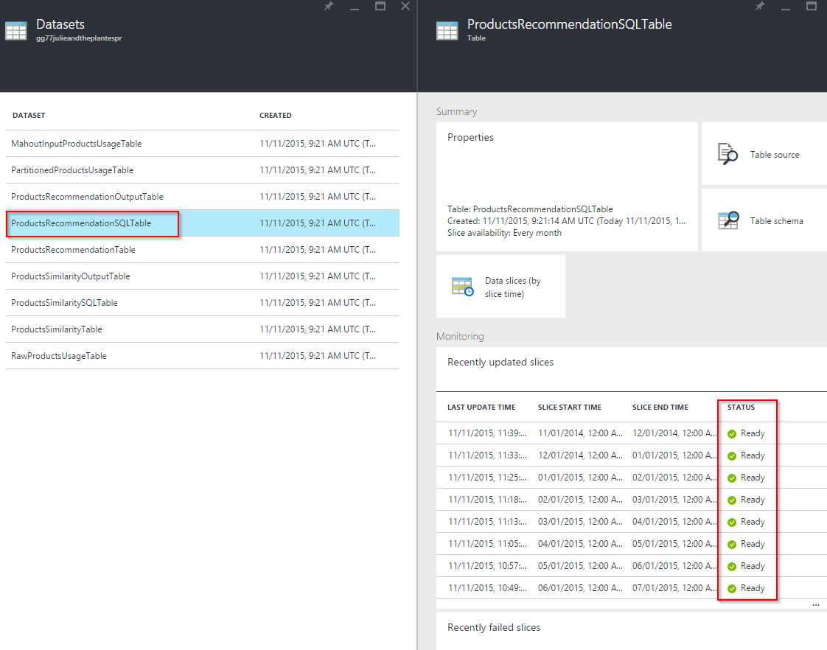

**Figure 115** ProductsRecommendationSQLTable

1. You can view personalized product recommendations on your WingTipTickets website. Click **Log in**, and then enter the user name [**gamal@microsoft.com**](mailto:gamal@microsoft.com)and thepassword **P@ssword1** to see the generated personalized product recommendations for the user Gaurav Malhotra.

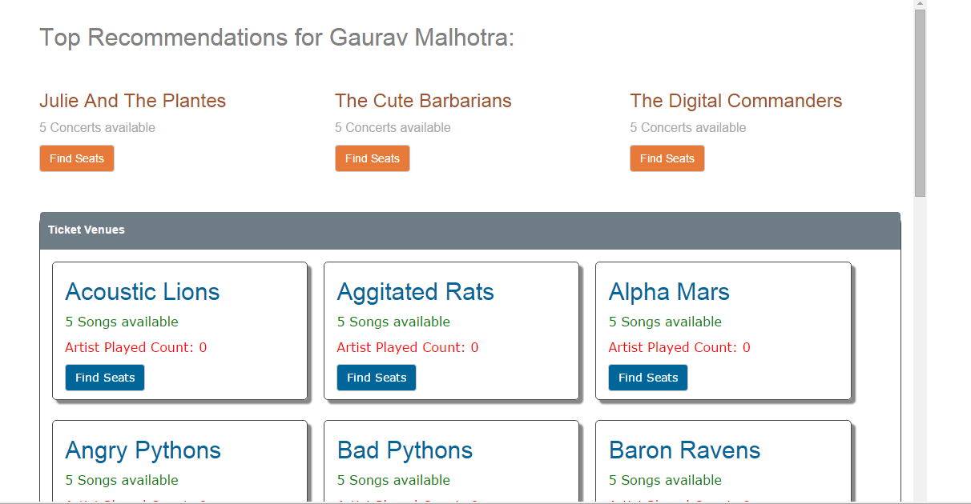

**Figure 116** Personalized recommendations for Gaurav Malhotra

1. Click **WELCOME GAURAV [SIGN OFF]**
2. You can also view personalized product to product recommendations on your WTT website for a different user. Click **Log in**, and enter the user name [**mike.flasko@microsoft.com**](mailto:mike.flasko@microsoft.com) and the password **P@ssword1** to see different personalized product recommendations for Mike Flasko.

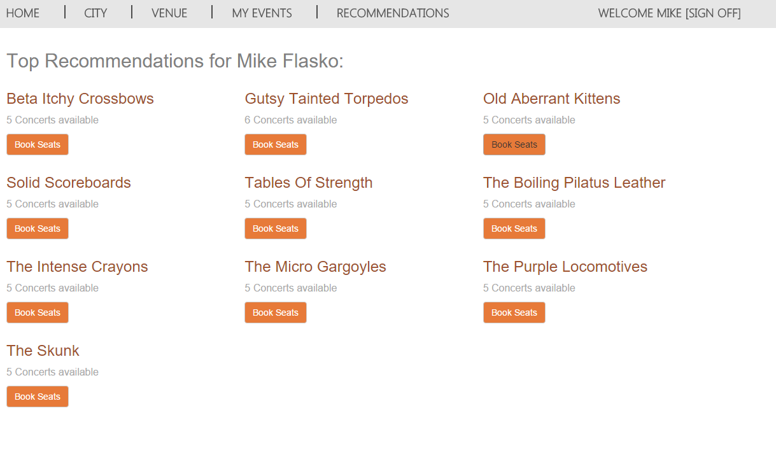

**Figure 117** Personalized recommendations for Mike Flasko

1. Navigate to <http://portal.azure.com>, and then sign in with your Azure subscription. You can view product-to-product recommendations once the Azure Data Factory workflow executes successfully, and you will be able to see personalized product recommendations on WingTipTickets website. To verify the successful execution of the Azure Data Factory workflow, navigate to your data factory in <http://portal.azure.com>, and then make sure that all the slices corresponding to the last produced dataset in the workflow (for example, ProductsSimilaritySQLTable) have executed successfully (that is, the status displays as "ready”).

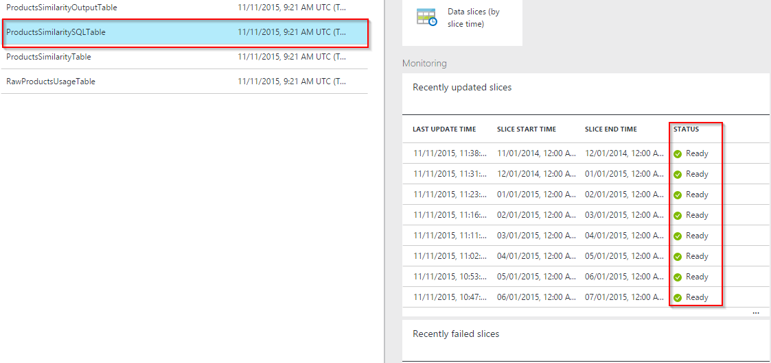

**Figure 118** ProductsSimilaritySQLTable

1. You can view product-to-product recommendations on your WingTipTickets website. You can see artists that are similar to the artist Beta Itchy Crossbows by clicking **Beta Itchy Crossbows**. The site then displays all the other artists that people who attended **Beta Itchy Crossbows** have purchased tickets for.

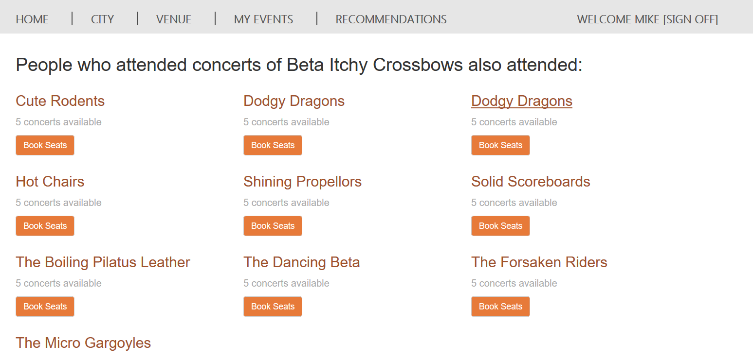

**Figure 119** Artists similar to Beta Itchy Crossbows

1. You can further explore individual processes of the Azure Data Factory workflow at your own pace with the following optional steps:
2. **Data sources**: The raw data sources for this use case are the web log files containing information about customer behaviors on WingTipTickets website.
3. **Ingest**: Use Azure Data Factory to ingest the customer-usage web-logs' data, the product catalog, and customer information into Azure BLOB storage.
4. **Prepare**: Use Azure HDInsight to partition the web logs data using Apache Hive, and then create input data for the machine learning recommendation model.
5. **Analyze**: Use the machine learning recommendation model (Apache Mahout) to generate an item-similarity matrix and a personalized-recommendation matrix and to provide recommendations to customers.
6. **Publish**: Use Azure Data Factory to copy the results to a relational store (Azure SQL Database) for consumption by the WingTipTickets website.
7. **Consume**: Consume the personalized recommendations on the WingTipTickets website.

# Task 13: Azure SQL Data Warehouse

The customer would like to track ticket purchases throughout the duration of the concerts being offered through the web application. To accomplish this task, they turn to Azure SQL Data Warehouse. Azure SQL Data Warehouse is capable of processing large data sets from multiple locations. It can also scale up or scale down based on demand, in addition to pausing if the service has no projected use during a given period. The data can also be used to create analytics reports using tools such as Excel and Power BI.

## Task 13 Steps

1. Browse to <https://portal.azure.com>.
2. Browse to **SQL databases**.  
   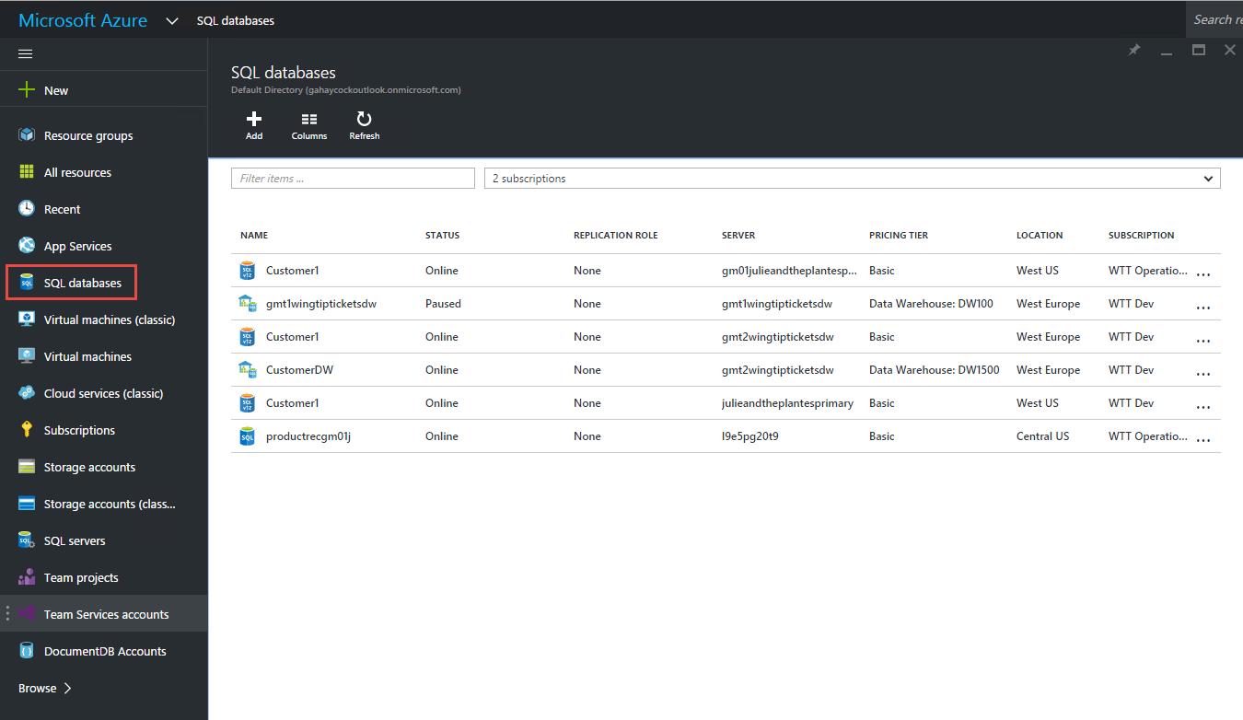  
   ***Figure 120*** *Review the SQL databases pane*
3. Click **CustomerDW**.
4. Click **Start**.  
   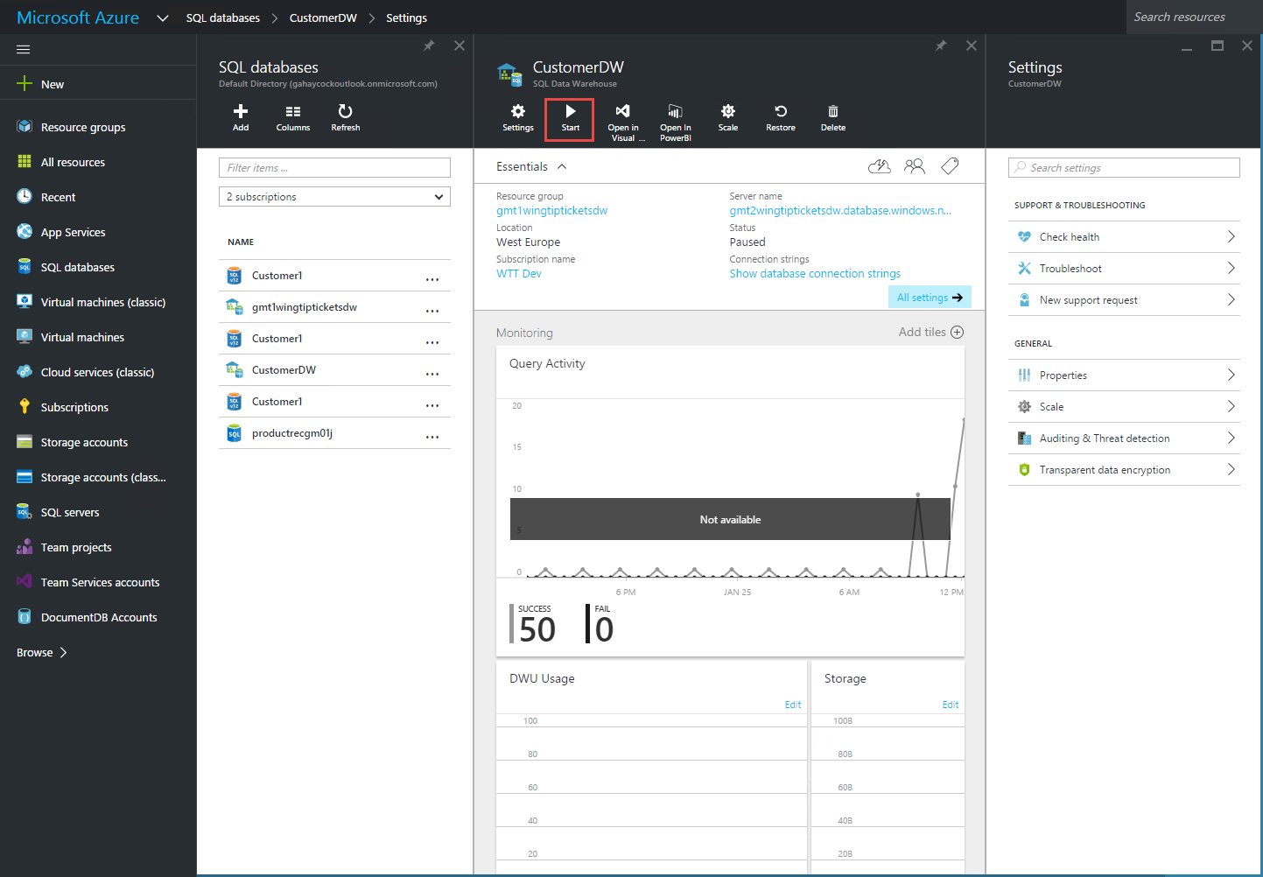  
   ***Figure 121*** *Start the Azure SQL Data Warehouse database*
5. Click **Yes** to start the Azure SQL Data Warehouse database.
6. Click **All settings**.
7. Click **Scale**.
8. Confirm that you can scale the Azure SQL Data Warehouse database up or down as needed for the best performance.  
   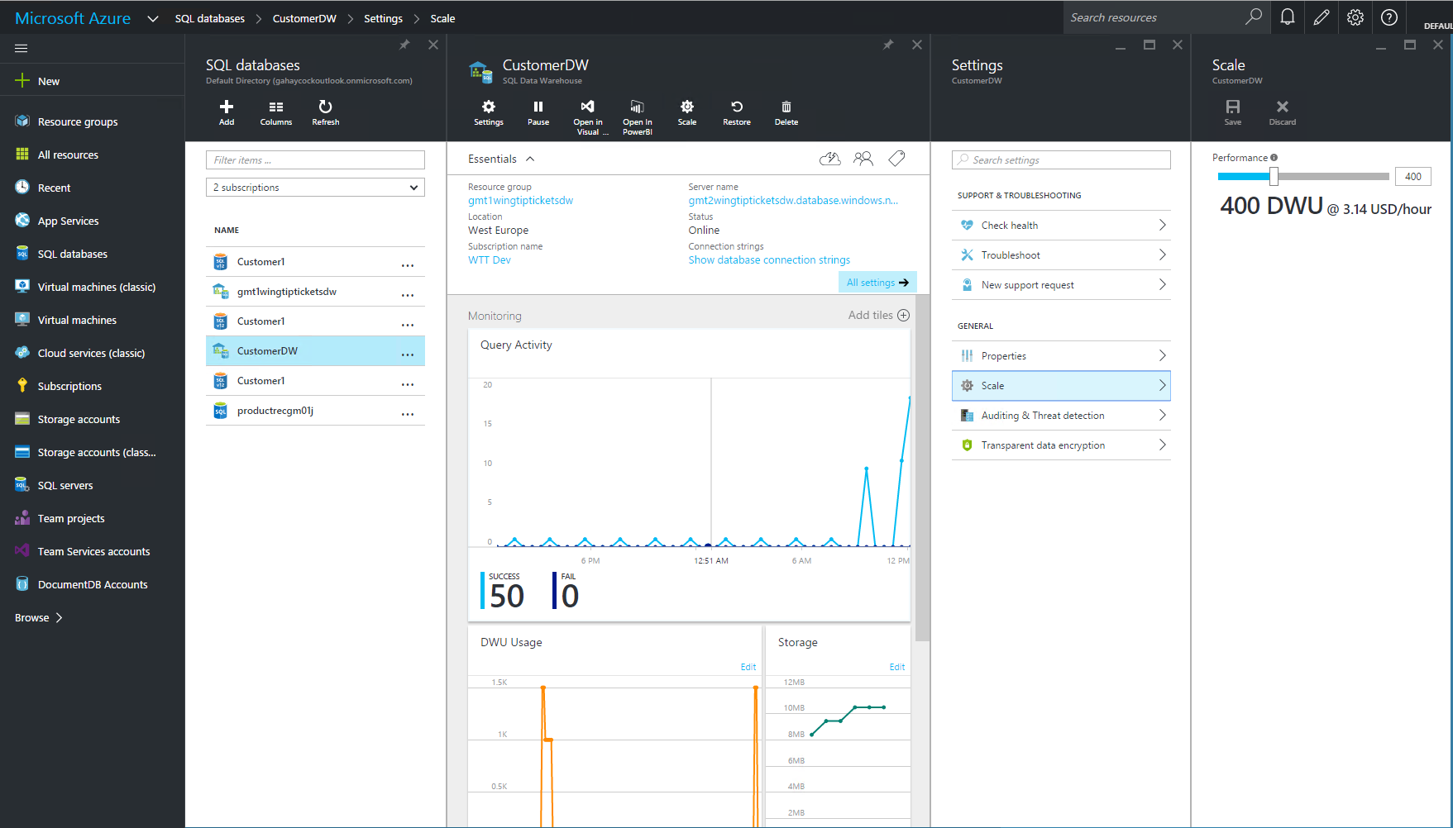  
   **Figure 122** Review the Data Warehouse Units (DWUs)
9. Confirm that the Data Warehouse Units (DWUs) are currently set at 400.
10. Click **Open in Visual Studio**.  
    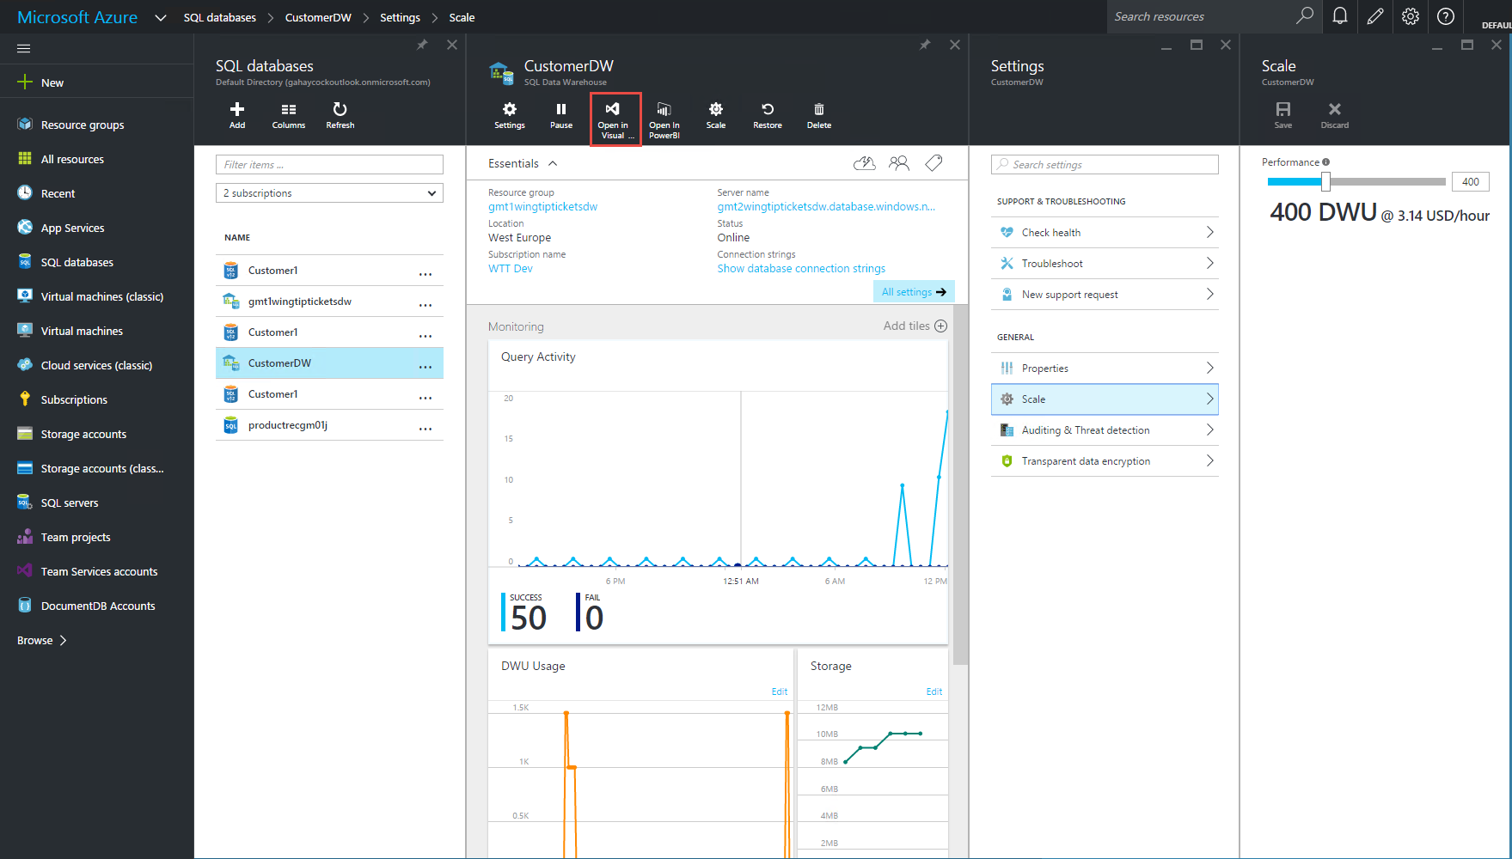  
    **Figure 123** Open Azure SQL Data Warehouse in Visual Studio from the toolbar
11. In the **Open in Visual Studio** pane, click **Open in Visual Studio**.  
    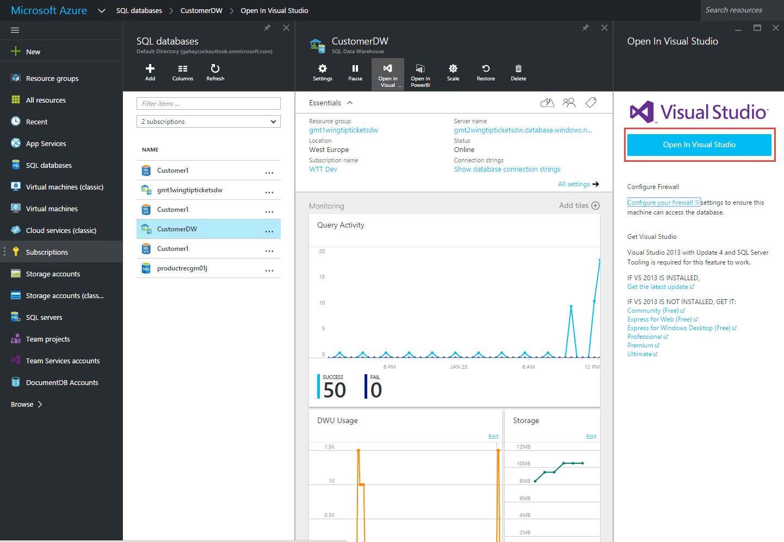  
    ***Figure 124*** *Open Azure SQL Data Warehouse in Visual Studio*
12. Expand the **SQL Server** connection.
13. Right-click **CustomerDW**.
14. Click **New Query**.  
    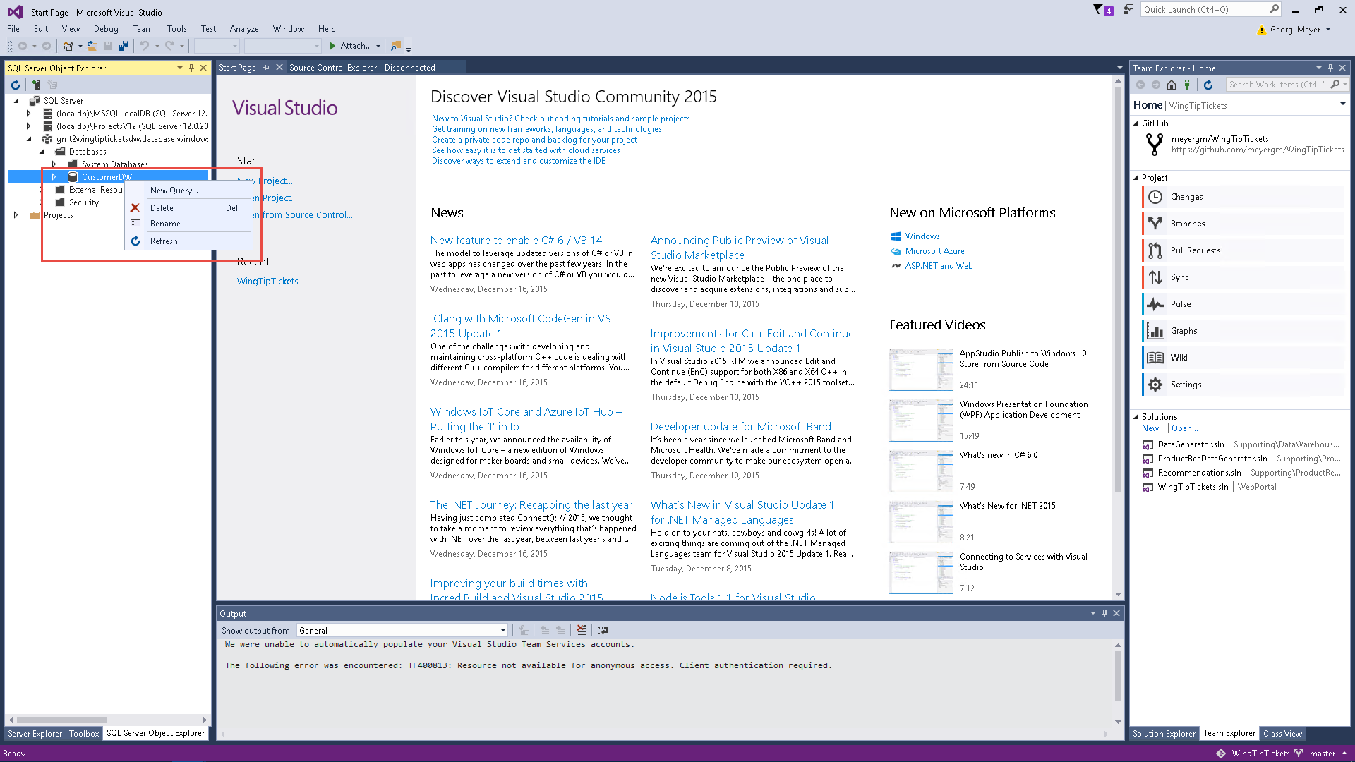  
    ***Figure 125*** *Open a New Query*
15. Run the following query:  
    SELECT

SalesOrderNumber as SalesOrderNumber,

CustomerKey as CustomerKey,

COUNT(OnlineSalesKey) as OnlineSalesKey,

AVG(SalesQuantity) as SalesQuantity,

AVG(SalesAmount) as SalesAmount,

AVG(DiscountAmount) As DiscountAmount,

AVG(DiscountQuantity) As DiscountQuantity,

AVG(UnitCost) as UnitCost,

AVG(UnitPrice) as UnitPrice,

AVG((SalesAmount-DiscountAmount)) As SalesAmountDifference,

AVG((SalesQuantity - DiscountQuantity)) as SalesQuantityDifference

FROM

FactSales

GROUP BY

SalesOrderNumber,

CustomerKey

HAVING

AVG(SalesQuantity) > 2  
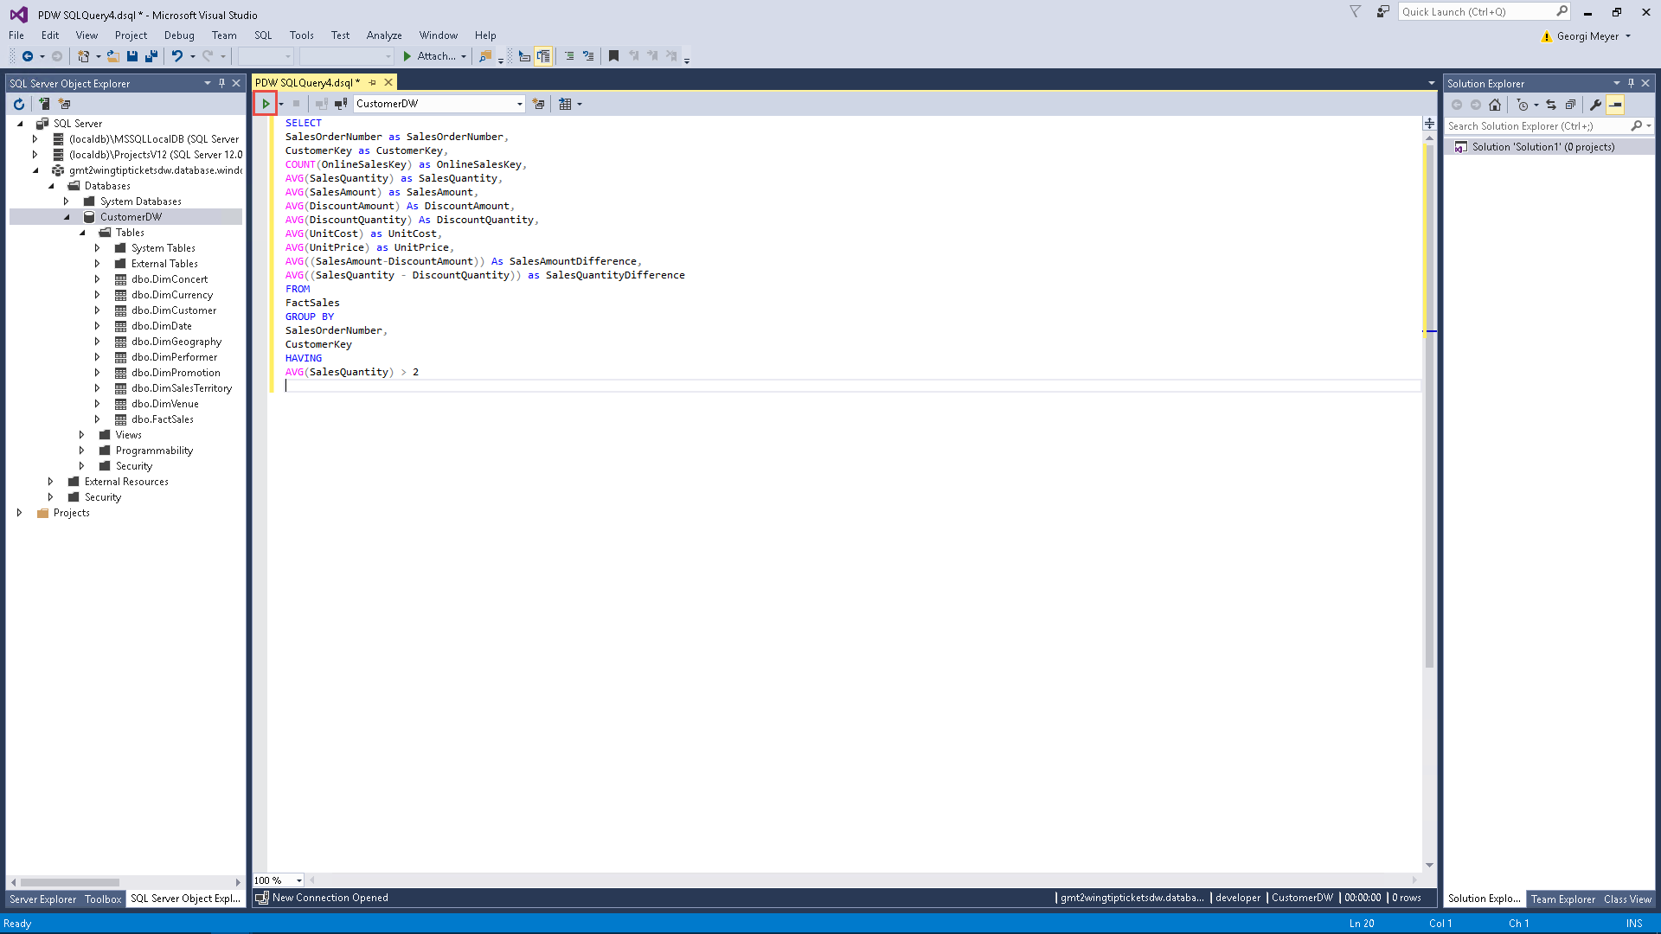

***Figure 126*** *Run a query*

1. Notice how long it takes for the query to run.
2. Return to <https://portal.azure.com>.
3. Click the **CustomerDW** SQL database.
4. Click **Monitoring**, and then review the **Progress** column.  
   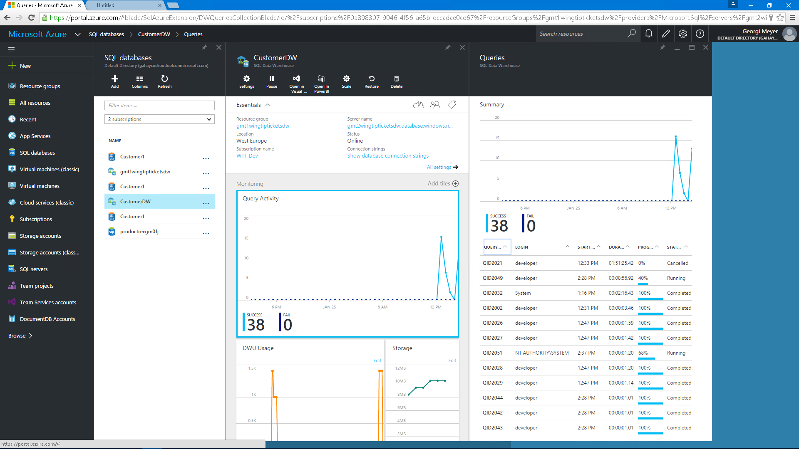  
   ***Figure 127*** *Review Azure SQL Data Warehouse monitoring*
5. During the Customer table-creation process, review the workload through Dynamic Management Views (DMVs).
6. Right-click **CustomerDW**.
7. Click **New Query**.
8. Copy and paste the following query to retrieve information about the connections to the Azure SQL Data Warehouse database:  
   SELECT * FROM sys.dm_pdw_nodes_exec_connections;

SELECT * FROM sys.dm_pdw_nodes_exec_sessions;  
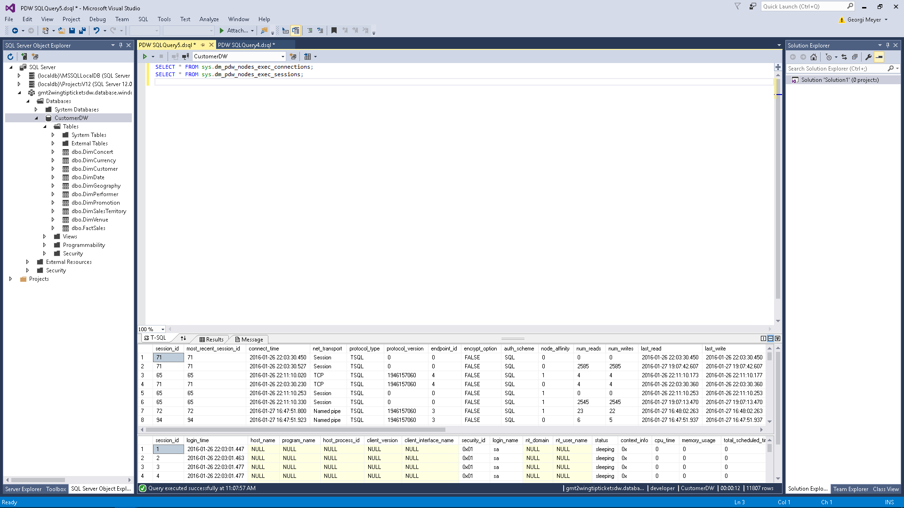  
***Figure 128*** *Execute connected sessions SQL Query*

1. Copy and paste the following query to retrieve information about the current connection to the database:  
   SELECT *

FROM sys.dm_pdw_nodes_exec_connections AS c

JOIN sys.dm_pdw_nodes_exec_sessions AS s

ON c.session_id = s.session_id

WHERE c.session_id = @@SPID;  
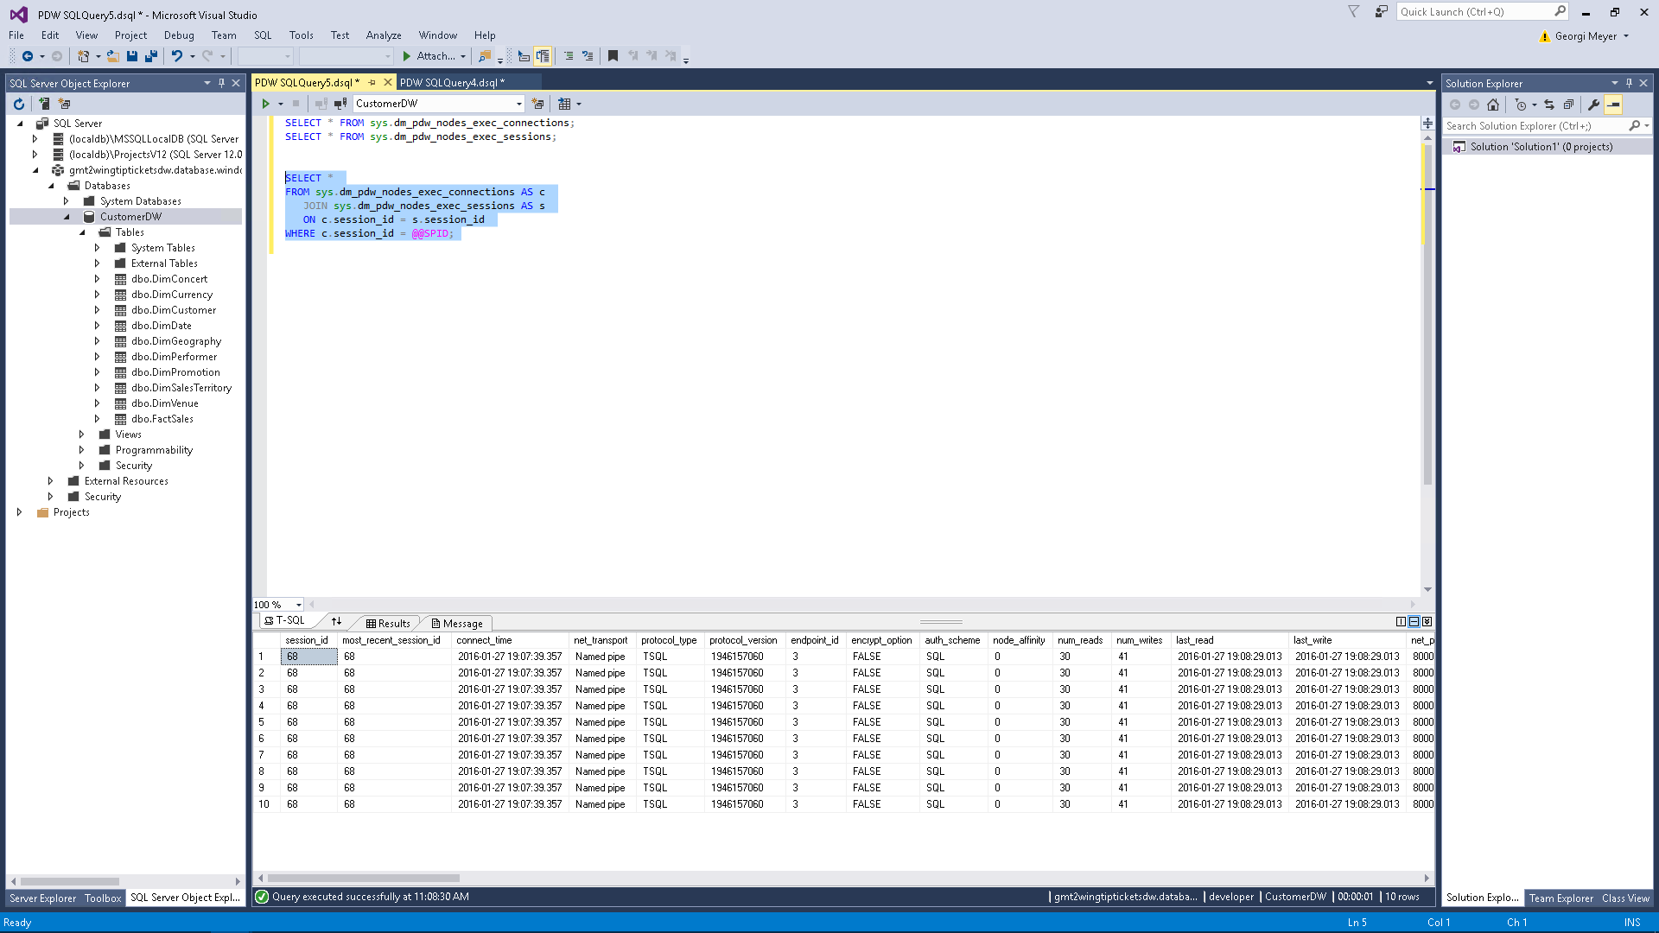  
***Figure 129*** *Execute current connected sessions SQL Query*

1. Copy and paste the following query to review running queries:  
   SELECT * FROM sys.dm_pdw_exec_requests WHERE status = 'Running';

SELECT * FROM sys.dm_pdw_exec_requests ORDER BY total_elapsed_time DESC;  
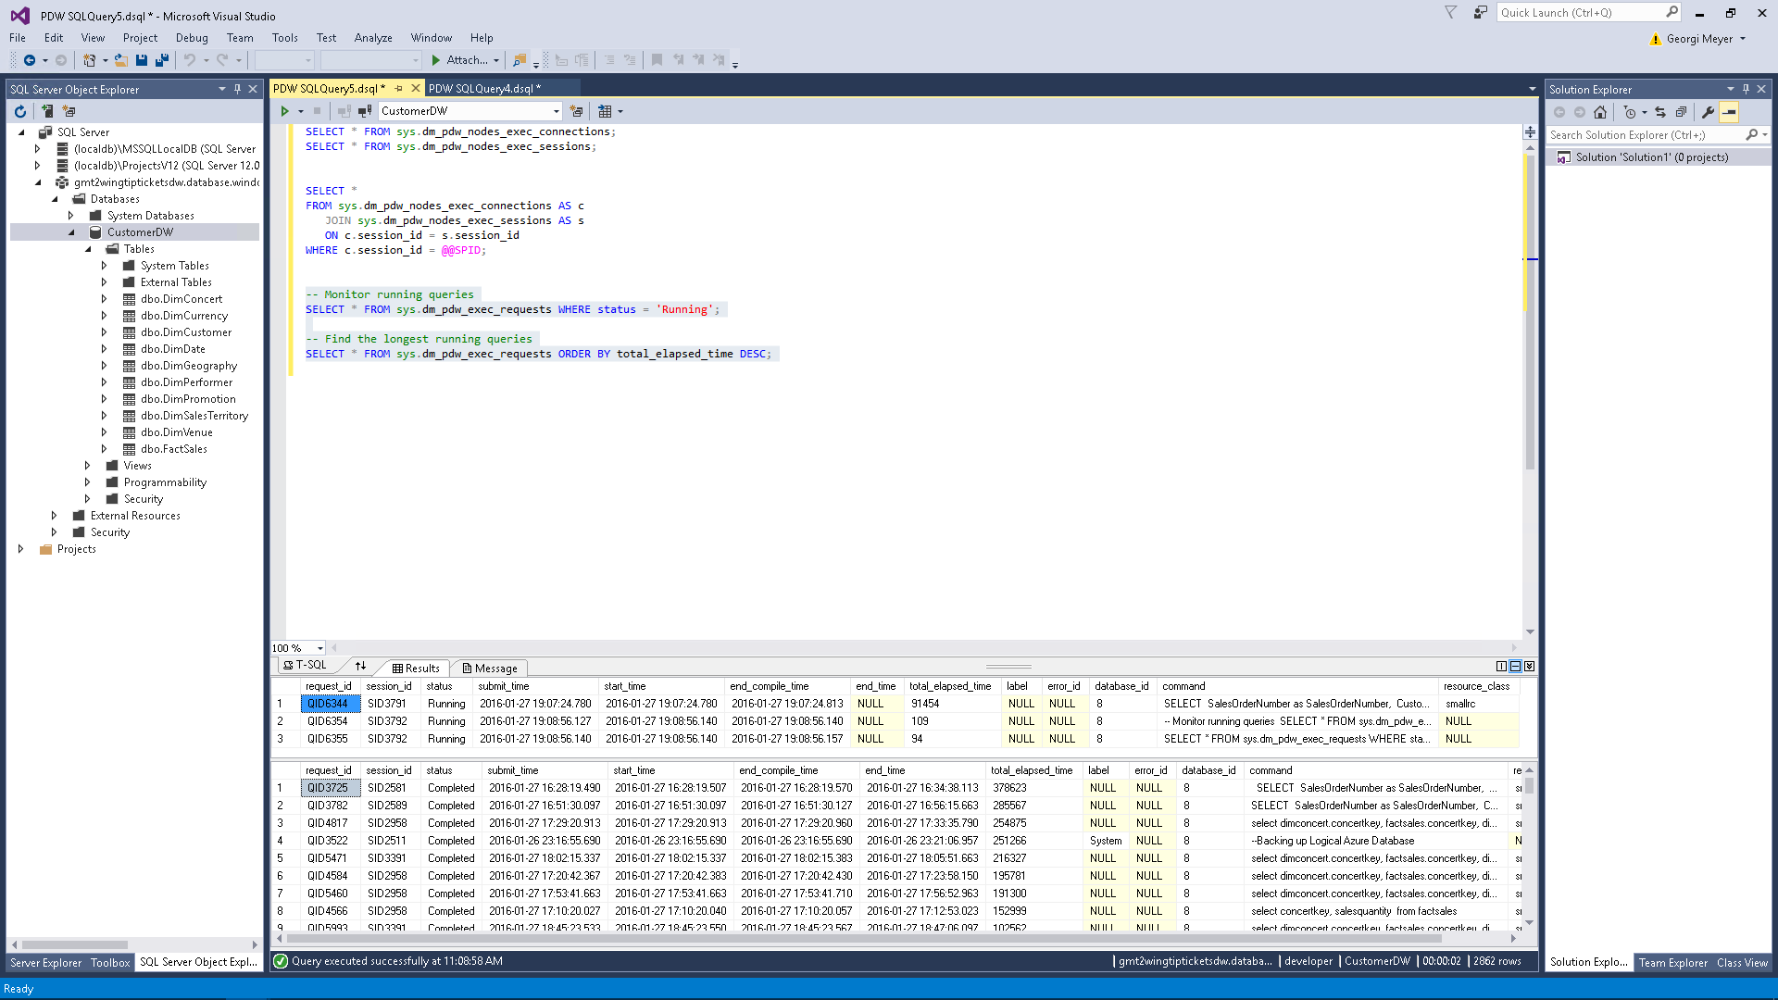  
***Figure 130*** *Execute longest running queries SQL Query*

1. Copy and paste the following query to review if the running query is waiting for resources. If the query is waiting, the state will display AcquireResources; if the query has the resources needed to run, the state will display Granted.

SELECT waits.session_id,

waits.request_id,

requests.command,

requests.status,

requests.start_time,

waits.type,

waits.object_type,

waits.object_name,

waits.state

FROM sys.dm_pdw_waits waits

JOIN sys.dm_pdw_exec_requests requests

ON waits.request_id=requests.request_id

ORDER BY waits.object_name, waits.object_type, waits.state;  
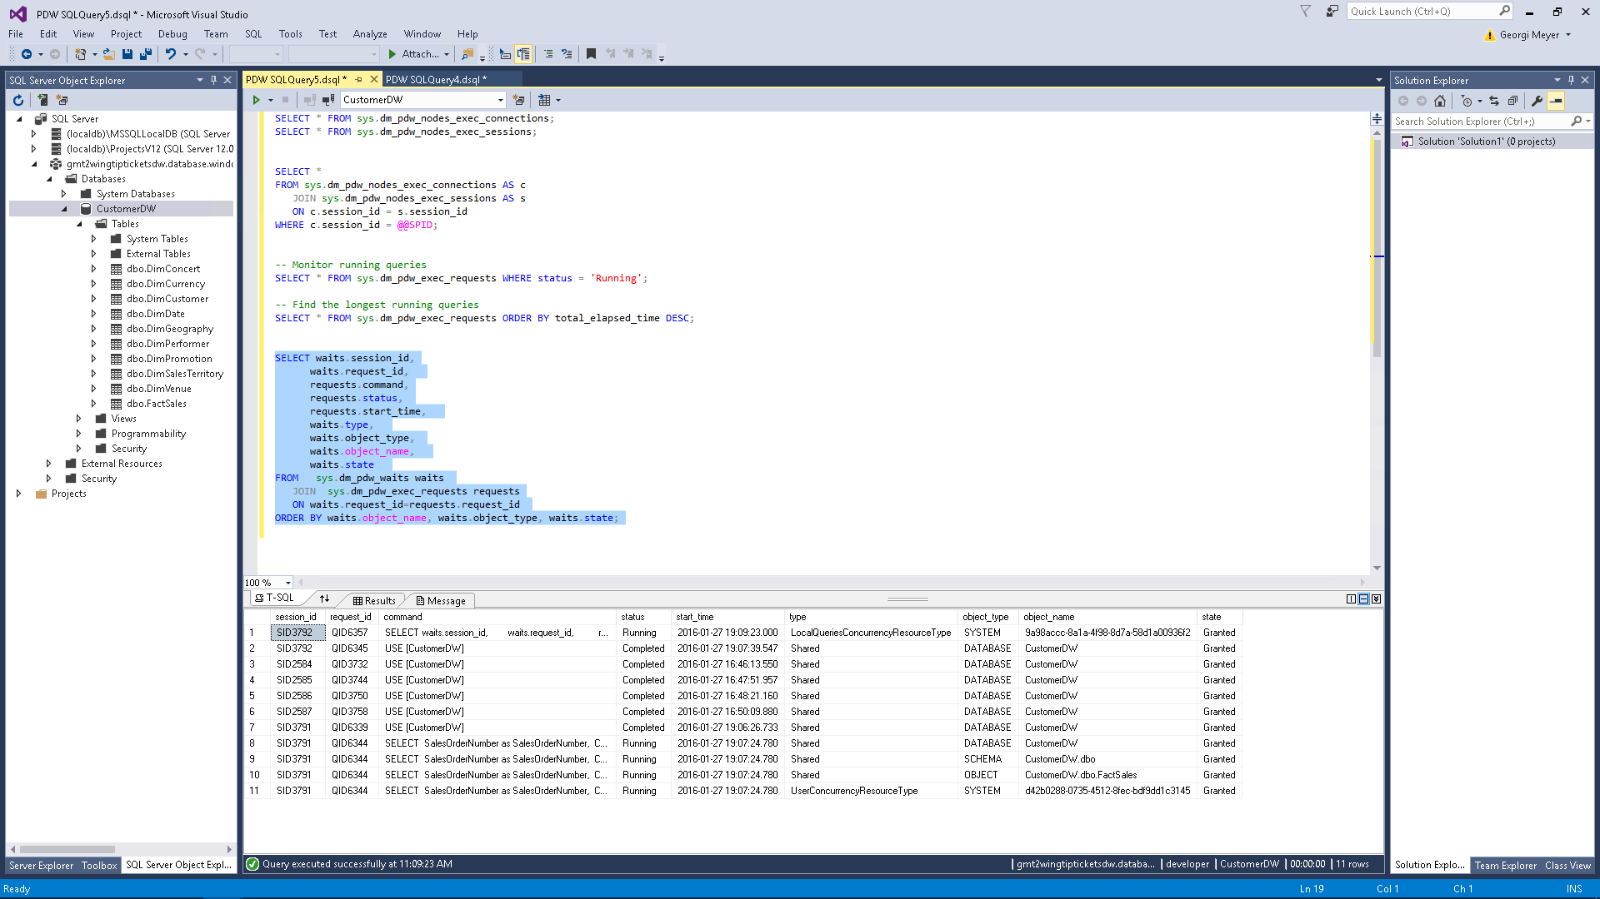  
***Figure 131*** *Execute current waiting queries SQL Query*

1. Copy and paste the following query to view the long-running step in the query. From step 25, review the longest query by looking at the **total_elapsed_time** column.

SELECT * FROM sys.dm_pdw_request_steps

WHERE request_id = 'QID<request_ID Number>'

ORDER BY step_index;  
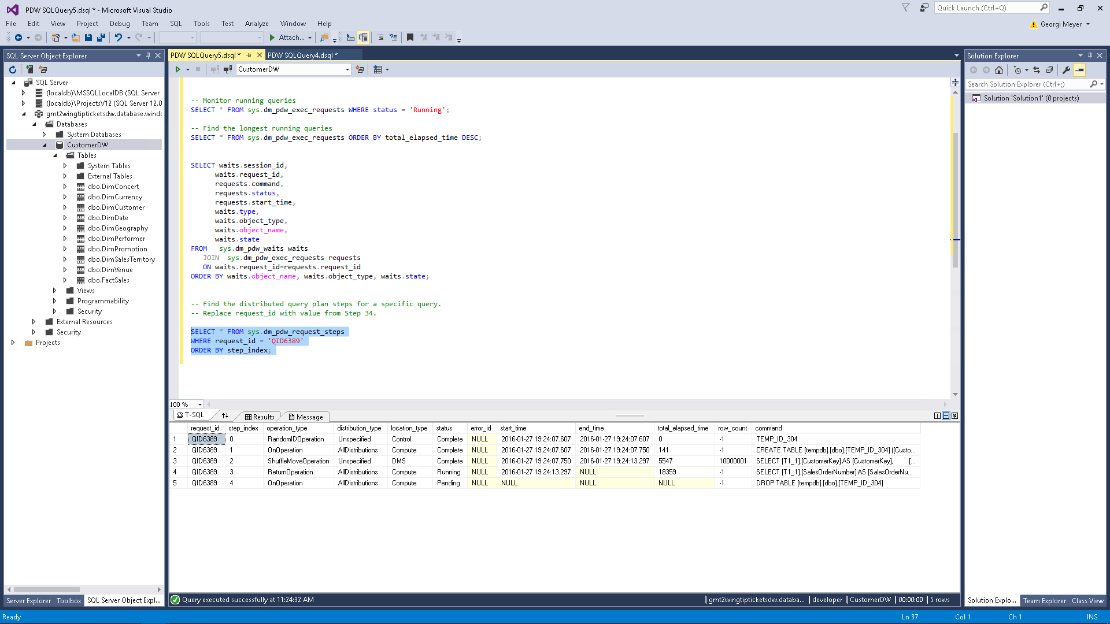  
***Figure 132*** *Execute longest running query for specific query id SQL Query*

1. Copy and paste the following query to view the long-running step in the query. From step 27, review the longest query by looking at the **total_elapsed_time** column.

SELECT * FROM sys.dm_pdw_sql_requests

WHERE request_id = 'QID<request_ID Number>' AND step_index = <Step Index>;  
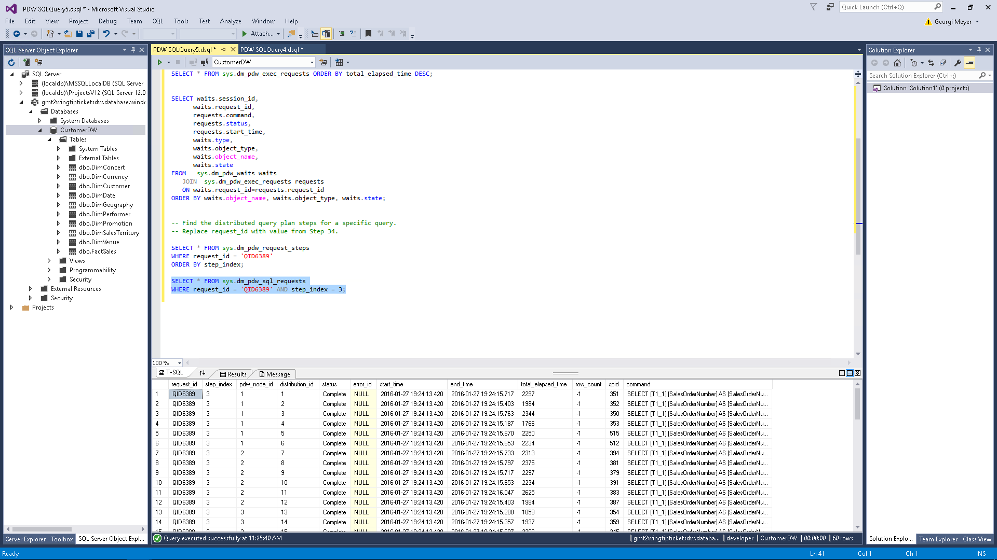  
***Figure 133*** *Execute step index query SQL Query*

1. Click **All Settings**.
2. Click **Scale**.
3. Upgrade the **DWUs** to **1000**.  
   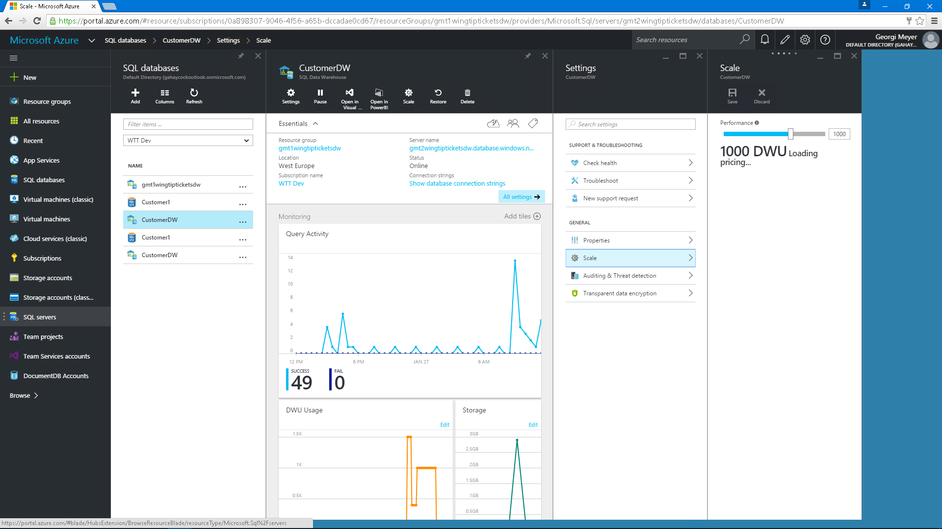  
   ***Figure 134*** *Scale Azure SQL Data Warehouse Units*
4. Return to Visual Studio.
5. Run the following query:  
   SELECT

SalesOrderNumber as SalesOrderNumber,

CustomerKey as CustomerKey,

COUNT(OnlineSalesKey) as OnlineSalesKey,

AVG(SalesQuantity) as SalesQuantity,

AVG(SalesAmount) as SalesAmount,

AVG(DiscountAmount) As DiscountAmount,

AVG(DiscountQuantity) As DiscountQuantity,

AVG(UnitCost) as UnitCost,

AVG(UnitPrice) as UnitPrice,

AVG((SalesAmount-DiscountAmount)) As SalesAmountDifference,

AVG((SalesQuantity - DiscountQuantity)) as SalesQuantityDifference

FROM

FactSales

GROUP BY

SalesOrderNumber,

CustomerKey

HAVING

AVG(SalesQuantity) > 2

1. Notice that the query takes less time than the previous one to run.
2. Right-click **CustomerDW**.
3. Click **New Query**.
4. Open **CreateDimCustomer.sql**.
5. Copy and paste the SQL command into the **New Query** window.
6. Click **Run**.  
   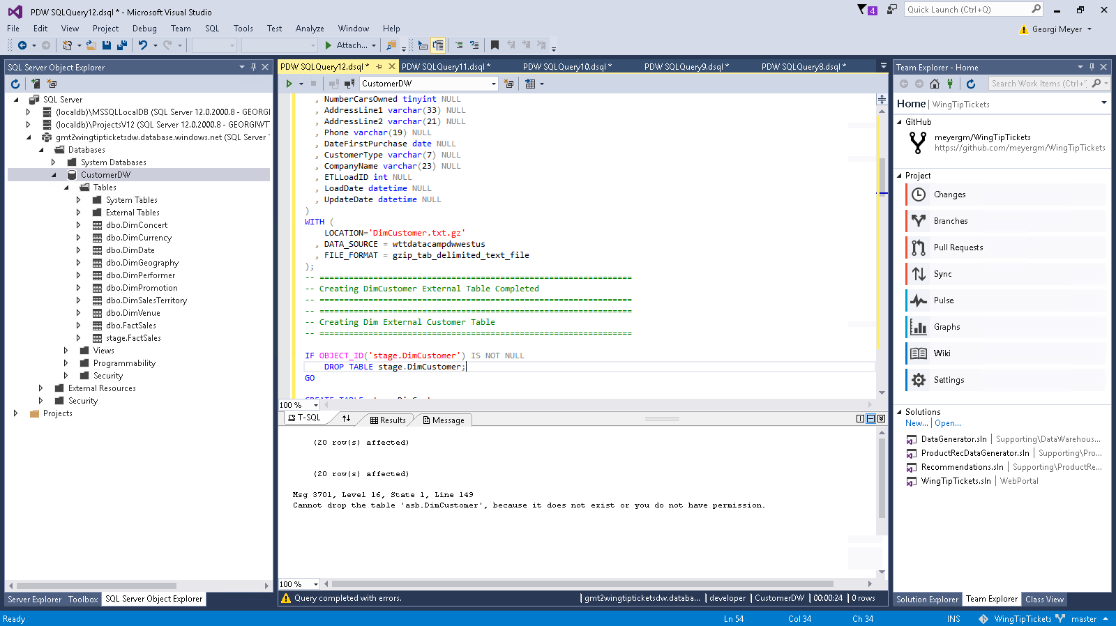  
   ***Figure 135*** *Execute SQL Query*
7. Watch as the Customer table is created and populated with data using Polybase from Azure Storage.
8. Open a **New Query**, and then run the following query to show that the data is loaded:  
   select * from dimcustomer  
   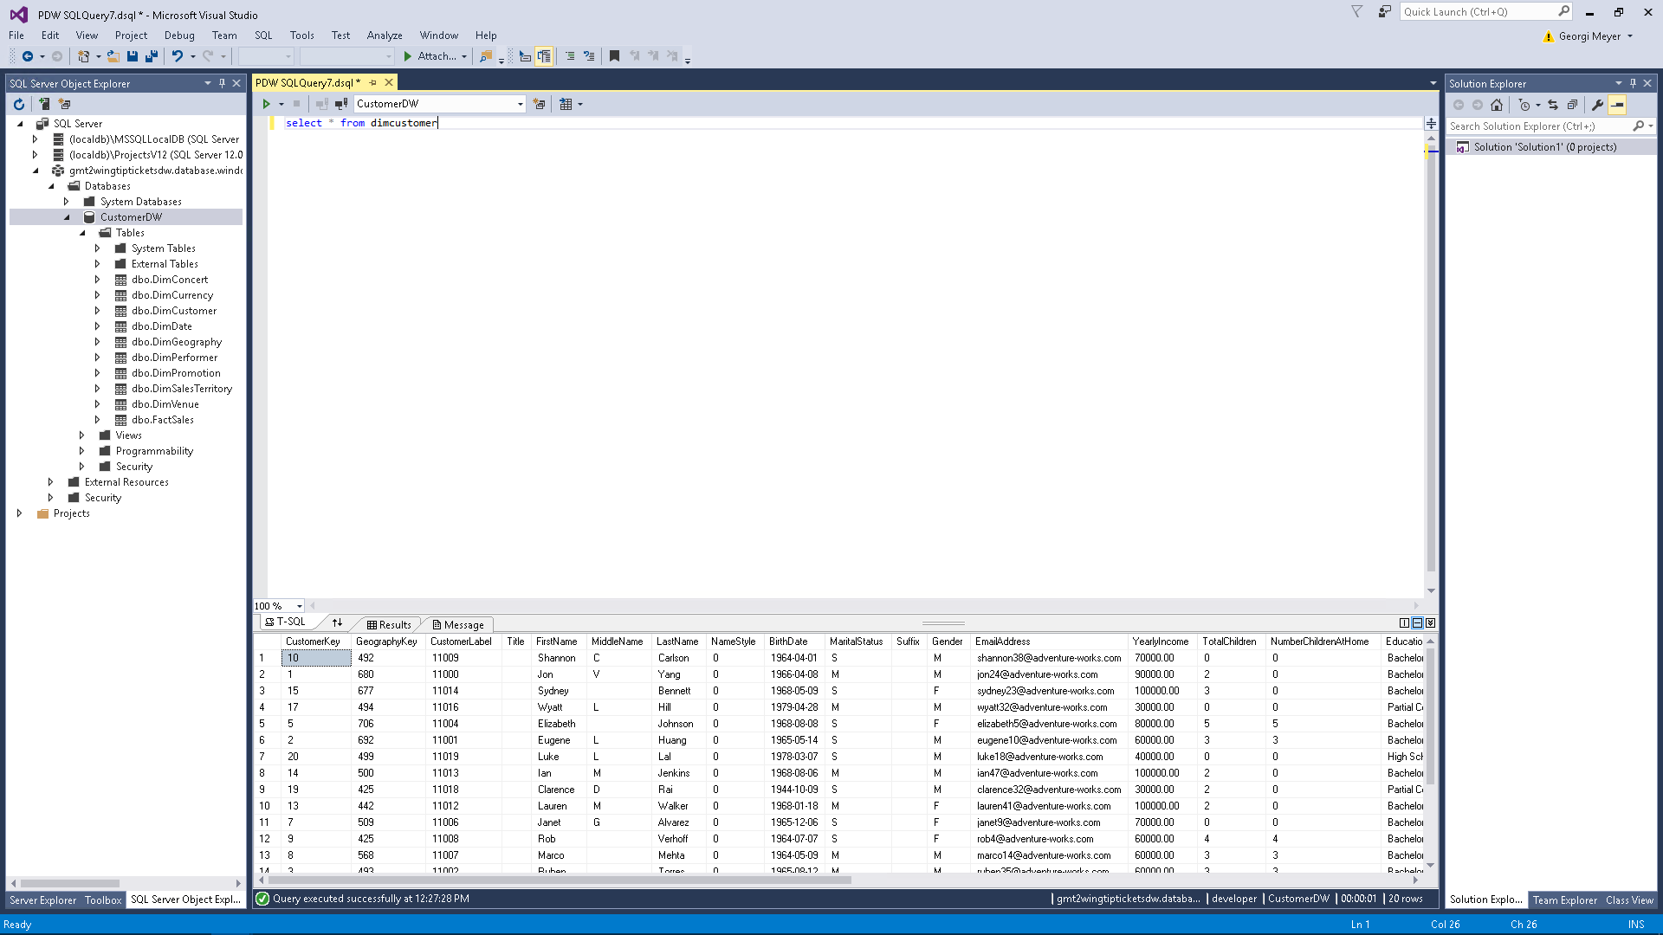  
   ***Figure 136*** *Execute SQL Query*

# Task 14: Power BI

Power BI gives the WingTipTickets administrator the power to visualize the data that is collected from concerts. The administrator can use the Power BI Desktop client to create reports and then publish those to the Power BI online service to share with the users of the WingTipTickets application. The dashboards created can then be embedded into an administrative view of the client web application.

## Task 14 Steps

1. Launch the Power BI Desktop client.
2. Click **Open**.
3. Open **WTTPowerBI.pbix**.
4. Click **Edit Queries**.  
   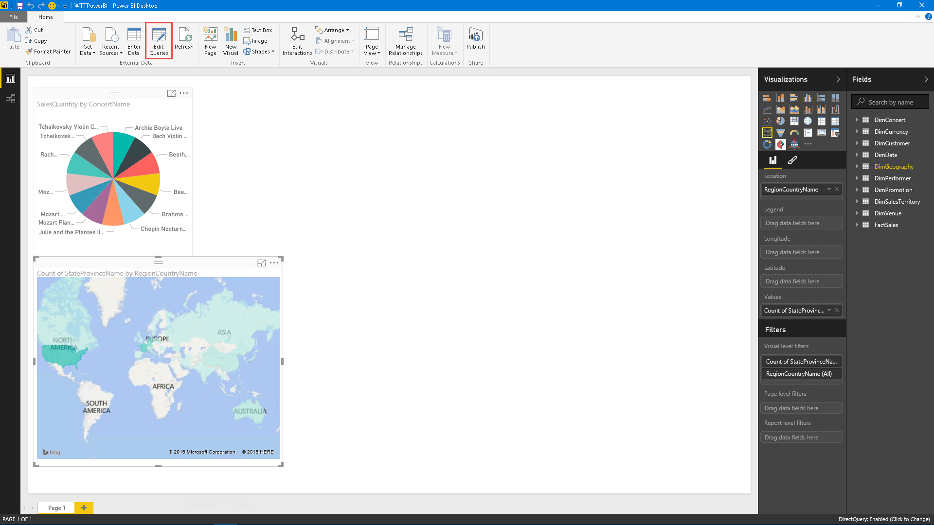 ***Figure 137*** *Power BI edit queries*
5. Beside **Source**, click the gear to edit the SQL Server.  
   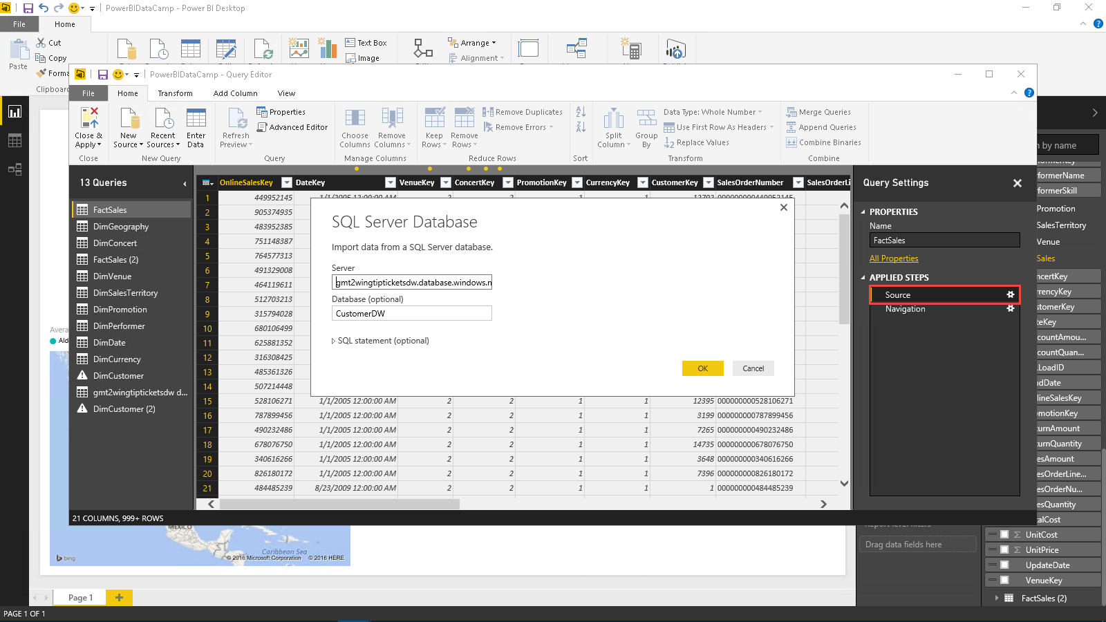  
   ***Figure 138*** *Update SQL Server database name*
6. In the server string, type the primary SQL Server name. In this example, this is *XX00julieandtheplantesprimary.database.windows.net*.
7. Click **OK**.
8. Click **Close & Apply**.
9. Click **Refresh**.
10. The visuals should refresh with the data from the new connection.
11. Expand **DimVenue**, and then select **VenueName**.  
    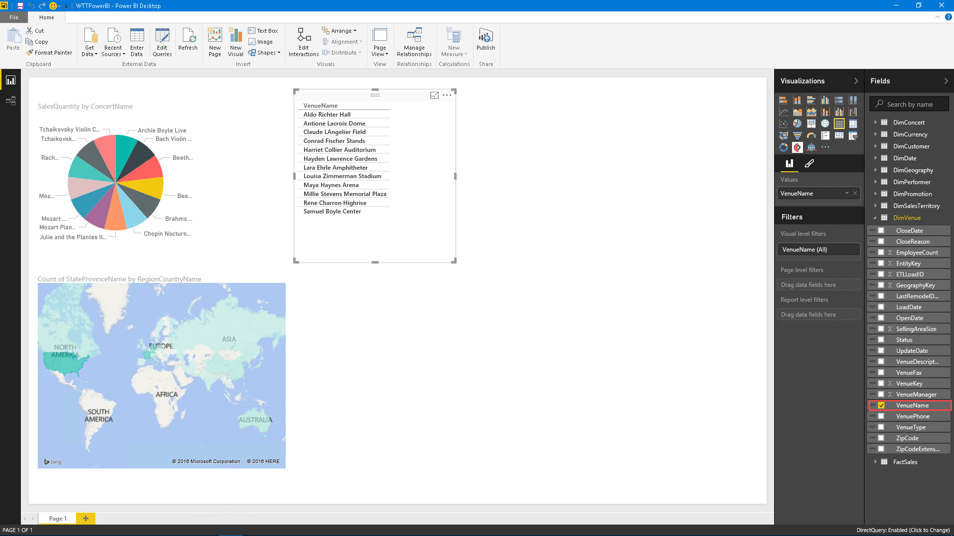  
    ***Figure 139*** *Add VenueName*
12. Expand **FactSales**, and then select **DiscountQuantity**.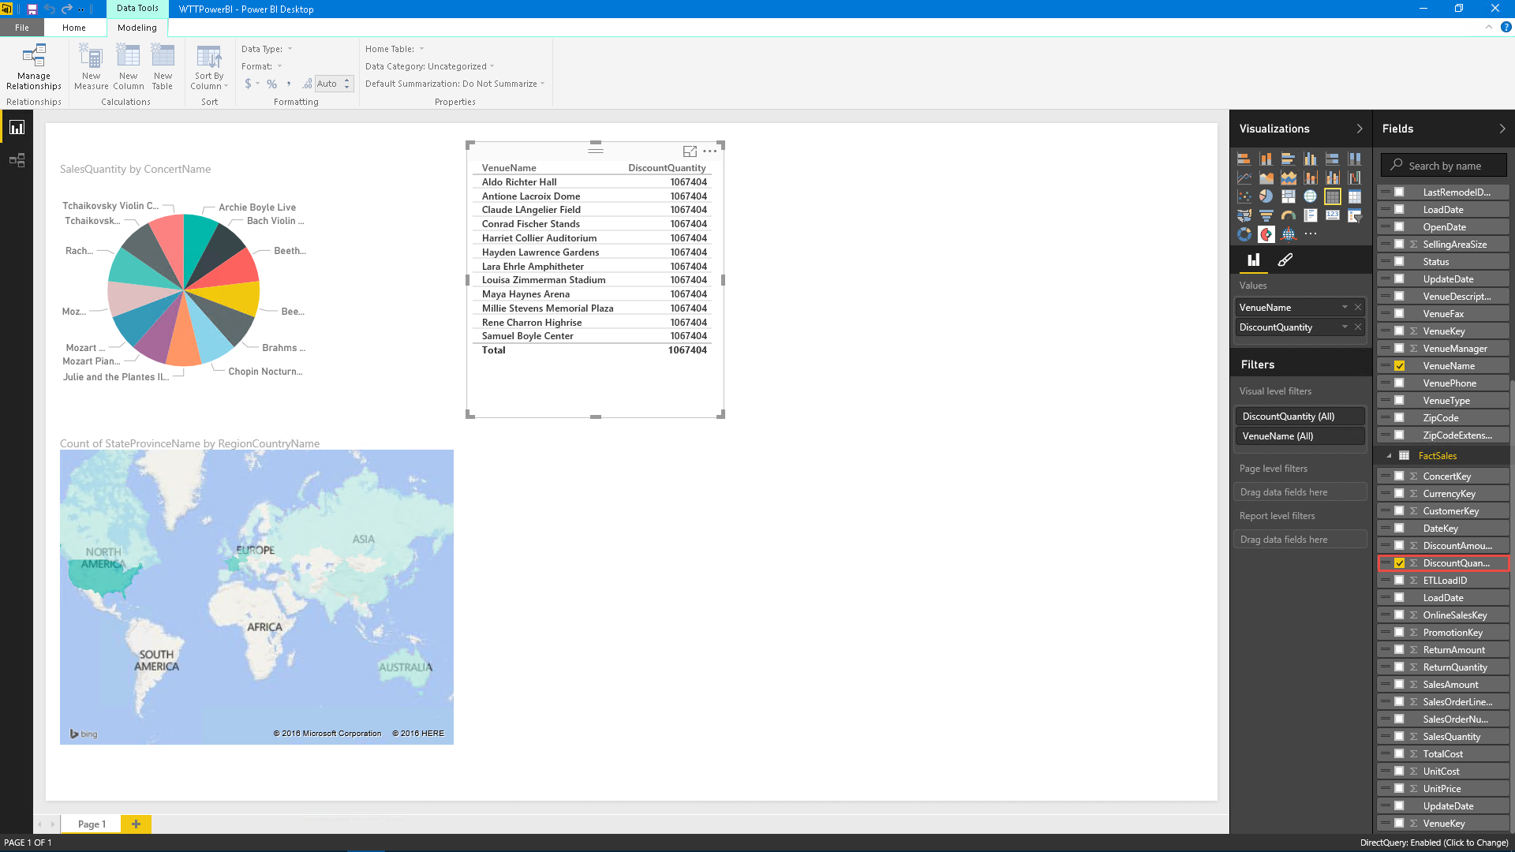 ***Figure 140*** *Add DiscountQuantity*
13. Click the **Treemap** visual.  
    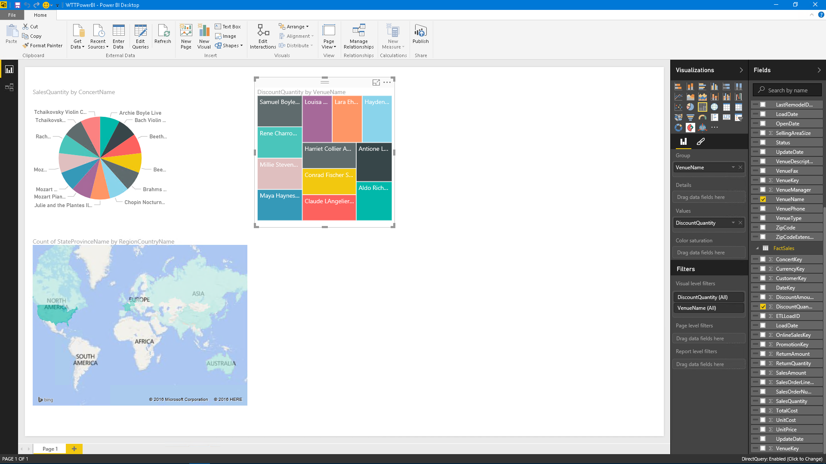  
    ***Figure 141*** *Add visualization*
14. This shows how many discount tickets were sold per venue.
15. Click the white space under the **Treemap** visual.
16. From **DimConcert**, select **ConcertName**.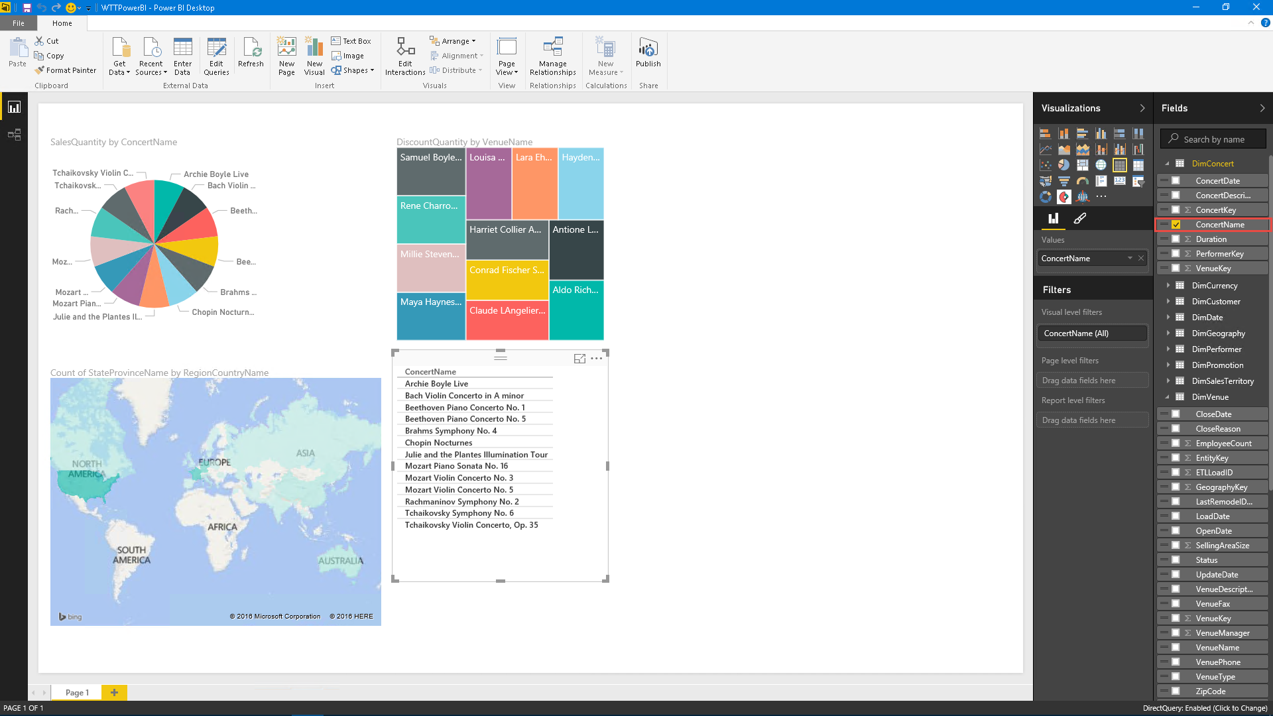 ***Figure 142*** *Add ConcertName*
17. From **FactSales**, select **TotalCost**.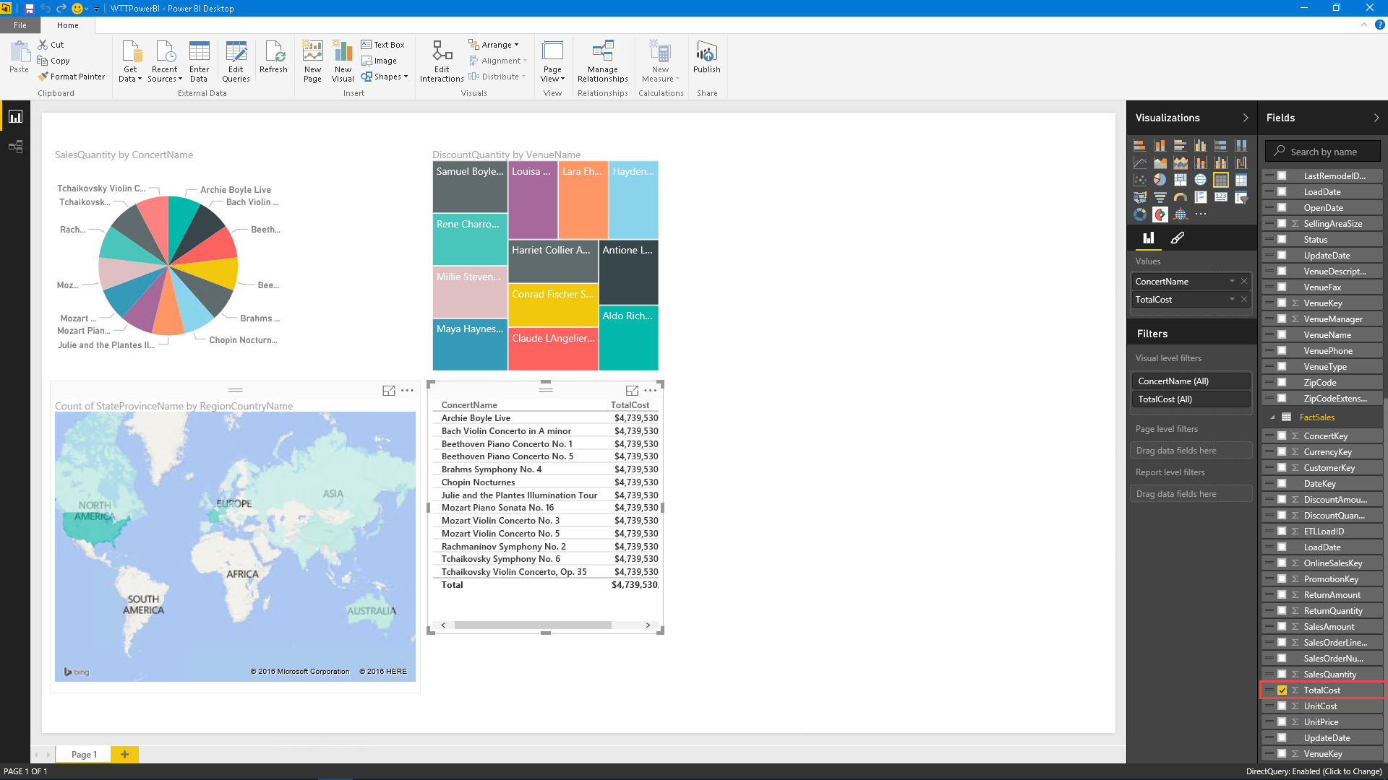 ***Figure 143*** *Add TotalCost*
18. Click the **Donut Chart** visualization.  
    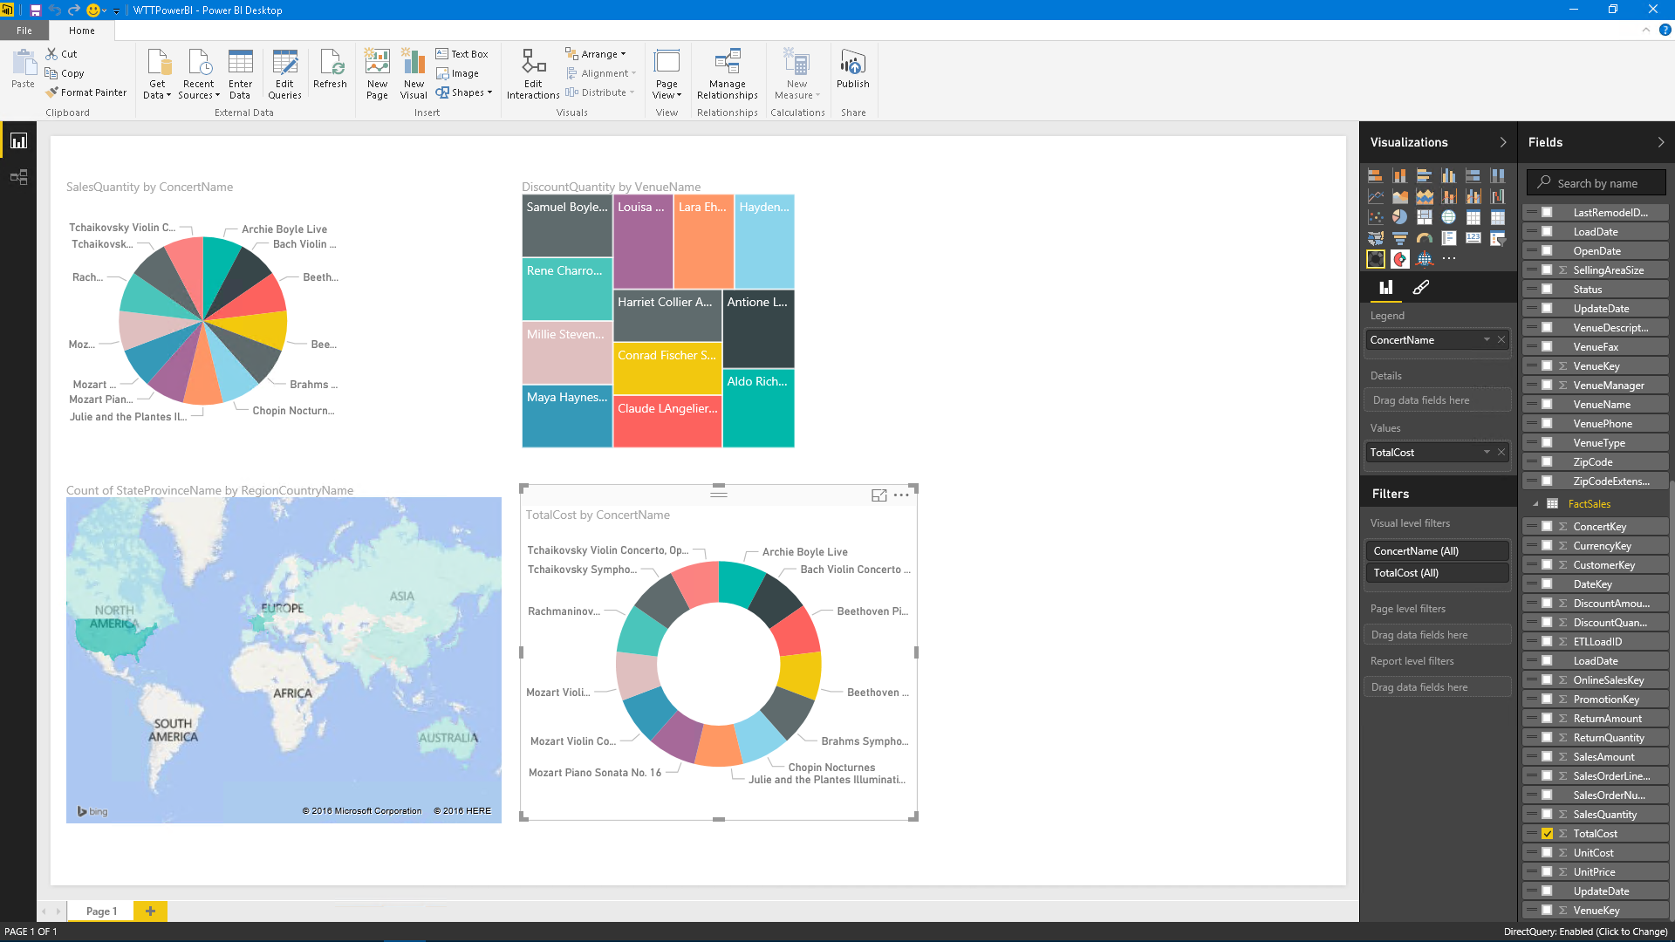  
    ***Figure 144*** *Add visualization*
19. This will show how much revenue the concerts have brought in for the venues.
20. Click **Publish**.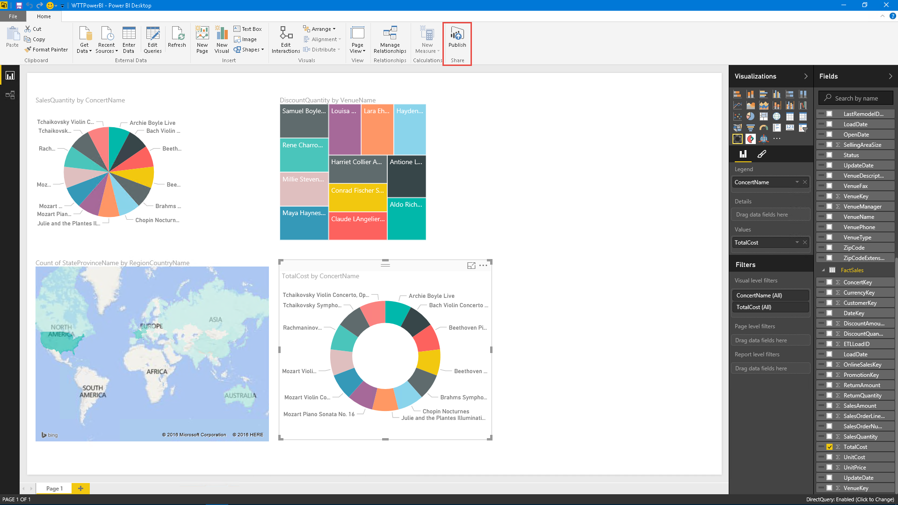 ***Figure 145*** *Publish Power BI report*
21. Click **Sign in**.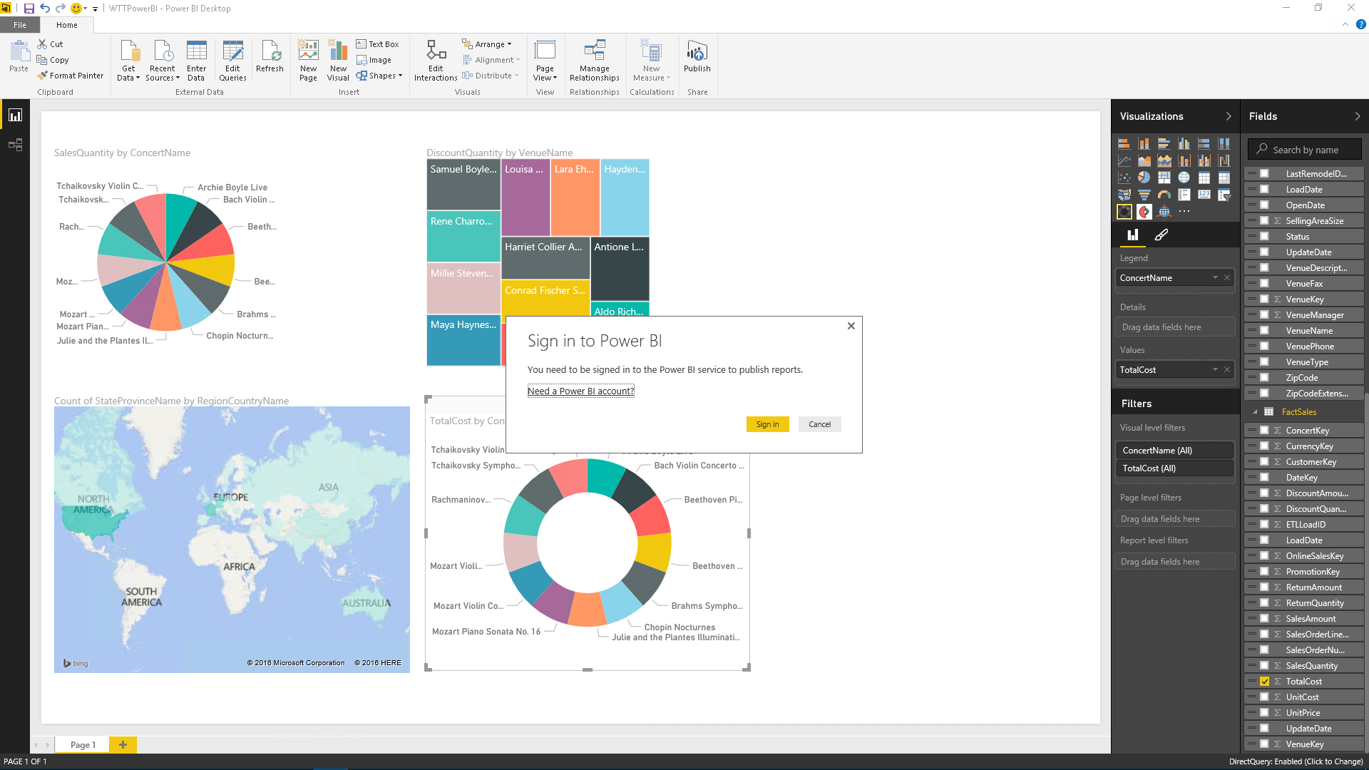 ***Figure 146*** *Sign in to Power BI*
22. Authenticate to the Power BI service by using the configured Power BI account.  
    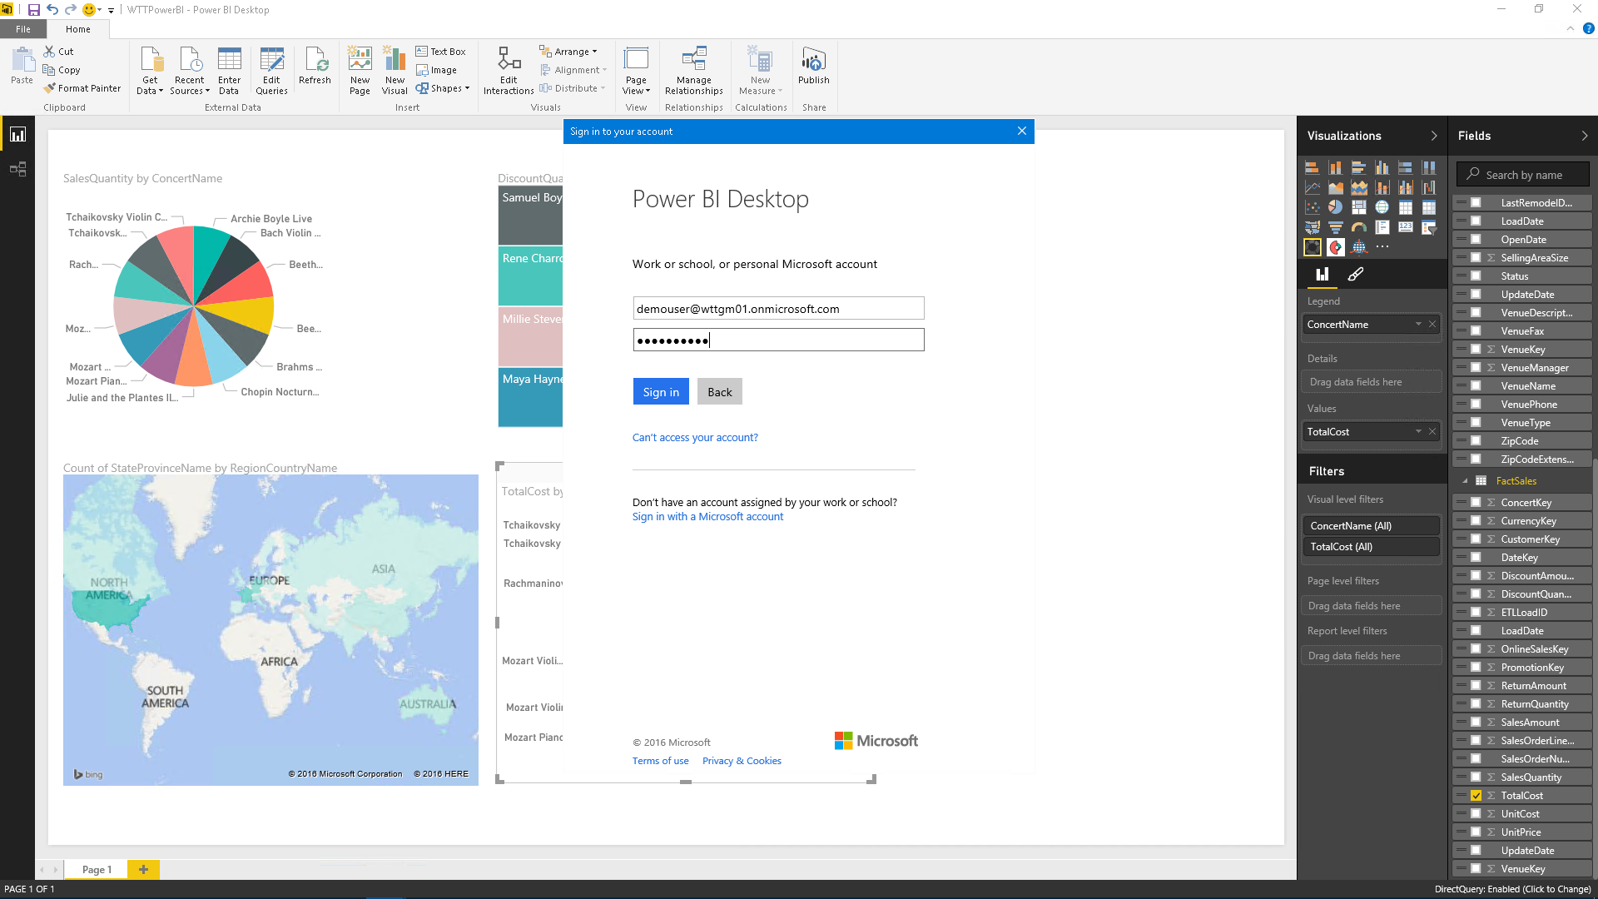  
    ***Figure 147*** *Sign in to Power BI*
23. Click **Open WTTPowerBI.pbix in Power BI**.  
    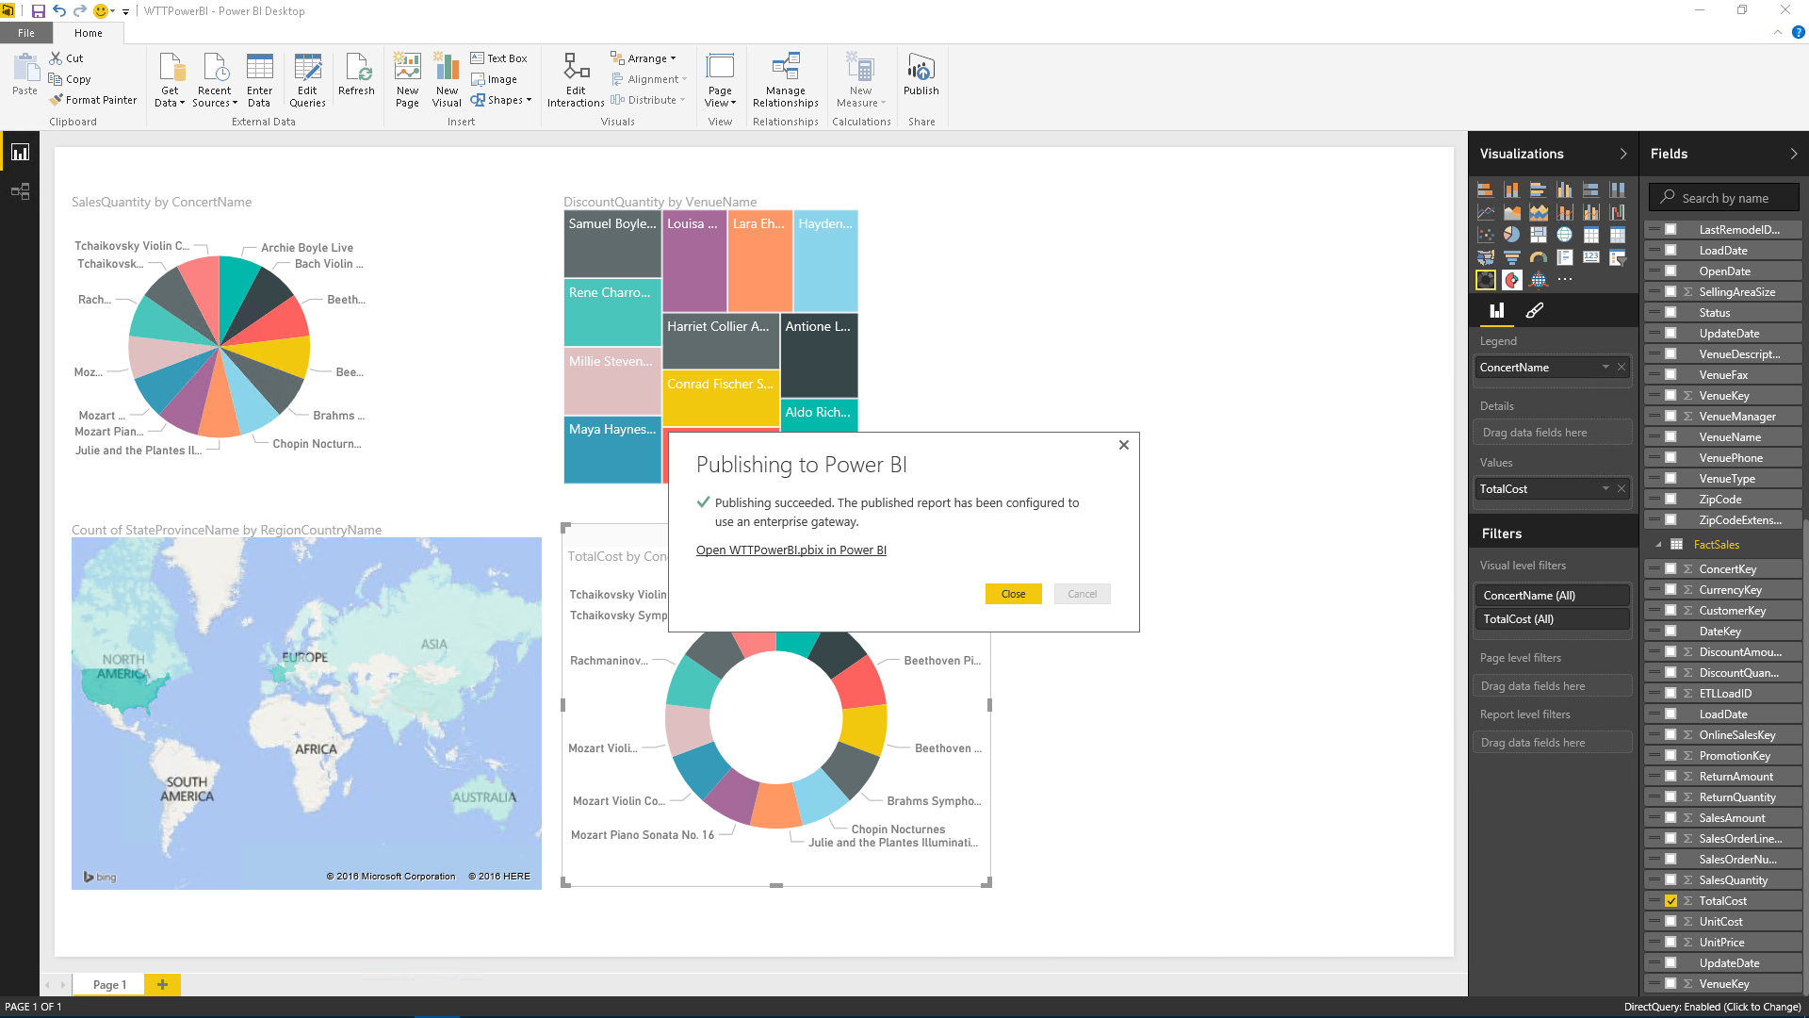  
    ***Figure 148*** *Go to the Power BI web application*
24. If needed, select **Enable Custom Visualizations**.
25. If needed, select **Enter Credentials**
26. The report is now published to Power BI.  
    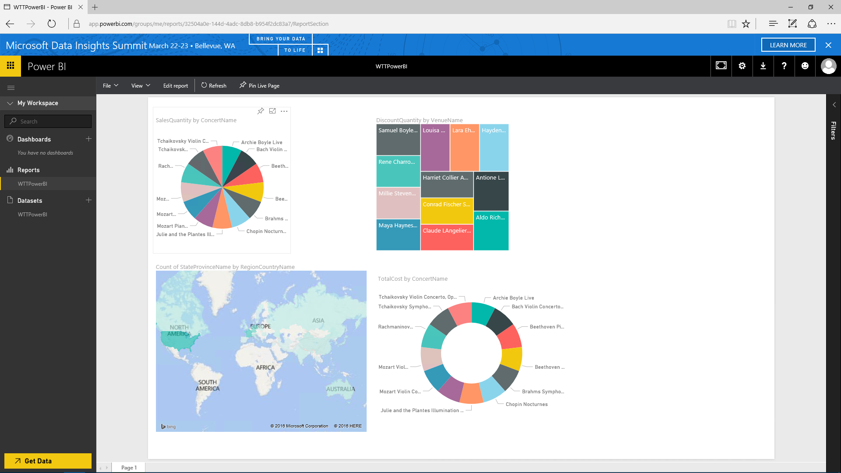  
    ***Figure 149*** *Review Power BI application*
27. Launch Visual Studio.
28. Click **Open Project**.  
    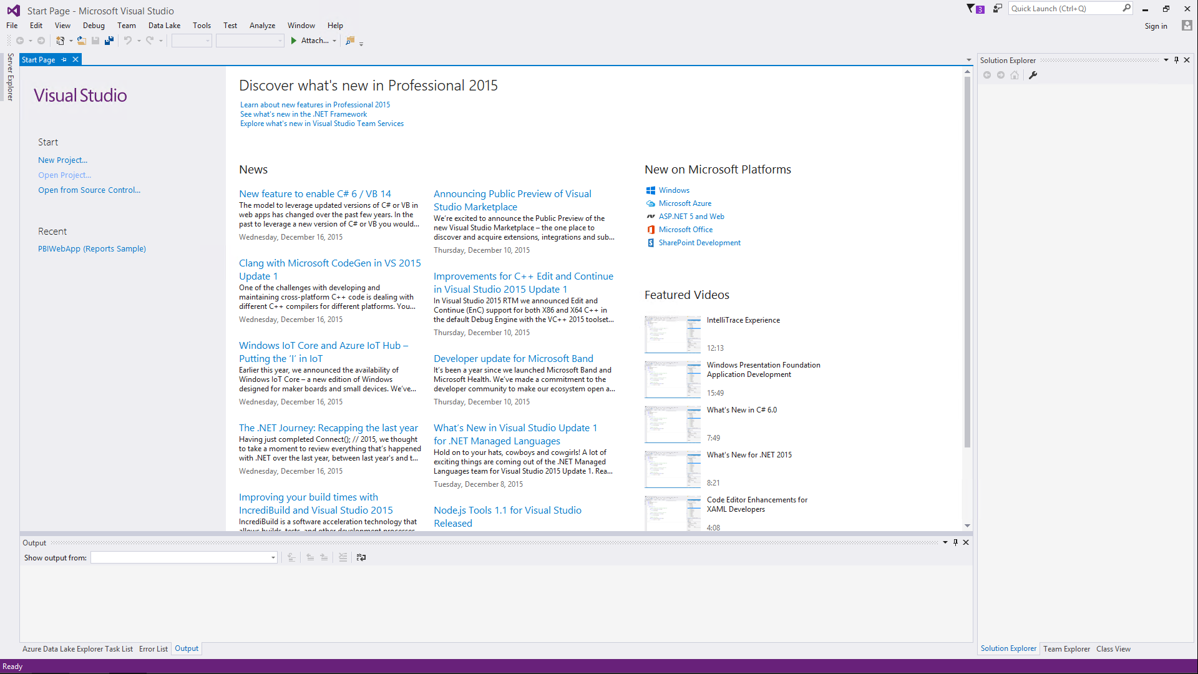  
    ***Figure 150*** *Launch Visual Studio*
29. Locate and open **PBIWebApp (Reports Sample).sln**.  
    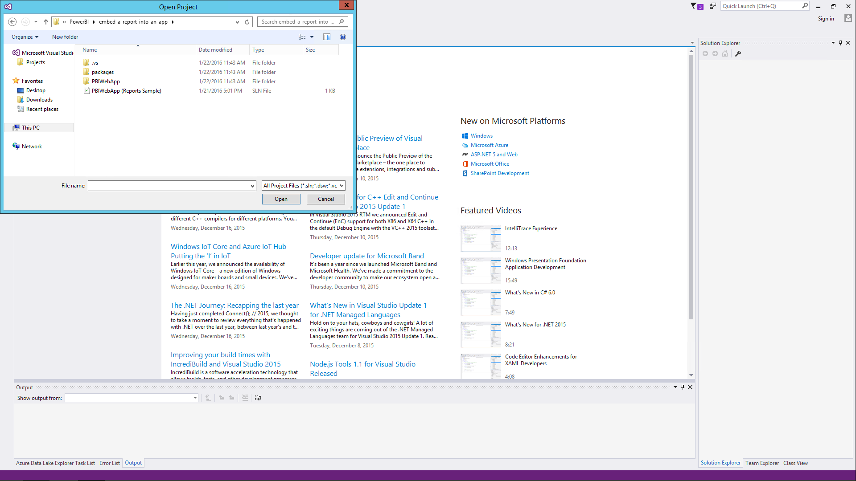  
    ***Figure 151*** *Open PBIWebApp sample*
30. Right-click **PBIWebApp**, and then click **Build**.  
    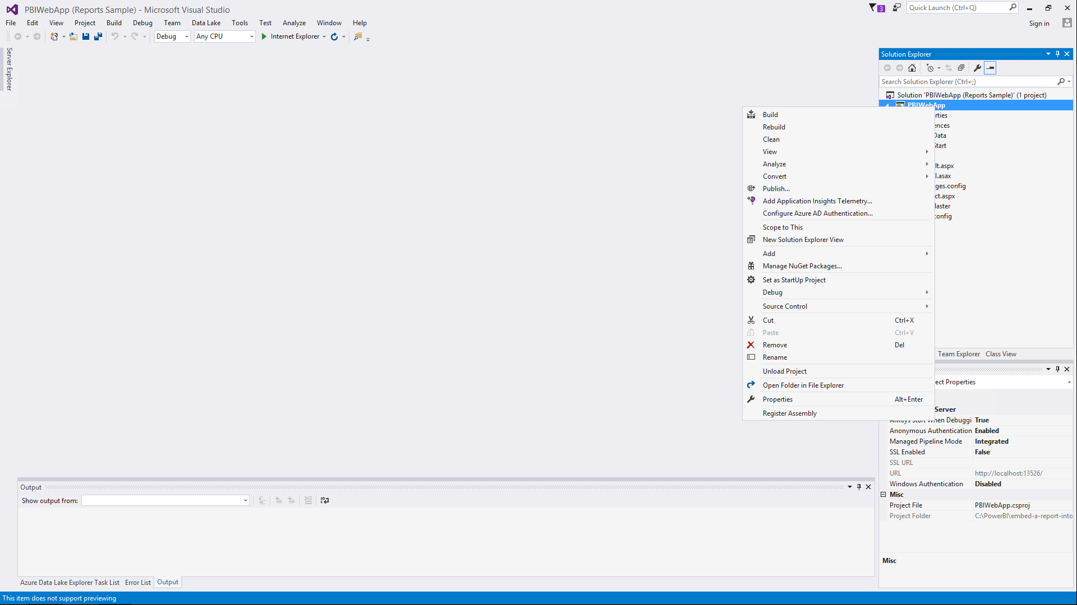  
    ***Figure 152*** *Build the PowerBIWebApp Sample*
31. Click **web.config** to open the file.
32. The following steps will register the application:
    1. Browse to <https://dev.powerbi.com/apps>.
    2. Click **Sign in with your existing account**.
    3. Log on using your existing Power BI credentials.
    4. In the **App Name** field type, **PowerBIWebAppSample**.  
       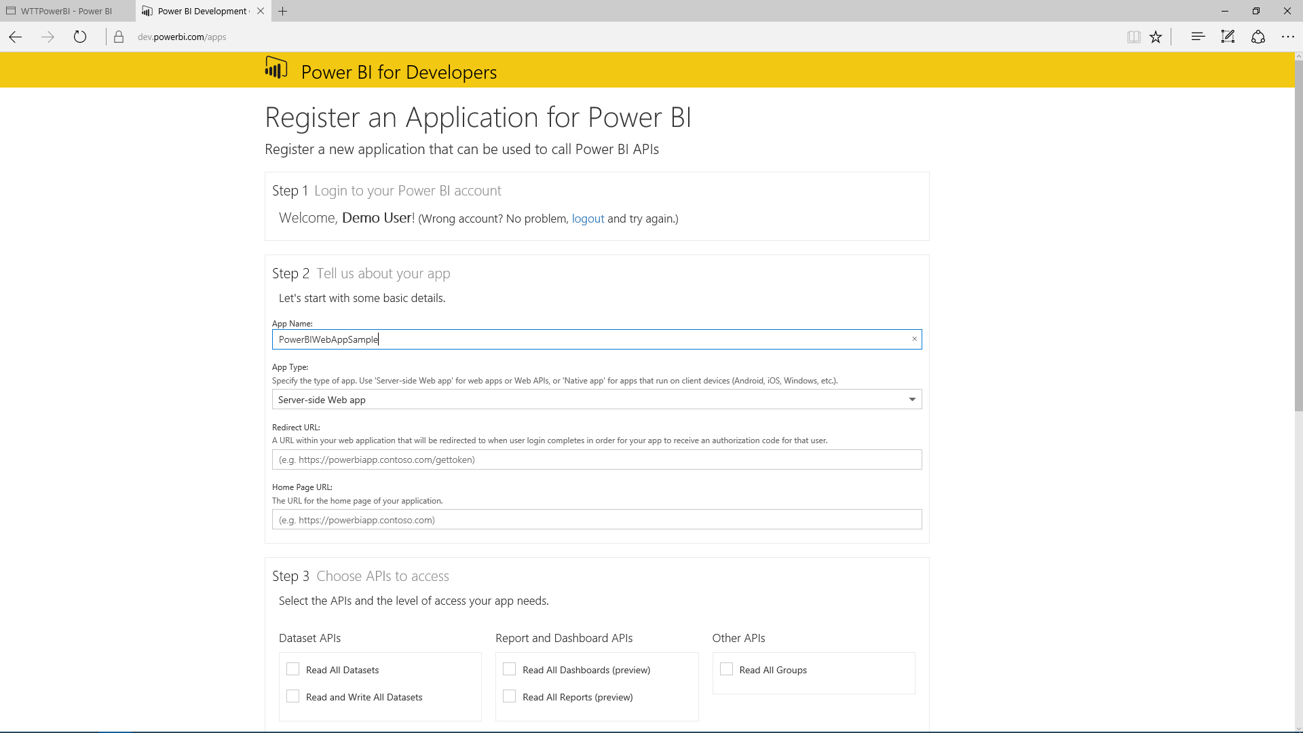  
       ***Figure 153*** *Assign an App Name*
    5. Leave **App Type** as it is.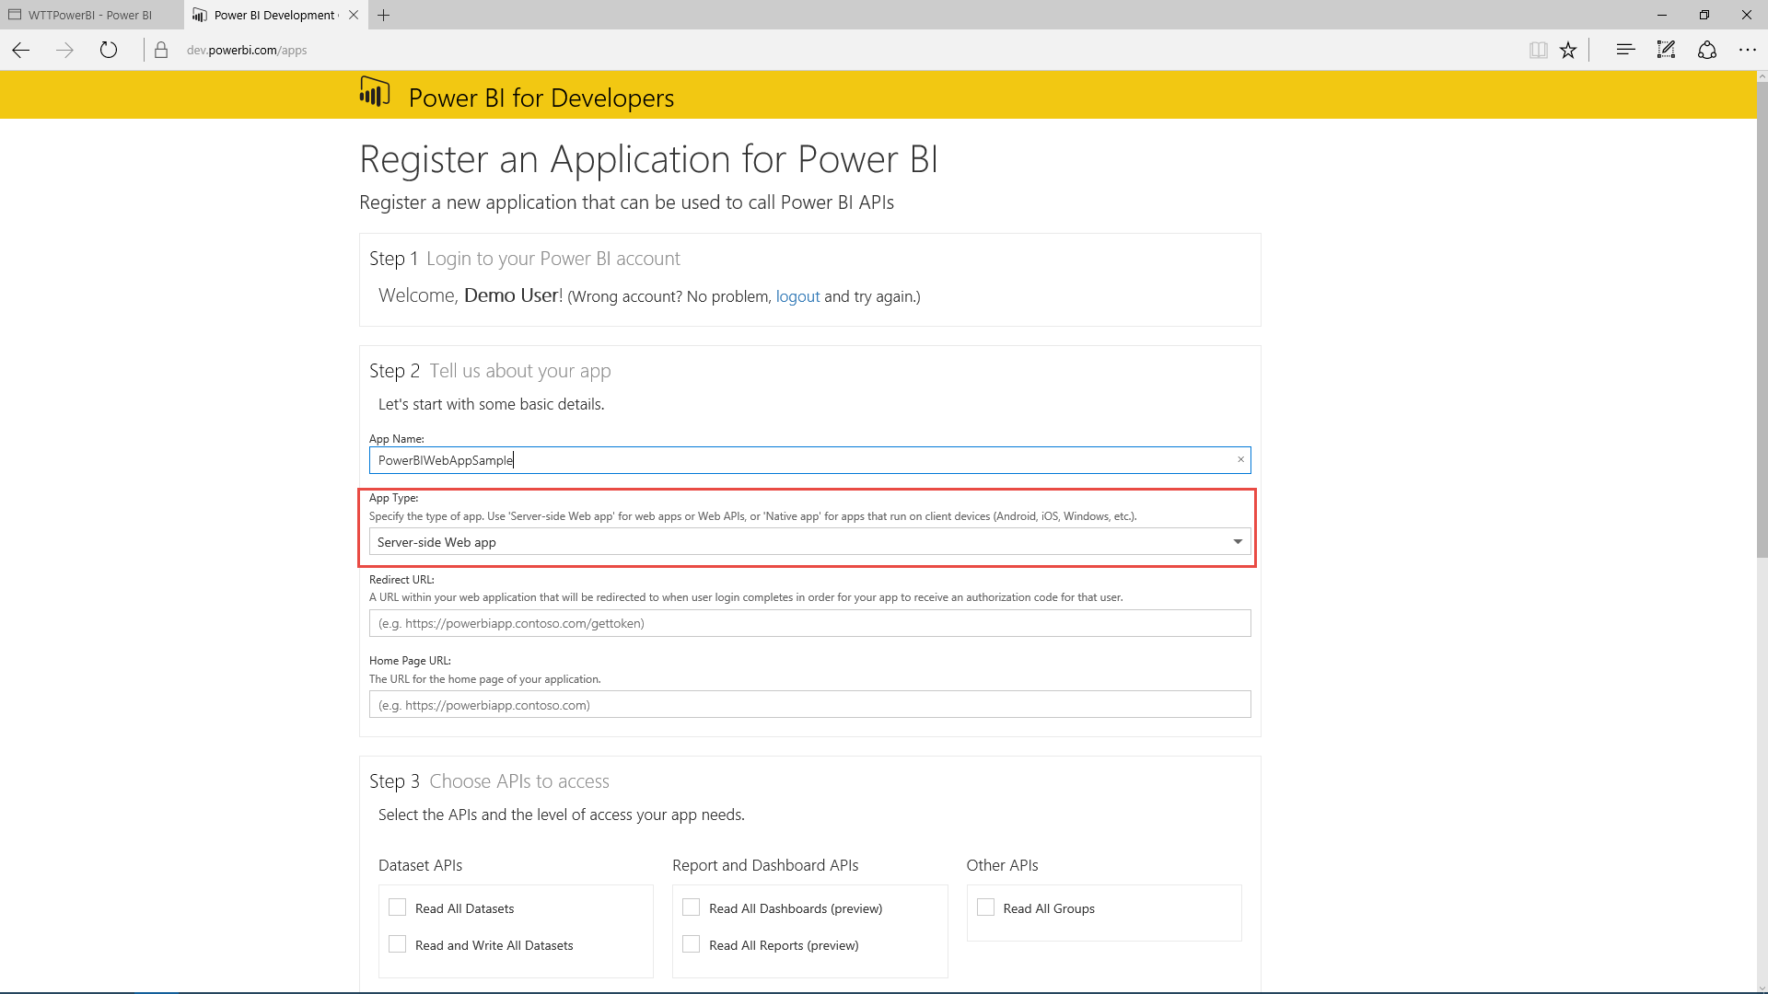 ***Figure 154*** *Specify App Type*
    6. In the **Redirect URL** field, type [**http://localhost:13526/Redirect**](http://localhost:13526/Redirect).  
       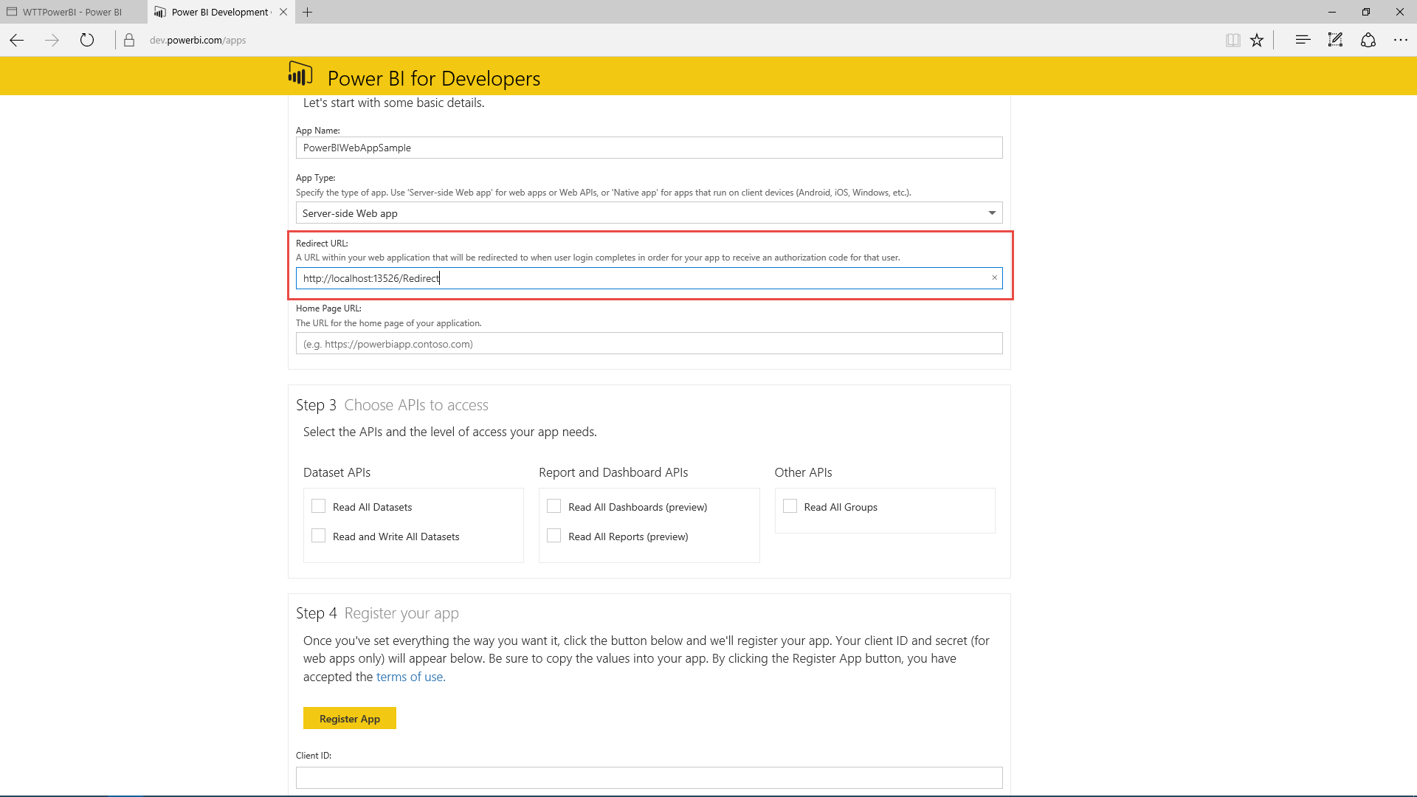 ***Figure 155*** *Type Redirect URL*
    7. In the **Home Page URL** field, type **http://localhost:13526**, and then click **Next**.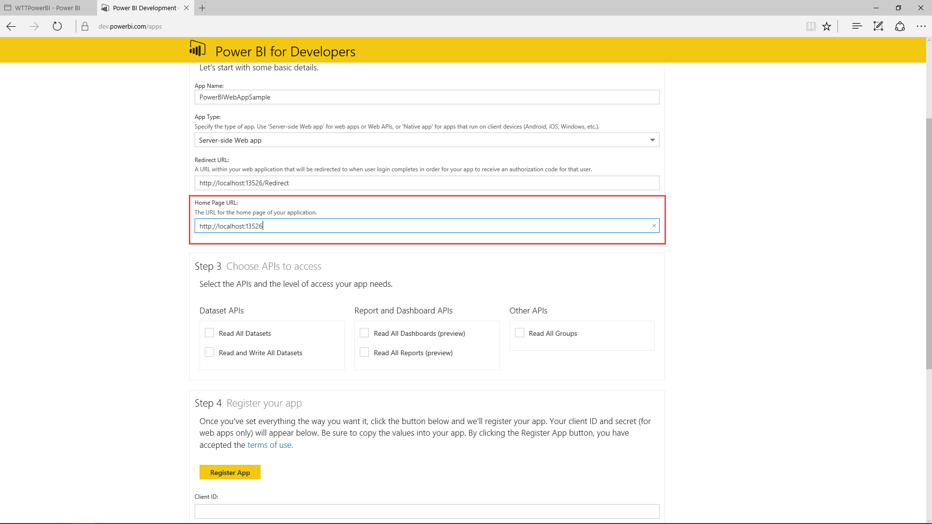 ***Figure 156*** *Type Home Page URL*
    8. In the **Choose APIs to access** area, select all check boxes.  
       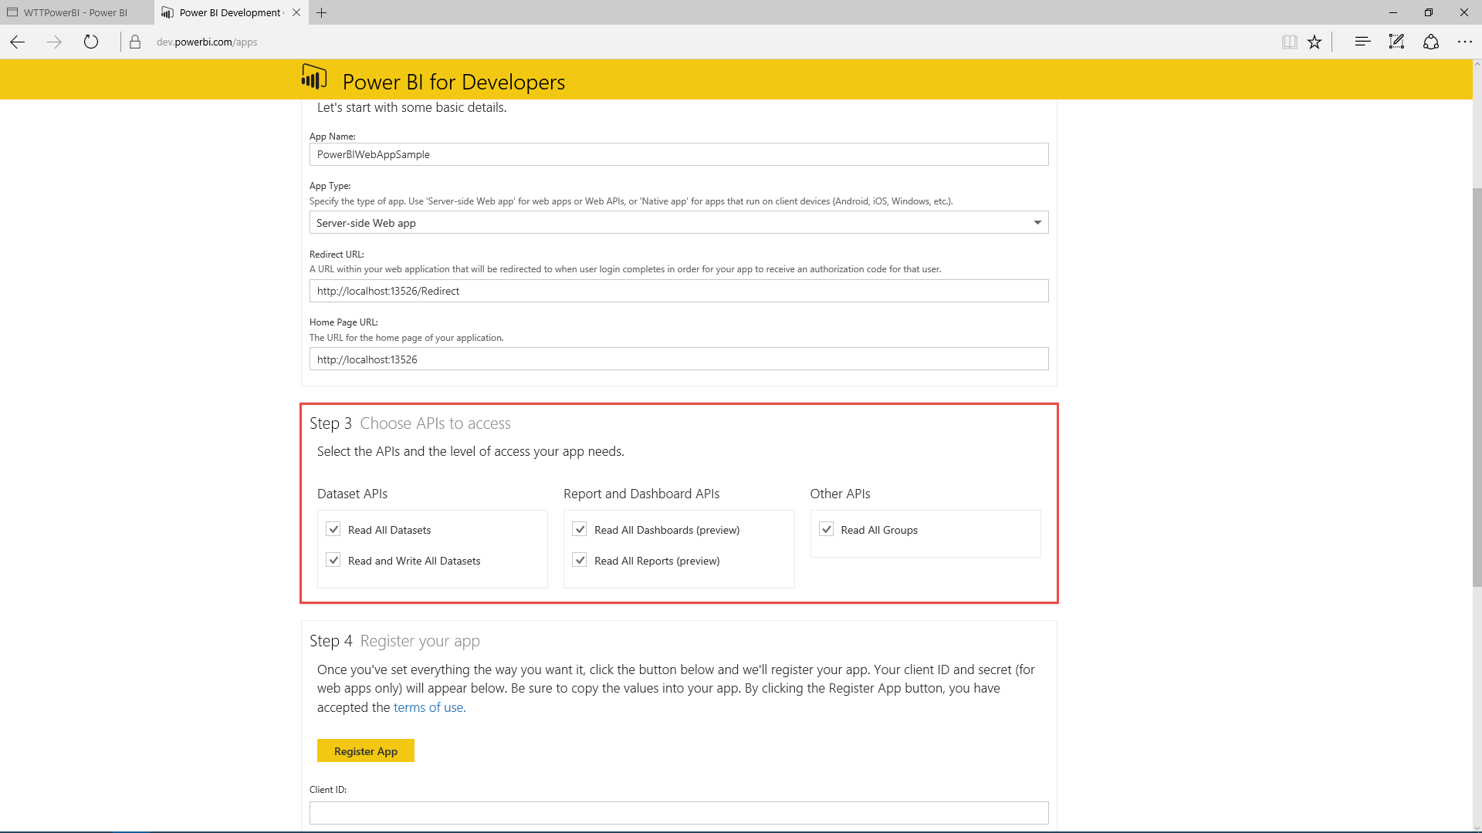  
       ***Figure 157*** *Select API permissions*
    9. Click **Register App**.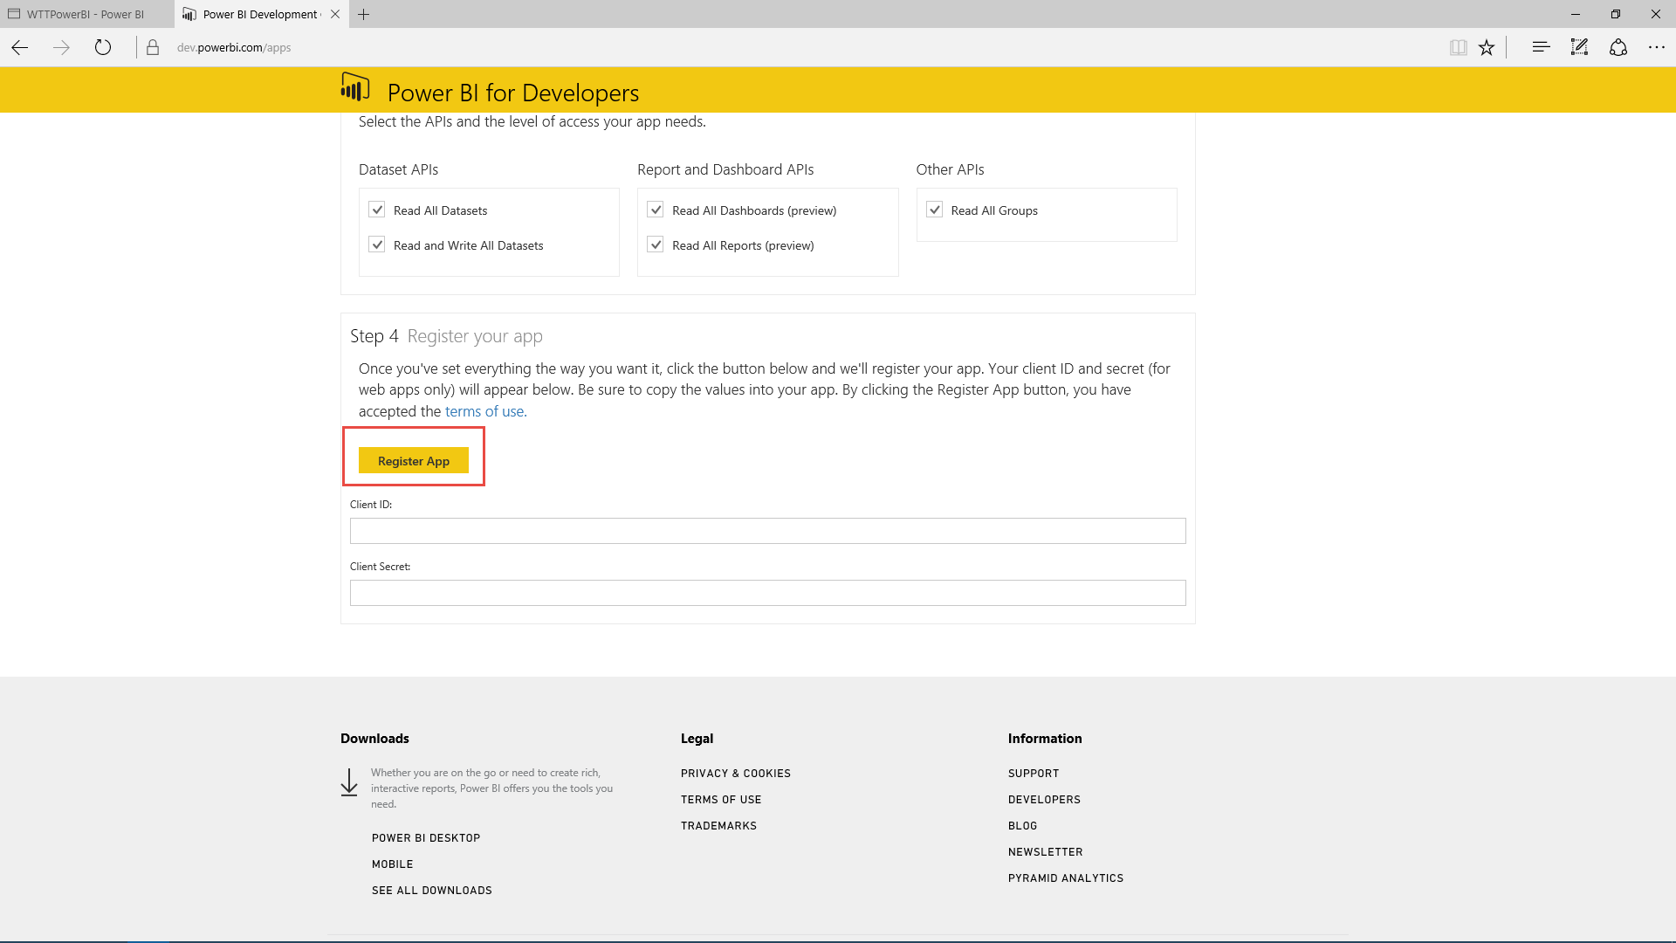  
       ***Figure 158*** *Register the application*
    10. Copy the **Client ID** and **Client Secret** to Notepad.  
        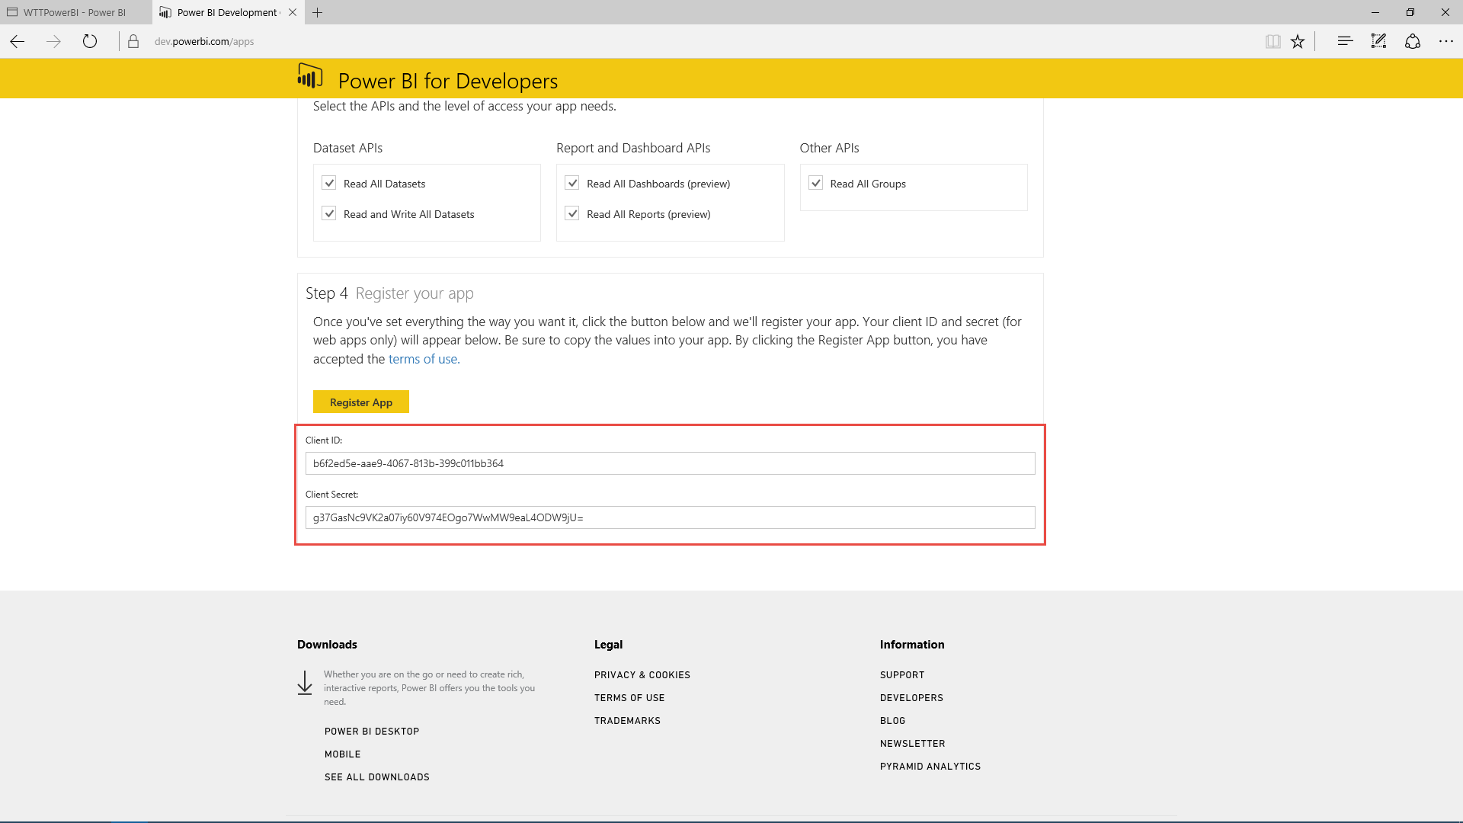  
        ***Figure 159*** *Copy the Client ID and Client Secret*
    11. Return to Visual Studio.
33. In the **web.config** file, locate the **<applicationSettings>** section.  
    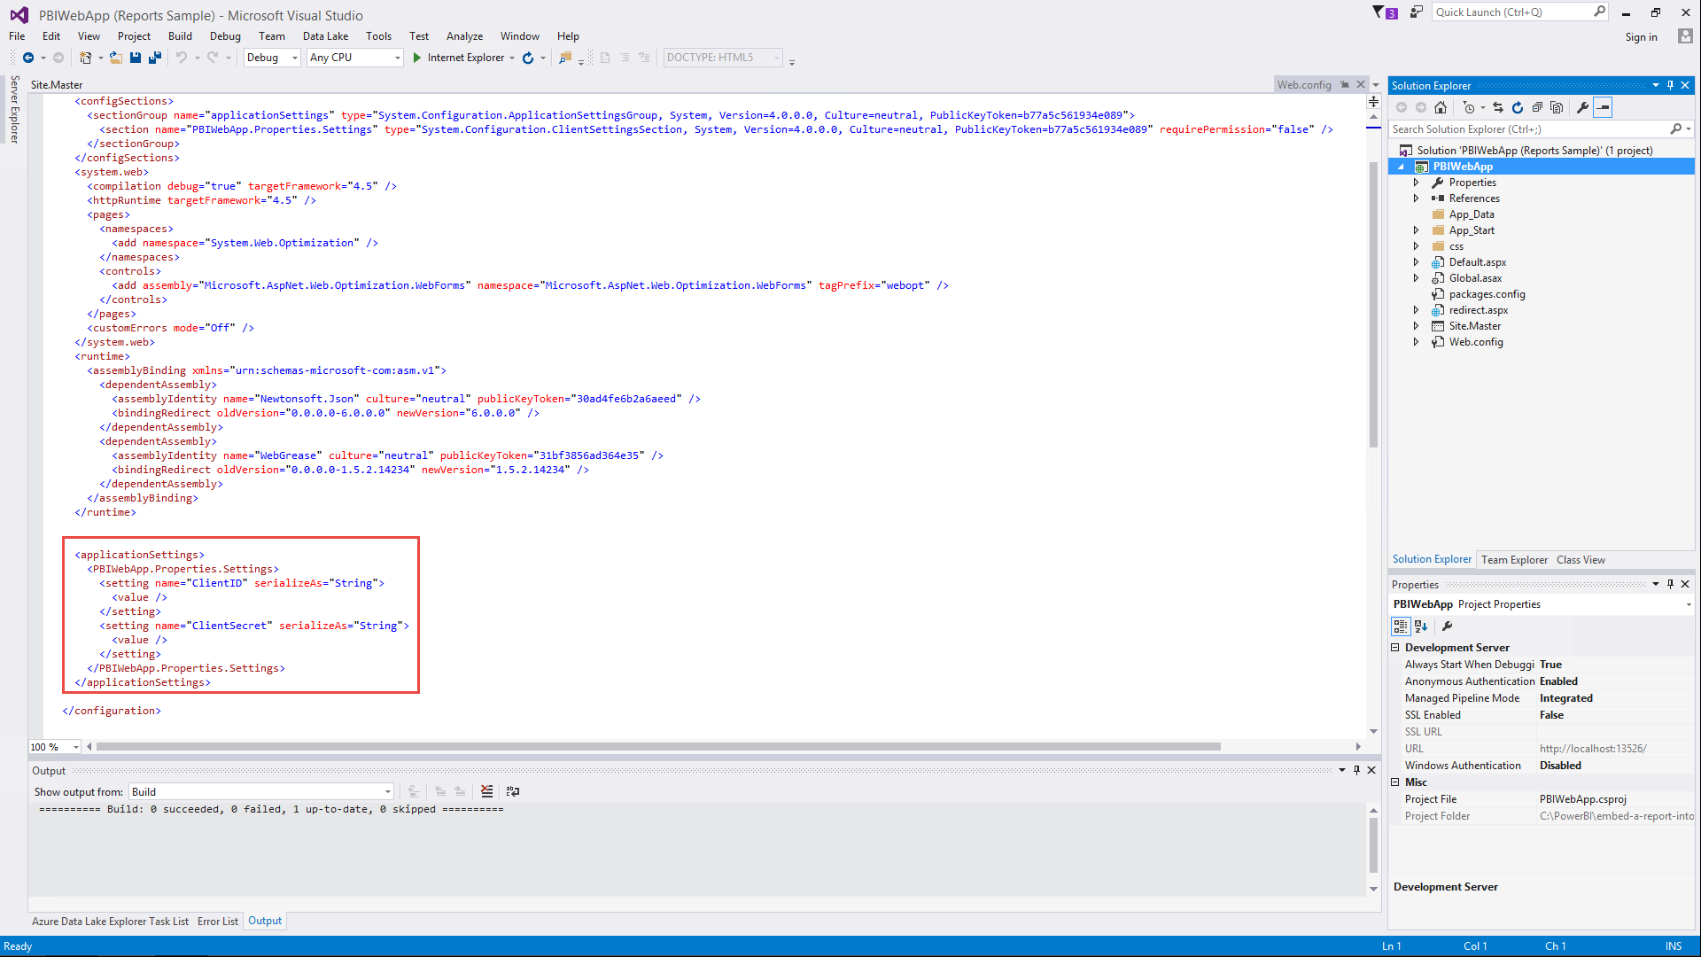  
    ***Figure 160*** *Update web.config ApplicatonSettings*
34. Update the **ClientID** setting with the Client ID string previously copied.
35. Update the **ClientSecret** setting with the Key Secret string previously copied.  
    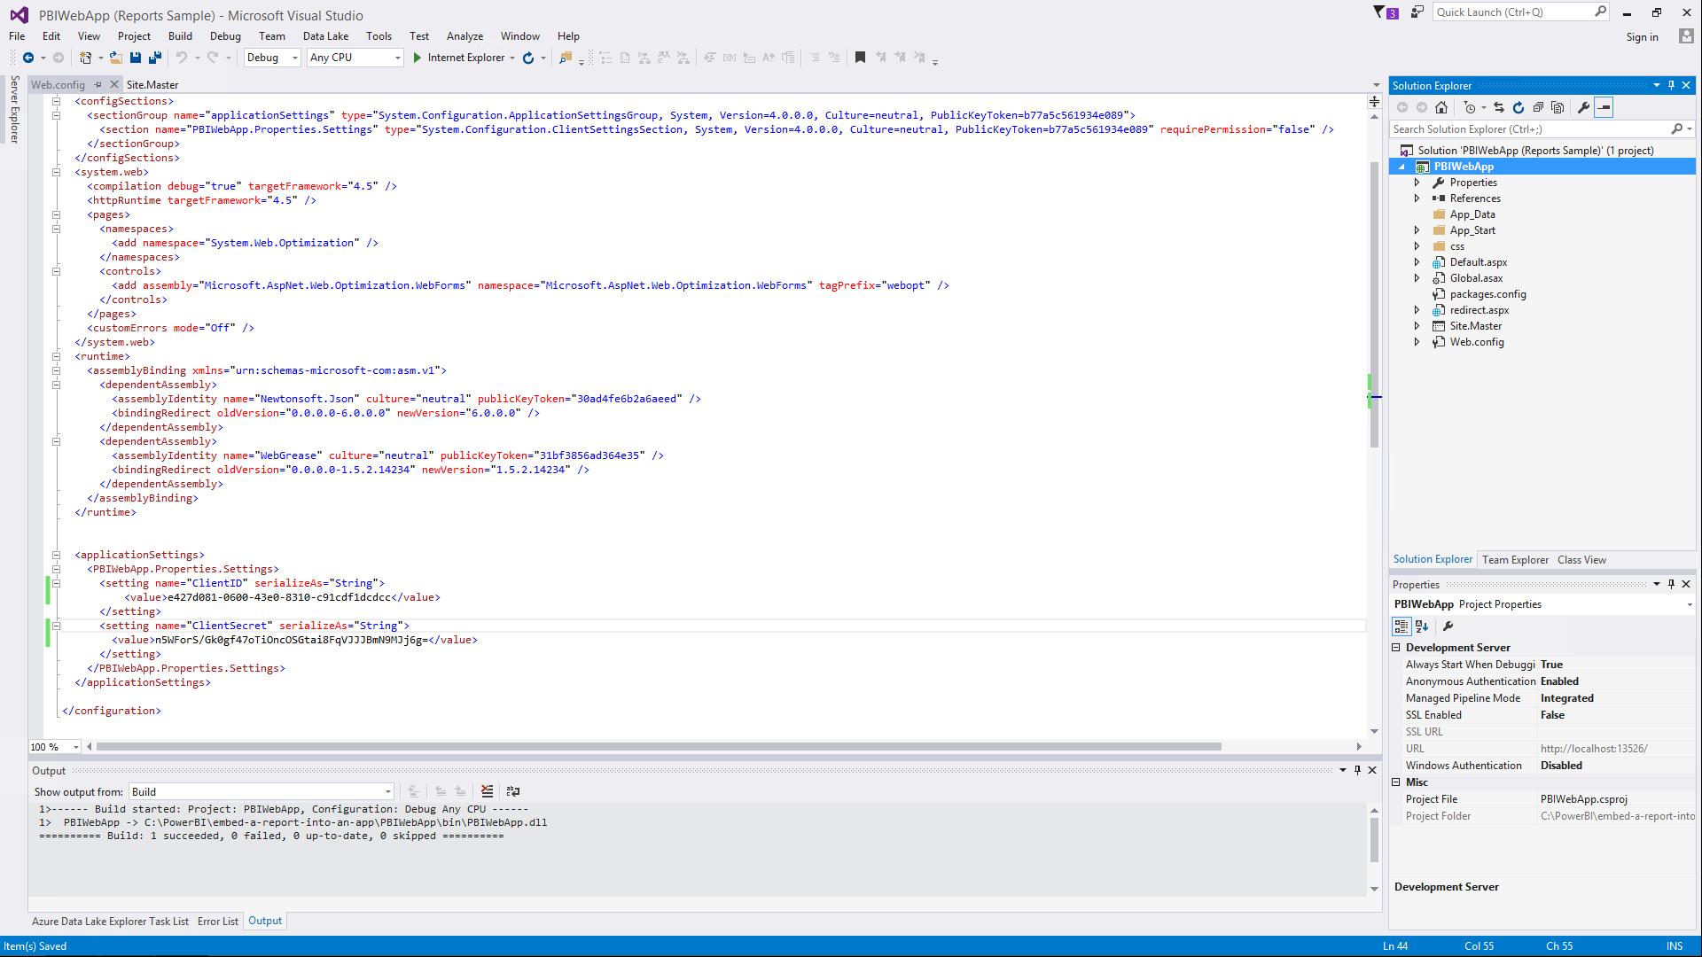  
    ***Figure 161*** *Update ClientID and ClientSecret settings*
36. Click **Save**.
37. Click **Run** from the tool bar.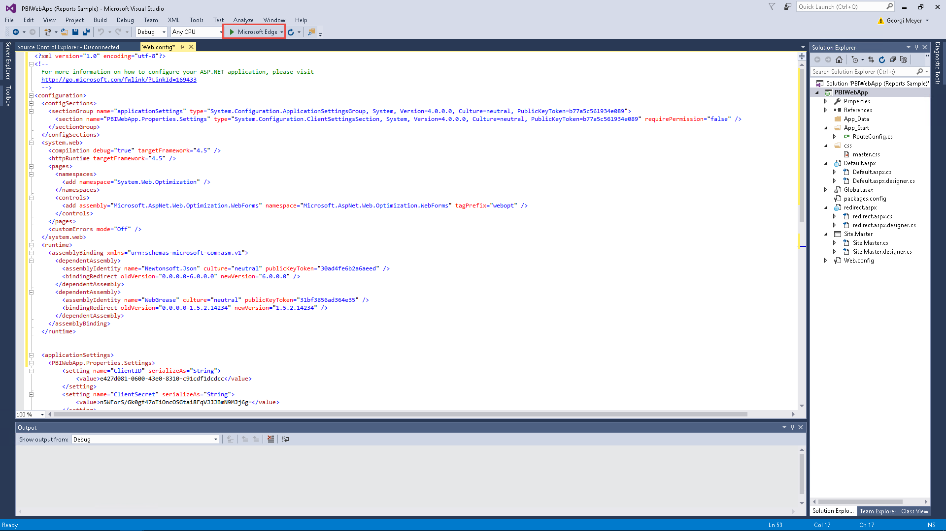 ***Figure 162*** *Run the Power BI WebApp Sample*
38. Click **Sign in to Power BI**.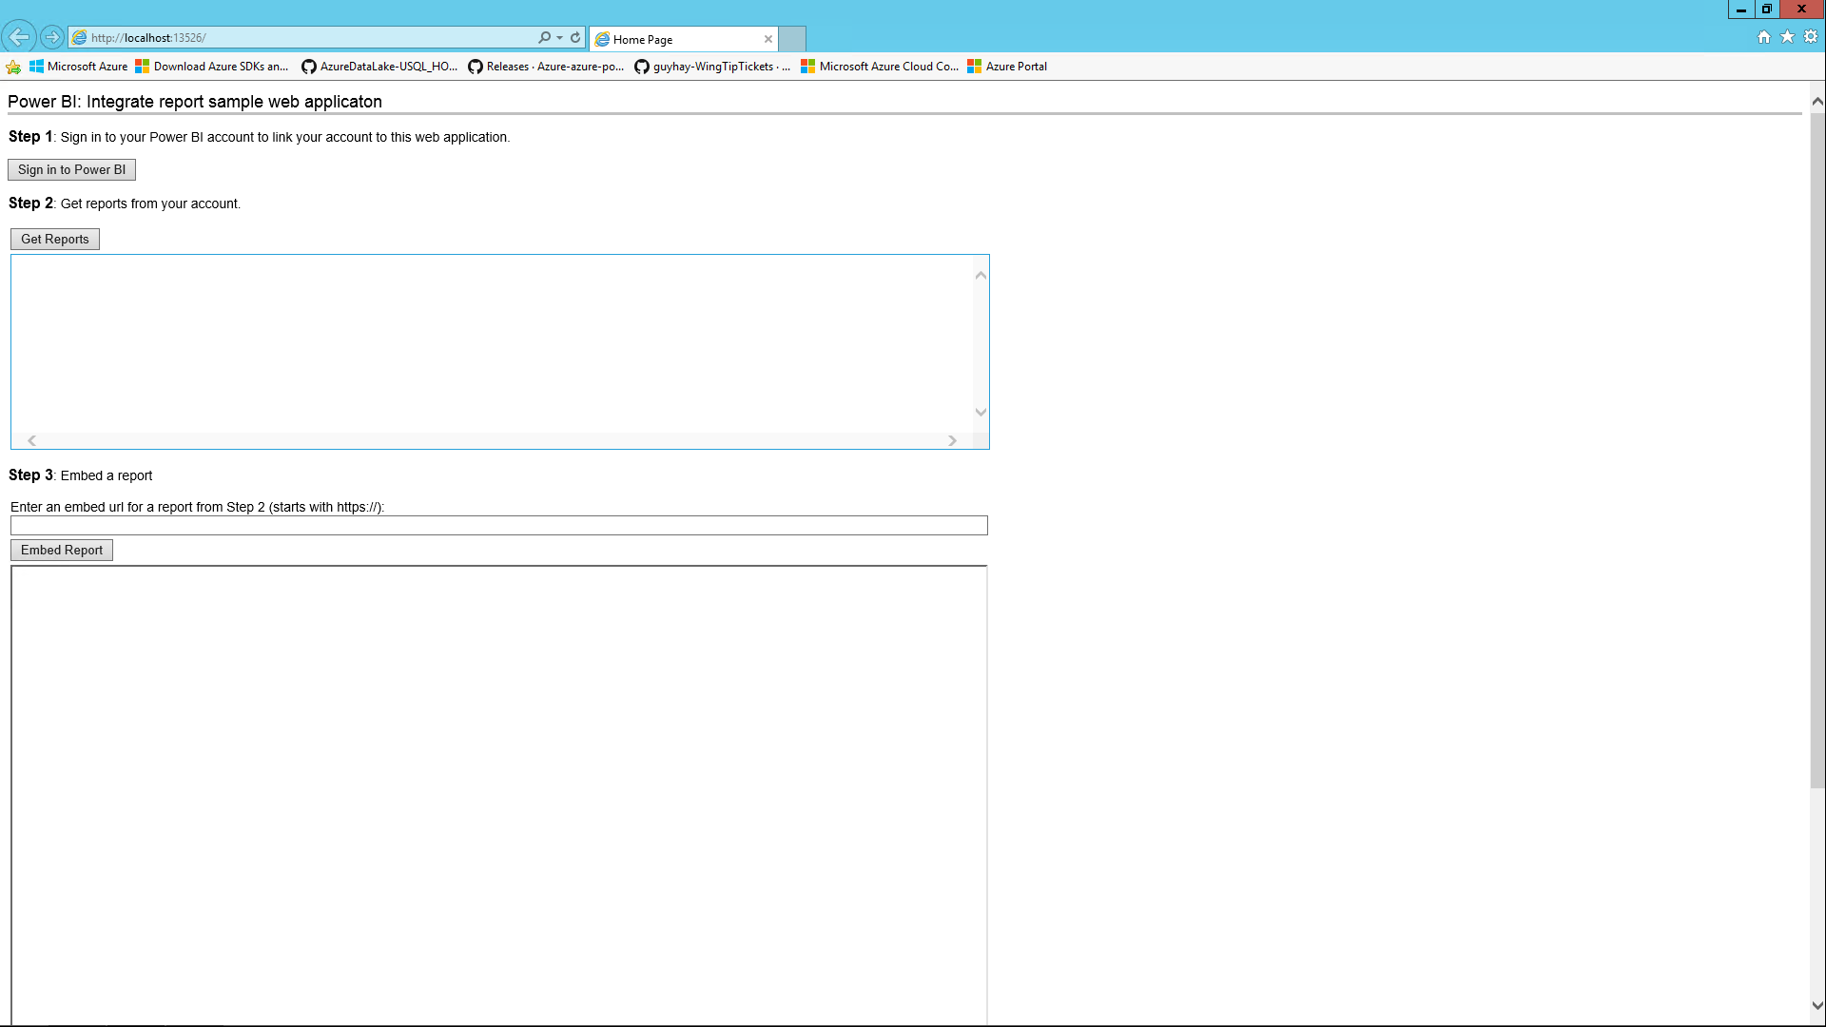 ***Figure 163*** *Sign in to Power BI*
39. Sign in using the Power BI account previously used.  
    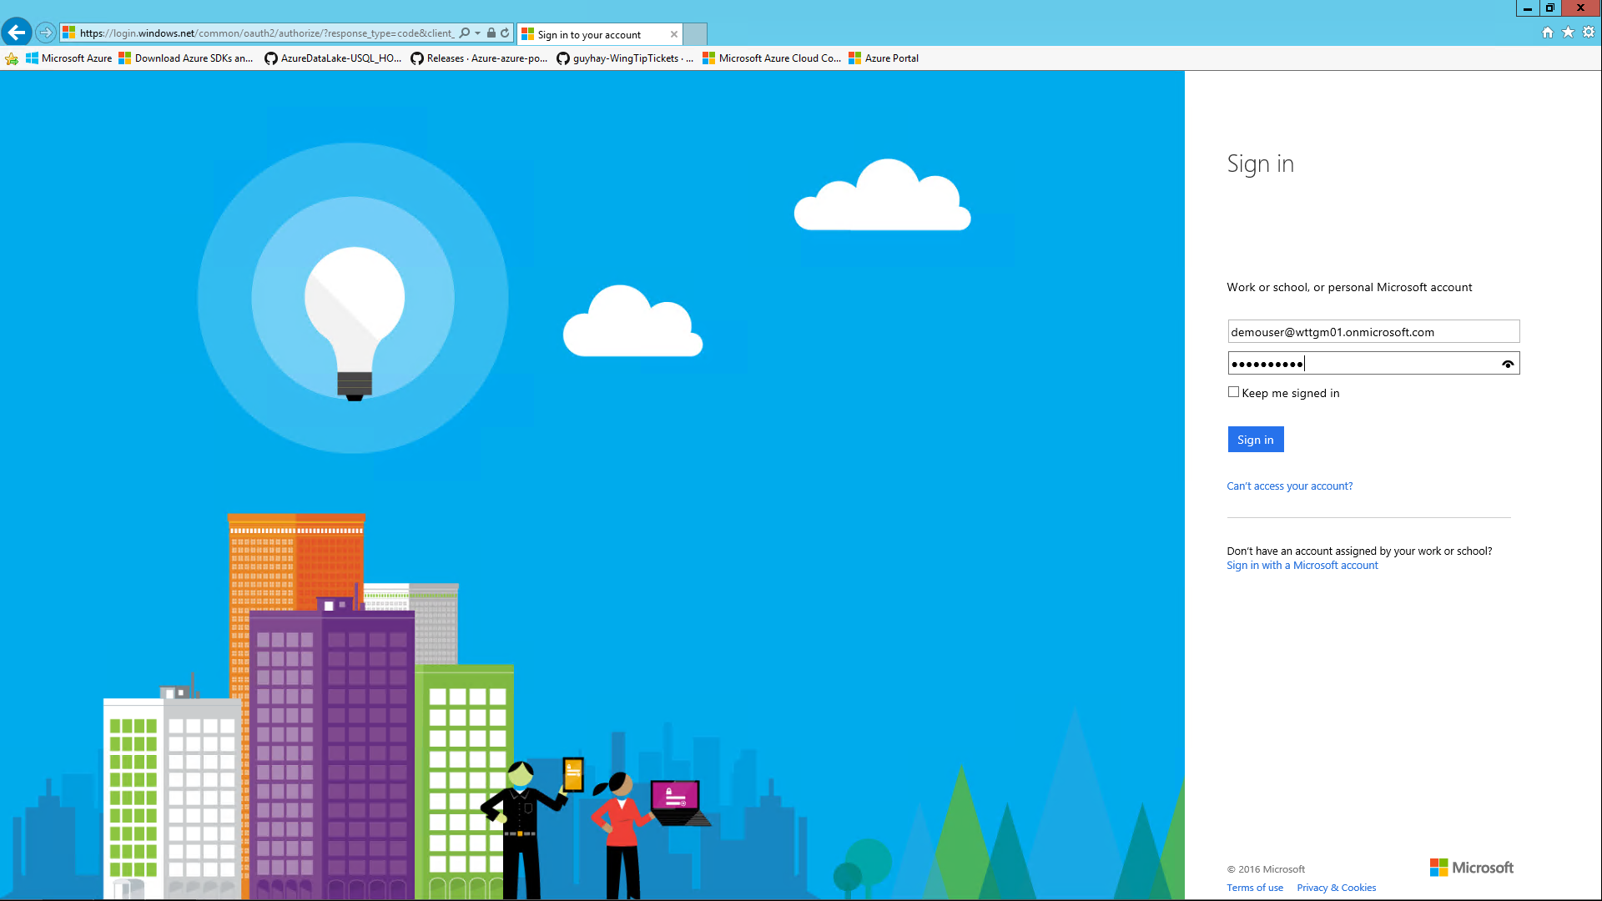  
    ***Figure 164*** *Sign in to Power BI*
40. Accept the app-publisher permissions.  
    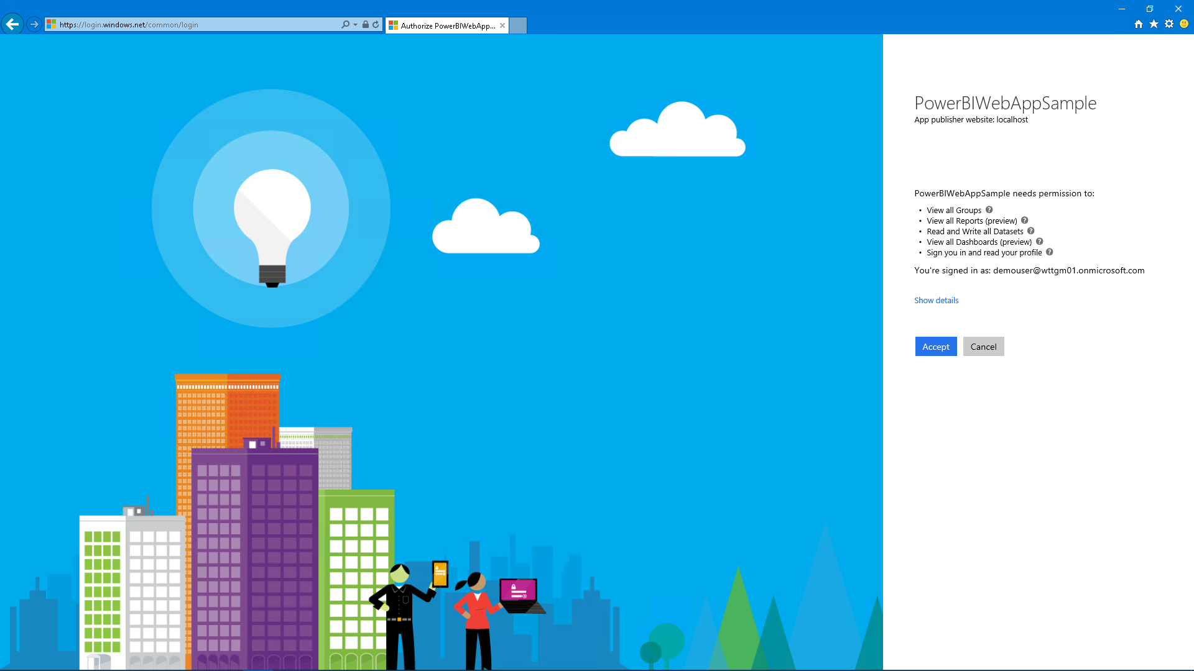  
    ***Figure 165*** *Accept the app-publisher permissions*
41. Click **Get Reports**.  
    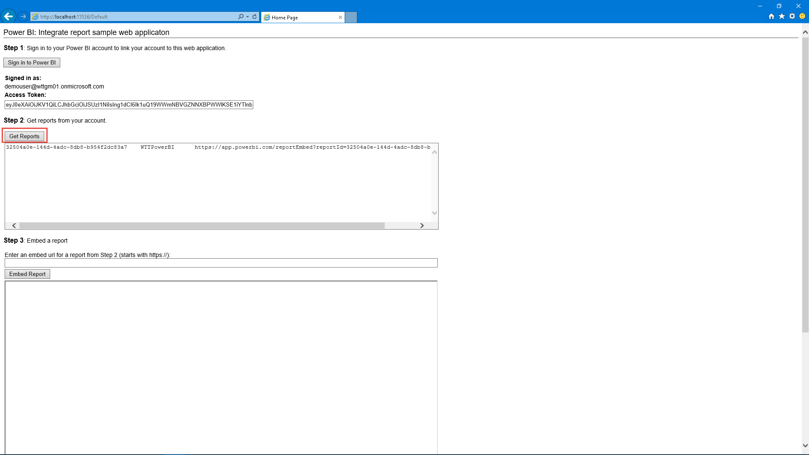 ***Figure 166*** *Get Power BI Reports*
42. Copy the URL starting with <https://app.powerbi.com>.
43. Paste the URL in **Step 3: Embed a report**.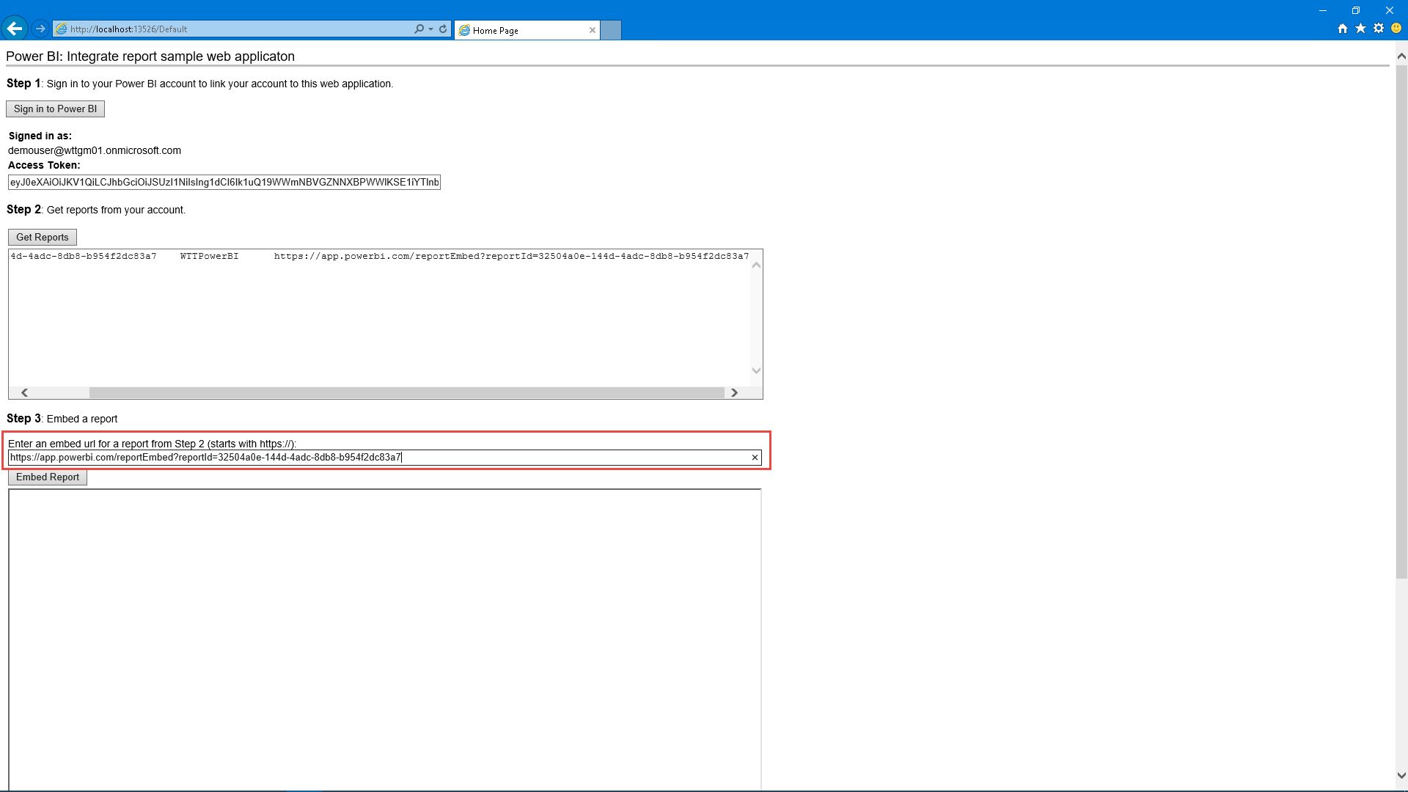 ***Figure 167*** *Paste the URL to embed the report*
44. Click **Embed Report**.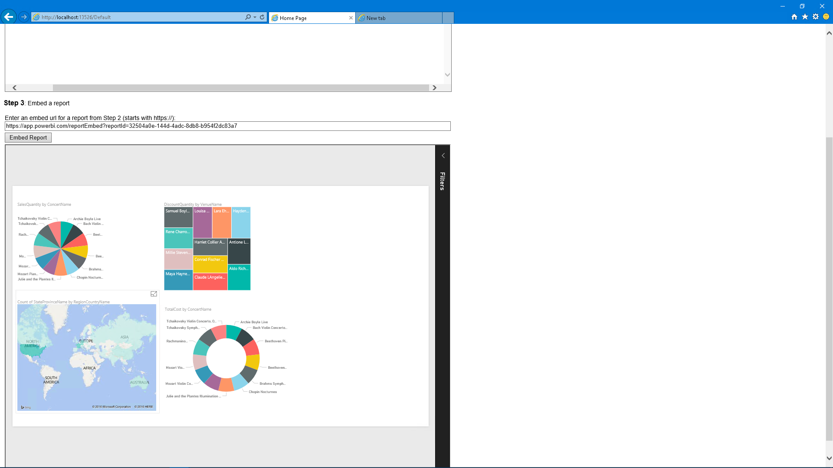 ***Figure 168*** *Embed the report*
45. Return to the Power BI Desktop application.
46. From the bottom left of the application, click **Add Page**.
47. Browse to <https://app.powerbi.com/visuals/>.
48. Click the **GlobeMap** visualization.  
    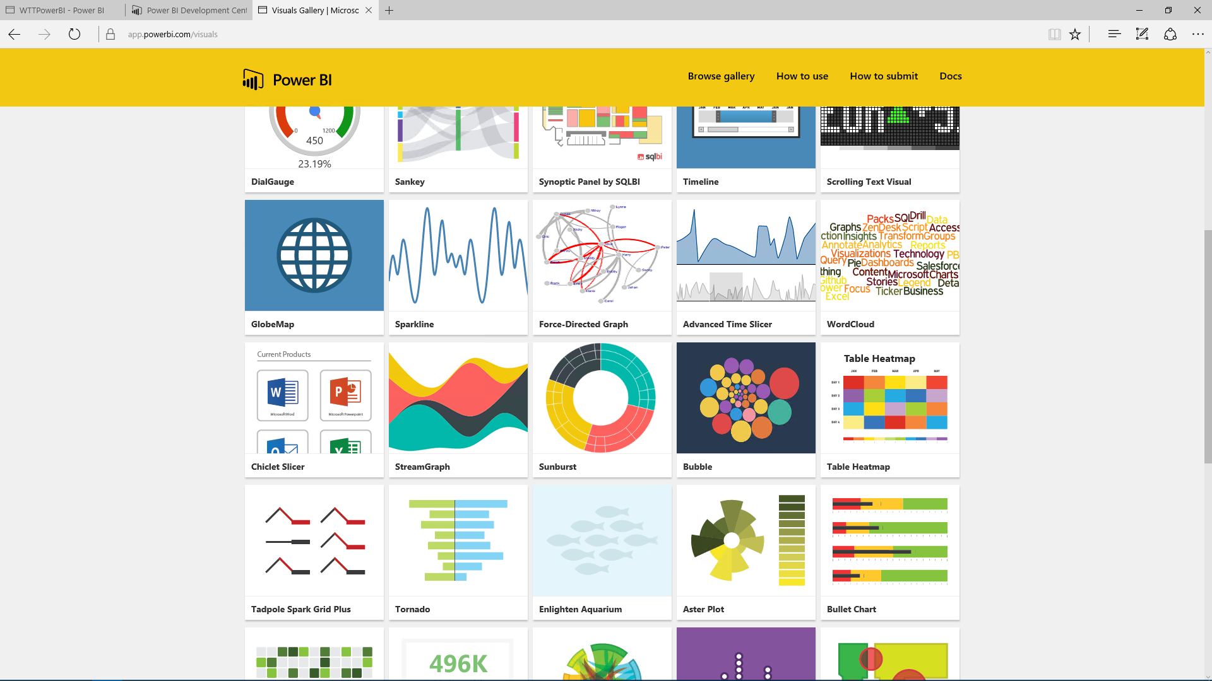  
    ***Figure 169*** *Power BI custom visualizations*
49. Click **Download Visualization**, and then agree to the terms.
50. Click the ellipses in the **Visualization** toolbar. From here, you can import custom visualizations.  
    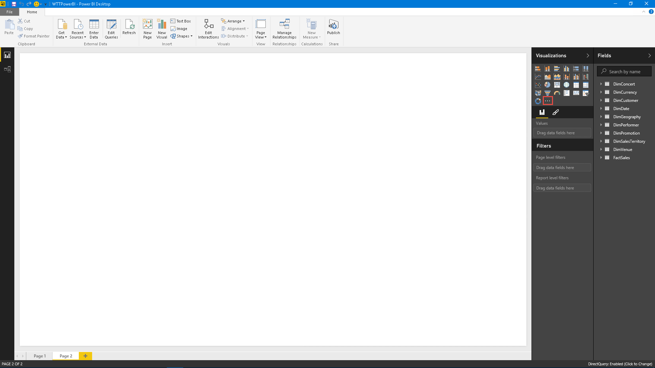  
    ***Figure 170*** *Import custom Power BI visualizations*
51. Click **Import**.  
    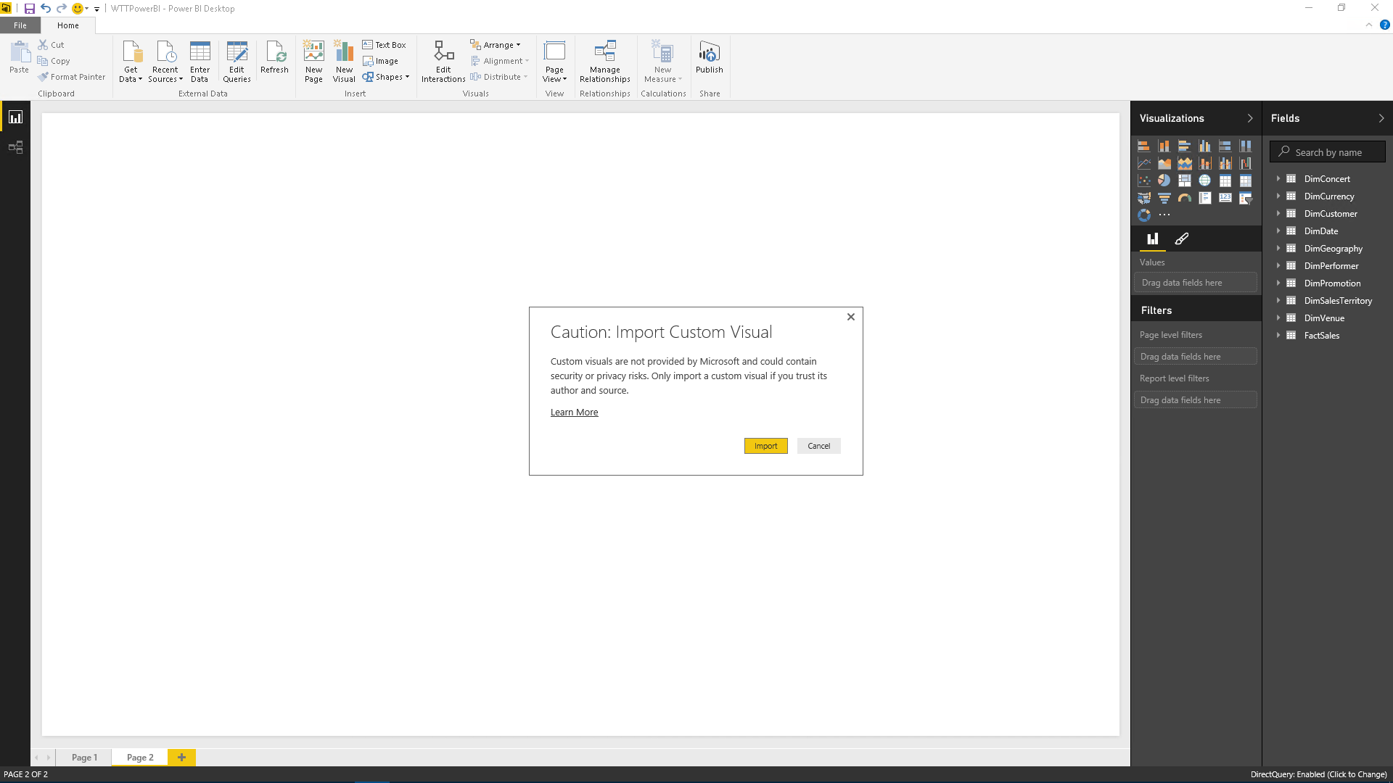 ***Figure 171*** *Continue importing the Power BI customization*
52. Browse to the location of the GlobeMap file, and then click **Open**.
53. Click the **GlobeMap** visualization.  
    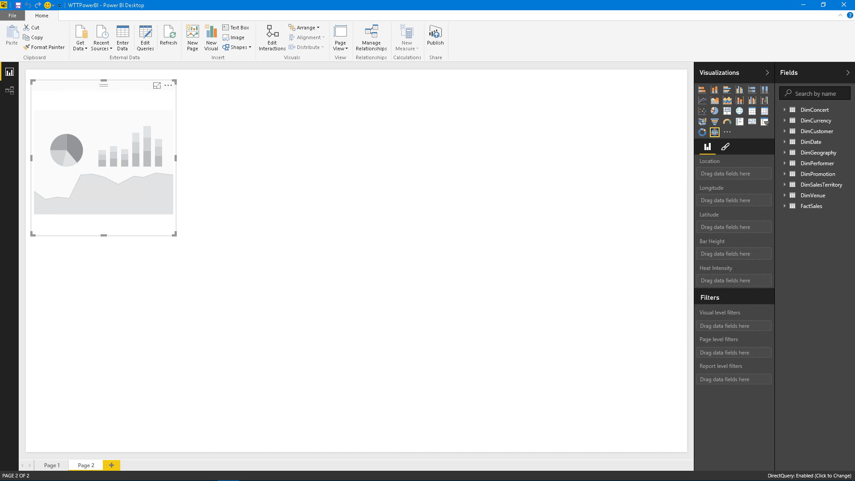  
    ***Figure 172*** *Add the customer visualization to the workspace*
54. From **DimGeography**, select **StateProvinceName**.
55. From **DimSalesTerritory**, select **SalesTerritoryRegion**.  
    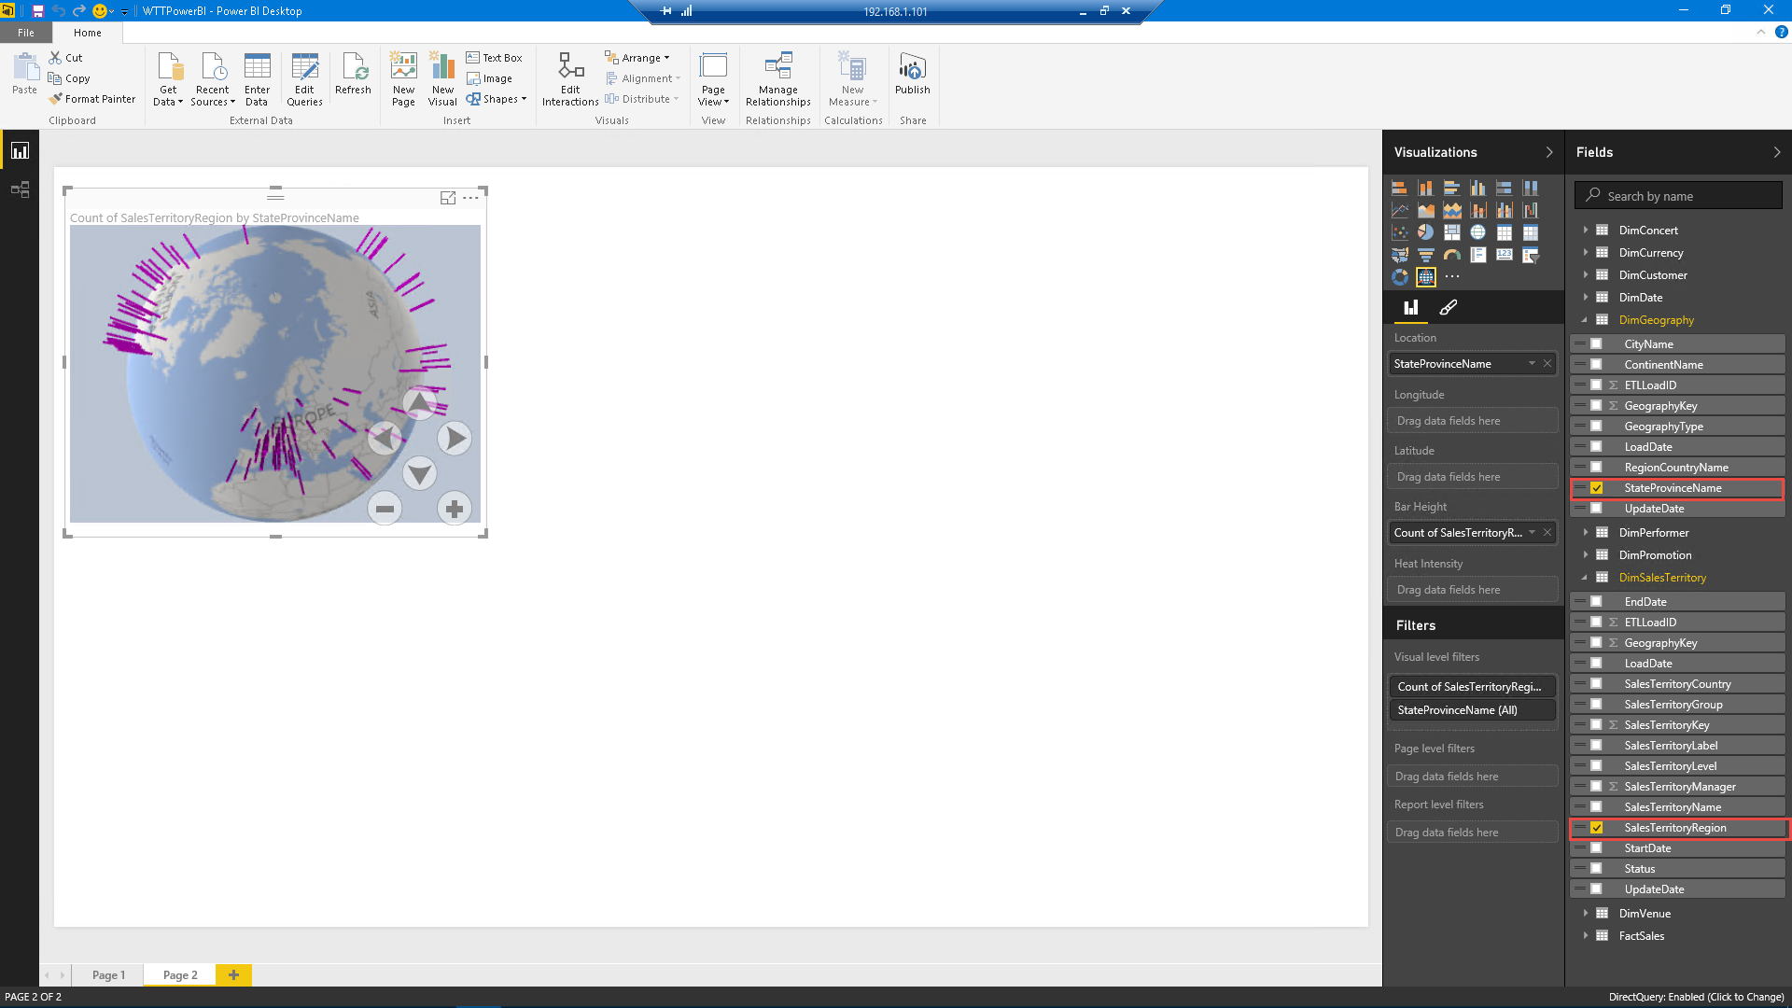 ***Figure 173*** *Add data to the custom visualization*

# Conclusion

In the course of this lab, you experienced many of the features that make it easy to set up and manage databases with Azure SQL Database.

Even though this lab used Azure PowerShell scripts to set up the lab environment efficiently, you saw how easy it is to set up one or several databases in Azure. Beyond database creation, you also:

* Learned about increasing the performance capacity of databases through vertical scaling.
* Saw how easy it is to implement dynamic scaling of groups of databases through elastic database pools.
* Tracked down errors in a database using auditing features in Azure SQL Database.
* Corrected errors using Azure SQL Database point-in-time restore.
* Saw how to prevent large-scale data loss with Azure SQL Database geographic disaster recovery.
* Implemented encryption on an Azure SQL Database.
* Provided the ability to search for an event using Azure Search.
* Provided the ability to save and retrieve JSON records from NoSQL Azure DocumentDB.
* Analyzed the Azure Data Factory pipeline that glues together an end-to-end personalized product-recommendation solution (Azure HDInsight, Azure Data Factory, and Apache Mahout) that can be visualized through the WingTipTickets website.
* Used Azure SQL Data Warehouse to process large amounts of data, in addition to using Power BI to create reports from that data.

With these skills in hand, you are better positioned to use Azure SQL Database, Azure DocumentDB, and Azure Data Factory to deploy and manage databases that use Azure to support your company or to support multiple customers in a SaaS environment.